BILLING SYSTEM FOR REYGUN SHOP

A Thesis

Presented to the Faculty of

Information and Communications Technology Program

STI College Global City

In Partial Fulfilment

of the Requirements for the Degree

Bachelor of Science in Information Technology

Rica Jane F. Lloren

Sebastien William C. Maravilla

Danille Ivan J. Roldan

Mark Joseph B. Ybid

January 13, 2020

ENDORSEMENT FORM FOR ORAL DEFENSE

TITLE OF RESEARCH: Billing System for Reygun Shop

NAME OF PROPONENTS: Rica Jane F. Lloren

Sebastien William C. Maravilla

Danille Ivan J. Roldan

Mark Joseph B. Ybid

In Partial Fulfilment of the Requirements

for the degree Bachelor of Science in Information Technology

has been examined and is recommended for Oral Defense.

ENDORSED BY:

Dexter B. Oseña

Thesis Adviser

APPROVED FOR PROPOSAL DEFENSE:

Mark Frederick V. Salonga

Thesis Coordinator

NOTED BY:

Maria Antonia G. Mariano

Program Head

November 2020

# APPROVAL SHEET

This thesis titled: Billing System for Reygun Shop prepared and submitted by Rica Jane F. Lloren; Sebastien William C. Maravilla; Danille Ivan J. Roldan; and Mark Joseph B. Ybid, in partial fulfilment of the requirements for the degree of Bachelor of Science in Information Technology, has been examined and is recommended for acceptance an approval.

Dexter B. Oseña

Thesis Adviser

Accepted and approved by the Thesis Review Panel

in partial fulfilment of the requirements for the degree of

Bachelor of Science in Information Technology

|  |  |
| --- | --- |
| Mark Frederick V. Salonga | Joselito Oyao |
| Panel Member | Panel Member |

Maria Antonia G. Mariano

Lead Panelist

APPROVED:

|  |  |
| --- | --- |
| Mark Frederick V. Salonga | Maria Antonia G. Mariano |
| Thesis Coordinator | Program Head |

November 2020

# Acknowledgements

The researchers would like to thank the following:

Thesis Coordinator, Mark Frederick V. Salonga for continuous guidance;

Thesis adviser, Dexter B. Oseña for the support and advice;

Thesis Review Panel, for patience and understanding;

Parents and/ or Guardian, for the financial and moral support and for letting us work overnight with our group in different places;

Friends and inspirations, for the willingness to help us when we are having difficulty in making the study, for working together, and for the fun that you gae us; and

We would like to express our deepest gratitude to the creator, Our God, for his constant guidance throughout this study**.**

# Abstract

Title of research**: Billing System for Reygun Shop**

Researchers: Rica Jane F. Lloren

Sebastien William C. Maravilla

Danille Ivan J. Roldan

Mark Joseph B. Ybid

Degree: Bachelor of Science in Information Technology

Date of Completion: March 2021

Key words: Online Shopping, Online Ordering

This project entitled, Billing System for Reygun Shop is developed to ease and accelerate the processes done within the company and the customers. This project is designed to resolve the problems that Reygun Shop is currently facing. The proposed system optimized the process which helps the company to handle transactions more efficient and faster.

The spiral model is used as a methodology in developing the system. This allows the developers to refine each process with a very high emphasis on risk analysis and allows incremental refinement of the product through each iteration. The methodology involves the identification, design, construct or build, evaluation and risk analysis. The developers used the data flow diagram and entity relationship diagram to represent the overall flow of the system.

The XAMPP, CSS/PHP/HTML, Java Script and ATOM are used as development tools for constructing and implementing the system.

# Table of Contents

|  |  |  |
| --- | --- | --- |
|  | | Page |
| Title Page | | i |
| Endorsement Form for Proposal Defense | | ii |
| Approval Sheet | | iii |
| Acknowledgements | | iv |
| Abstract | | v |
| Table of Contents | | vi |
| List of Tables | | vii |
| List of Figures | | Viii |
| List of Appendices | | x |
| Introduction | | 1 |
|  | Background of the problem | 3 |
|  | Overview of the current state of technology | 6 |
|  | Objectives of the study | 8 |
|  | Scope and limitations of the study | 9 |
| Literature Review | | 10 |
|  | Review of related literature, studies or systems | 10 |
|  | Synthesis | 22 |
| Billing System for Reygun Shop | | 25 |
| Results and Discussions | | 34 |
| Conclusions and Recommendations | | 39 |
| References | | 40 |
| Appendices | | 41 |
|  | |  |
|  | |  |

# List of Tables

|  |  |  |
| --- | --- | --- |
| Table |  | Page |
| 1 | Table 1 - Minimum and Recommended Hardware Requirements | 33 |
| 2 | Table 2 - Minimum and Recommended Software Requirements | 33 |
| 3 | Table 3 – Likert Scale | 36 |
| 4  5 | Table 4 – Admin Survey Result  Table 5 – Staff Surey Result | 37  38 |
|  |  |  |
|  |  |  |

# List of Figures

|  |  |  |
| --- | --- | --- |
| Figure |  | Page |
| 1 | Entity Relationship Diagram | 27 |
| 2 | Context Flow Diagram | 28 |
| 3  4  5  6  7  8  9  10  11  12  13  14  15  16  17  18  19  20  21  22  23  24  25  26  27  28  29  30  31  32  33  34  35 | Data Flow Diagram Level 0  Hipo for Billing System for Reygun Shop  Hierarchical Input-Process-Output Illustration for Admin  Hierarchical Input-Process-Output Illustration for User  Gantt Chart  Job Order  Letter Order  Mission Order  Certificate of license to own and possess firearms for individual  Monthly Report  Gun parts  Login.php  Index.php 1  Index.php 2  Index.php 3  Store.php 1  Store.php 2  Store.php 3  Store.php 4  Cart.php  Account.php  Ai.php  Orders.php  Contact.php  Register.php  Forgotpass.php  Create-new-pass.php  Store.php  Users.php  Adminindex.php  Orders.php  Grammarian’s Certificate  Grammarian’s Signature | 30  31  32  32  53  55  56  57  58  59  60  62  62  63  63  64  64  65  65  66  66  67  67  68  69  69  70  70  71  71  72  366  367 |
|  |  |  |

# List of Appendices

|  |  |  |
| --- | --- | --- |
| Appendix |  | Page |
|  | A. Project Acceptance and Certificates | 42 |
|  | B. Transcript of Interview | 45 |
|  | C. Project Involvement Form | 48 |
|  | D. Gantt Chart | 52 |
|  | E Sample Forms  F Screen Design  G Actual Thesis Expenses  H Database Schema and Tables  I Survey Questionaires  J Survey Result and Tally  K Source Code  L Data Sheets  M Grammarian’s Certificate | 54  61  73  75  78  82  84  362  365 |
|  |  |  |

**INTRODUCTION**

The internet is becoming the world’s largest tool for communications; it has provided an environment where everyone can use online at any given time. That is why, people all around the world are enjoying the convenience of click and order procedure wherein they carry out a proper search and prefer a wide range of options. This has become an avenue to make and accomplish things easier and faster.

The combination of visual and auditory information at the human-computer interface is a natural step forward. In everyday life both senses combine to give complementary information about the world; they are interdependent. The visual system gives us detailed data about a small area of focus whereas the auditory system provides general data from all around, alerting us to things outside our peripheral vision. The combination of these two senses gives much of the information we need about our everyday environment.

These advantages can be brought to the multimodal human-computer interface. Whilst directing our visual attention to one task, such as editing a document, we can still monitor the state of other tasks on our machine. Currently, almost all information presented by computers uses the visual sense. This means information can be missed because of visual overload or because the user is not looking in the right place at the right time. A multimodal interface that integrated information output to both senses could capitalize on the interdependence between them and present information in the most efficient and natural way possible. This thesis aims to investigate the creation of such multimodal interfaces.

"In our interaction with the world around us, we use many senses. Through each sense we interpret the external world using representations and organizations to accommodate that use. The senses enhance each other in various ways, adding synergies or further informational dimensions". [Dannenberg & Blattner]

Developing an billing system for reygun shop is to make the process of their business light and convenient and also for their customers. By the use of this system, they can ensure to provide a good quality service to their valued customers. Background of the problem

The main reason of creating this system is to adapt in the wide range area of promoting the business into the gun industry. The customers who wish to look inside of what services the shop can offer even if they are far from the main branch of the shop, now it can be made possible by the use of the developed system which is the Billing System for Reygun Shop.

Background of the study

Reygun Repair and Services was established on October 2016 in 330 Abraham St. C5 Palar Village Barangay Pinagsama Taguig City by Reynante Mendoza, the owner. The shop has another branch which is located in Bacoor, Cavite. Reynante Mendoza stands as the manager and the one who has the control in terms of decision making within the business. It opens at 8am in the morning and closes at 6pm in the evening. The shop currently has 6 staff members which consist of the owner (1) who also act as a front desk, the machinist (2), the finishers (2), and the gun coater (1). Depending at the time of the year number of customers increase specially in December or a gun events like shoot fest or decrease because of gun ban, but most of the time there are around 5-8 customers per month and the customers with a gun license are only allowed in the shop.

The services the shop can offer are customization, colour coating, and repairing. There are various colours that are available from the shop, Hard Chrome ₱4,000.00, Black Chrome ₱6,000.00, Titanium ₱6,000.00, Ceramic ₱6,000.00, Damascus ₱8,000.00, Digital ₱8,000.00, Cerakote ₱10,000.00, Re-blue ₱2,500.00, Parkerized ₱3,000.00. For Repairing it depends on how many parts of the gun needed to be repair, up to ₱75,000.00 for a single stock and ₱85,000.00 for high capacity guns. For customization it also depends on what parts and how many parts are needed to be customized, up to ₱15,000.00 for tuning up. All the staff is knowledgeable about all kind of services. And the time needed to consume are different from each of the services they can provide. Customization takes 1-2 weeks if the customer wanted the service to finish as soon as possible, and 1 month if the customer is not in a hurry. For colour coating takes 2-3 days, and repairing the unit only takes less than a day.

In line with this, the developers sought the need for them to have an billing system for Reygun shop. This system will help them modernize their current way of managing their business process and monitoring their monthly sales. This is also a great technique to increase the company’s popularity and customers by using the online platform. The process of the system starts by browsing in the internet and search for the website of Reygun. Afterwards, you will be going to the website of it and you will see the main page. The customer can register a new account if the customers are new to the website. After the customers register, the customers will now have access into the system and log in the registered user name and password and now can order send the details to the shop online using the developed system.

Business process

Inquiry

The customer may inquire through a phone call, walk-in, or Face book. The secretary is the one who is giving information about assistance to the customers. The shop offers customization, repairing, and color coating for the customer`s unit and shows some samples of services the shop can provide with a book of pictures showing the previous work. Walk-in customers can choose what the shop can provide, for the customers who inquire through a phone call can ask if what services the shop can provide and through Face book, customer can see what services and can ask for the services the shop have

Stating the cardinal rules of gun safety to customer

The customer needs to follow the four cardinal rules of the Reygun for safety. Every gun should be considered loaded. Do not point your gun at anything you do not want to eradicate. Do not insert your trigger finger unless you are prepared to fire. Be sure of your target and what is in front and behind it.

Service Ordering

The customer can choose what type of services they want and the secretary will give some recommendations to the customer of what is the best customization for the unit, the secretary will inspect the gun if there are any defects in the unit of the customer and the secretary will write down the ordered service of the customer in the job order.

Requirements validation

The secretary will ask for the requirements of the customer for validation if the customer is MIL (Military)/PNP (Philippine National Police)/LEA (Law Enforcement Agency) customer need to show 3 requirements. First is Military/Philippine National Police/Law Enforcement Agency I.D, second is acknowledged receipt of the equipment, and last is mission order. For civilians, the first requirement is any valid I.D (Ex. Philippine passport, Driver’s license, SSS, UMID ID). Second is a license to own and possess firearms and the last is permitted to carry firearms outside the residence and if the customer does not have requirements the shop will automatically reject the ordered service of the customer and if the customer has these requirements the secretary will verify the requirements if it is valid through scanning the code in the I.D of the customer. The secretary will make a copy of the customer's requirements and compile them in the folder.

Payment

The secretary writes down the name, address, license number, or mission order, phone number, date, prices of the ordered service/s. the secretary will ask the customer what mode of payment the customer wants. The shop has two modes of payments, first is a full payment mode, the customer can pay the full amount of the service/s, second is installment, the customer is obliged to pay 50% of the amount for the down payment. The shop will only release the unit if the customer paid the full amount of the ordered service. The time needed to consume varies from each of the services they can provide. Customization takes 1-2 weeks if the customer wanted the service to finish as soon as possible, and 1 month if the customer is not in a rush. For color-coating service, it takes 2-3 days and repairing the unit only takes less than a day.

Testing units

Once the customer claims the unit, the staff will instruct the customer to test the finished unit in the shop's firing range for faults and if the gun is defective, the customer can return it to the shop as long as the gun is covered by the warranty.

Warranty

The shop will give a 1-month warranty for each unit for them to check the defect and can return the unit if the customer is not satisfied. If the warranty is expired the customer needs to have a new transaction.

Monthly report

The secretary will collect all important information like the name, address, license to own and possess firearms control number, Firearms registered control number, kind of firearm, the brand of the firearm, caliber, serial number, the scope of repair. Every end month to report it in camp crame.

## Overview of the current state of the technology

The business establishment is currently using a manual system of writing down and producing the customer's requested services orders. That of which includes an everyday set of recordings and as an old practice, it is unreliable because if someone forgets to write some of the requested services it can affect the outcome of the services provided. Considering that it is a small line of business, technically speaking there is less need for those requirements. The problem occurs when recently, one of the staff of the Reygun shop misplaced the records of the service order list. Over time, the staff can notice that the current manual system the company is using is not that reliable. To help the establishment to have an accurate and hassle free way of recording the list of services and calculating each transaction of the shop, we proposed to the establishment to use a billing system.

The usual process of the shop was to record all the customer's requested services that come every week or every month. Every service that has been requested by the customer will manually be computed and jotted down to the job order receipt pad. All of these transactions must have a copy for the shop and the customer. So based on the information above, it would take a certain amount of time and effort for the system to be developed and become a usual solution for the shop's current dilemma.

In this system, the shop can easily register the customers who arrive at the shop from prior to recent. This strategy can protect the customer's order information that will be discussed with the shop. It is also a user-friendly system. After the installment of the system, the developers continuously monitor the system including the shop to maintain the quality of the system.

Statement of the Problem

General Problem

The main challenge is that the Reygun shop has difficulty in getting the details through phone calls and Facebook. The shop has a lot of logbooks scattered around. Online inquirers can’t be all entertained because of the tedious schedule.

Specific Problem

Time-consuming in collecting orders of the customers

The shop’s secretary has difficulty in getting the details through phone calls and Facebook because texting and phone calls do not show the exact detail of the order and customer’s information.

The customer ordered services status

The customer does not know the status of the ordered services. The client does not know when to return to the shop if the ordered services are completed.

Lengthy process of billing

The prolonged process of billing Manual computation of the services and parts is a very long process. Parts and Service transactions are computed one by one, so it consumed too much time especially if the client avails for more than five services. The secretary encounters a slow pace in checking out the price of a particular service and it takes time to write it down on the official receipt making work slower and time-consuming.

General Objective

The enhancement of a module that will reduce the time being consumed in organizing the client's transactions that is also a user-friendly system so that the users and customers can comprehend it easily and also to give more information about the shop`s services. So the developers decided to enhance a billing system for Reygun shop to improve the process, especially in customer service so the company can provide efficient service for the customers.

Specific Objective

To develop a module that will help the secretary keep track and sort the orders

The developers will establish an ordering management system that will benefit both the clients and the employees. The secretary can sort and track the details of the ordered services and the information of the clients.

To design and develop a module that will monitor the status of the ordered services

The developers will develop a module that the client can monitor the status of ordered services. The customer can track and view the condition of the client’s firearm.

To develop a module that can speed up the process of billing

The developer's aim is to develop a module that can speed up the billing process. It avoids miscalculations and avoids misstating of prices of particular parts and services. Having a bunch of clients at the same time will not be a challenge anymore since the computation is more accurate and faster in a way that the client will be satisfied with the service. This system helps the secretary to reduce the work that is being done in process of calculating bills.

Scope and limitation of the study

Scope

The clients can pay online through PayPal and can check the status of their order's details and the clients can also contact the shop for the desired design of the unit.

Limitation

This system is limited in the credit card process of purchasing. Payment in credit card like BDO and BPI ( Banco de Oro and Bank of the Philippines Islands) is not recommended to Reygun shop especially in large transaction and verification of the requirements the customer still need to go to the shop physically for the validation of the unit and the license and shipping details of the ordered product. The shop provides parts of 45 Caliber, Colt M1911, Beretta M92 for .9mm handgun, and Winchester M1887, Benelli Nova, Beretta 682 for shotgun and 35M Rifle, Armalite AR-15, AK-47, AMP-69 for the rifle.

# Literature Review

## Review of related literature, studies or systems

For further understanding of the study, the researchers made use of different reading materials related to the online system. These materials such as books, magazines, newspapers, thesis, and other web articles are essential in expanding the knowledge of the researchers. These will also guide the researchers to achieve their target objectives by obtaining ideas from other related studies and generate improvements as possible.

The information gathered by the researchers focuses on the development of e-commerce or online marketing and its advantages to the economy, consumers, and businesses. Security measurement information in terms of payment and customer’s privacy to be considered in developing an online system are also obtained.

Foreign

The web has become an opportunity for the marketers to add value to products and services.   The phenomenal growth and rising of the popularity of the internet and the World Wide Web has become a key to attract more consumers and businesses to engage the benefits of Electronic Commerce (E-commerce). This E-commerce is sited as any form of business transaction in which the parties interact electronically rather than by physical exchanges or direct physical contact (Aldin, Brehmer & Johansson, 2004). This has transformed the traditional commerce and enhanced sales and exchanges of merchandise and information.  It is not just considered as single entity of technology but a combination of technologies where applications, processes, business strategies are necessary to do business electronically. The availability of goods and services with the click of a mouse is changing the global setting.

Consideration of the websites design and operations are dependent upon the nature of business activities and target consumers. According to Burleson (2005), a website must be simple and focused site to succeed. One that is easy to build, maintenance-free, low cost, trustworthy, and a powerful traffic-builder and customer-converter. Having the right tool and the right product alone doesn’t ensure the success of the website. To be effective, the Website must be designed with the target audience as foremost consideration. Website designers must balance design considerations and capabilities with client objectives and the consumer’s level of understanding in the modern technology (Geissler, 2001).

|  |
| --- |
|  |

It is critical for companies to know how do they attract customers to their website, engage them to turn into paying customers and also retain them in returning to your website.  Online communications techniques used to achieve goals of brand awareness, familiarity and favourability and to influence purchase intent by encouraging users of digital media to visit a web site to engage with the brand or product and ultimately to purchase online or offline through traditional media channels such as by phone or in-store (Chaffey, 2009).

Online buying behavior is affected by various factors like, economic factors, demographic factors, technical factors, social factors, cultural factors, psychological factors, marketing factors and legislative factors. Customers choose an online-shop mainly based on references, clarity terms of delivery, graphic design and additional services. Problematical customers read discussions on the Internet before they spend their money on-line and when customers are incapable to purchase the product fast and with no trouble they leave online-shop. Kotler, (2003) described Consumer buying method as learning, information-processing and decision-making activity divided in several consequent steps: Problem identification, Information search, Alternatives evaluation, Purchasing decision, Post-purchase behavior. Efthymios, identified the main constituent of the online shopping experience as follows: the functionality of the Web site that includes the elements trade with the site’s usability. the emotional elements planned for lowering the customer’s hesitation by communicating trust and credibility of the online seller and Web site and the content elements including the aesthetic aspects of the online presentation and the marketing mix. Usability and trust are the issues more regularly found to influence the online consumer’s behavior. Karayanni, (2 examined that discriminating of potential determinants between web- shoppers and non-shoppers. Free shipping is a great motivator to purchase the products and customers are willing to pay nominal charges for getting their products. While compare the shopping with others shopping, consumers take product price and shipping charges almost equally into deliberation. There are some ways that retailers can do to improve the experience for their online shoppers. The first is to write the expected delivery date of the order, customers are willing to wait for their orders but want to know just how long that force is. Timely coming of product shipment encourages shoppers to recommend an online retailer. Consumers also want to track updates and delivery notifications to understand when their package is incoming. Online shoppers want flexibility in their shipping, mainly the ability to give special delivery instructions or schedule a delivery time .Customers are also want to get the address changing option for filling the wrong address when they are purchasing online.

Advantages of Online Ordering

Easier ordering process

People love to boss around when it comes to their orders. When the companies are introducing apps or websites for their business on the internet, there's no need for human interaction with the customer. People can choose and customize accordingly.

**Reviews**

You can always check the reviews on the websites or app and then decide to buy. You head to a store, see a toaster you’ve been dying to buy, but suddenly realize there aren’t pages and pages of reviews stuck onto the shelf. How will you know if the toast toasts on both sides? What if the spring thing jams? Buying online means you can read millions of reviews, ensuring the toaster of your dreams wings its way to you speedily.

**Enhance Productivity**

By avoiding the phone ordering, online ordering system makes the ordering process entirely automated. This mainly saves a lot of time for the employees and increases productivity by avoiding unnecessary phone calls.

In addition to this ordering system provides the exact details of the customer like mail id, mobile number, etc.

Increased Customer Satisfaction

The price of expectation is high. And according to [NPD Group](http://qz.com/452609/online-food-delivery-ordering-is-about-to-overtake-phone-ordering-in-the-us/), more delivery orders will soon be placed online than over the phone and [QSR Web found that digital restaurant ordering is growing 300 percent faster](http://www.nrn.com/sponsored-content/restaurant-takeout-and-delivery-are-taking-bite-out-dine-traffic) than dine-in traffic. By offering online ordering, your business is catering to the convenience generation and deepening customer relationships.

New Revenue Stream

Boost sales by introducing a new stream of revenue into your business. By offering the convenience of online ordering, you can usher in additional sales that you wouldn’t normally capture. A new demographic of customers, who may not otherwise visit your establishment, can contribute to your revenue. And this can quickly become a huge source of revenue, for example, online ordering now makes up [45 percent of Domino’s Pizza’s sales](http://www.pmq.com/February-2015/Online-pizza-ordering-grows-toward-50-percent-of-market/) in America.

Bigger Check Size

[Pizza sales](http://pizzasalesonline.com/online-pizza-ordering/online-pizza-order-is-18-higher-than-by-phone/) reports that the average online pizza order is 18% higher than orders by phone. Average online check sizes are generally higher than in-store check sizes because online websites can personalize their upselling and cross-selling items to ensure that shopper’s online baskets are full. Also, when consumers purchase from a person, some psychologists say this makes them purchase less out of guilt or fear of being judged.

Improved Efficiency

Ordering online improves operational efficiency by effectively eliminating order error. By giving total control to the consumer to place an order, you can streamline your operations and increase throughput. It also helps to cut down on wait times, and by implementing a Self-Service Kiosk you can make take-out simple and quick for your customers.

Disadvantages of Online Ordering

Losing Valuable Real Estate on Google & Losing Control over Your Business

Relying on a third-party service (like these online food delivery portals do) to advertise your business can actually take the spotlight off your own website. And push clients towards ordering food from these online delivery portals. **Instead of having them ordering directly from your own website and keeping the profits to yourself.**That happens because all of the food portals are heavily investing in aggressive Ad Words campaigns.

These Food Portals Prevent You from Getting in Touch with your Customer

That happens because they have access to all of your clients’ emails. And that is bad for business because they’re not granting you any access to them. In fact, they’re keeping them and sending YOUR customers offers and promotions from some of the bestselling and best-performing restaurants that they’re partnering up with. Because this way, they get the lion’s share.

Local

In the Philippines, e-commerce is mostly being implemented by major retailers and multinational corporations for bank-to-bank exchange. A number of Business-to-consumer transactions have emerged through the years such as auctions, online shopping, and online banking (Lacson, Pasadilla, 2006). This just shows that Filipino businesses welcome this new opportunity in selling goods since 16% of the population is using Internet. This new marketing strategy will not only benefit those big companies but also the small businesses who cannot afford to advertise their products. Just by creating a website in a very affordable cost would make the business grow in terms of sales and enhance the company image as well.

Philippine firms have yet to fully tap the potentials of e-commerce that will help them to compete in domestic and global markets. In the process of preparing themselves to conduct e-commerce, these firms will be changing the way they do business.  These changes are expected to have an impact on the welfare of Philippine workers. Most efforts to measure the economic effects of e-commerce—including those on workers’ welfare—have focused on the U.S. and Europe, who are considered to be the leaders in e-commerce. (Roberto, 2002) In general, it discuss the changes in the nature of work from the front to back office is likely within the sectors performing services Employment demand for these industry, they may be focused away from agents and blue collared workers, toward higher management and executive staff.

 As Filipinos entered the 21st century, local e-commerce transaction reached Php 1 billion. It shows that there’s at least one billion transaction sales growth annually. If this trend continues, figures can reach up to Php 20 billion as more businesses conduct online transactions. If significant economic growth takes place in the next 10 years, these estimates may even double or triple (T oral, 2004).

One indisputable benefit of e-commerce is its ability to reduce transaction costs. For consumers or buyers, this is most likely to take the form of lower search costs and better information on products and prices. There could be drastic savings in production and delivery costs of electronic or digital goods as well. (Lee, 2006)

Information and Communication Technology (ICT) has become and will continue to be an integral part of the day-to-day life of every Filipino across all levels of our society. The occurrence of communication technology around the world necessitates that government get on a cohesive and coordinated strategy on how to prepare its citizens to survive, live and thrive in a digital world. (The Philippine Digital Strategy Transformation 2.0: Digital Empowered Nation 2011) The main objective of the paper is to have a competitive society where everyone has a reliable, affordable and secure information access in the Philippines.

Lewis (2002) stated that the reason for using computers vary from person to person. Some of the computers in business are to perform accuracy, to be as productivity, to decrease bottle necks or hassles to alter cash flows or to simples elevate your status.

Jane's (2001) stated that computers are extremely reliable device and very powerful calculators with some great accessories applications like word processing problem for all of business activities, regardless of size, computers have three advantages over other type of office equipment that process information because computer are faster, more accurate more economical.

Reyes (2005) task would be time consuming to accomplish manually and more practical with the aid of computers field in cabinet.

Dioso (2001) stated that computer assist careful intelligent planning, organizing, actuating and controlling .This maybe observed from the past that they monitor production activities, solve scientific problem and help arrive in tentative answer to a multitude of involve conditions.

Ralph M. Stair (1999) emphasized that the development of technology through the years have enabled us to do more with less effort. From the orientation of the light bulb to the industrial revolution and beyond, we have continuously tried to in a more efficient means of doing tasks.

More and more Filipinos are beginning to shop online, according to the results of MasterCard’s Online Shopping Behavior Study 2012 in 14 Asia Pacific countries. The survey also shows that the country’s e-commerce potential is expected to grow even more with the emergence of enabling technologies.

Dominating the Philippine e-commerce landscape are local deals and promo websites, although the most visited website is e bay (12.5%). It is followed by Sulit (10.1%), Metro deal (7.2%), Cebu Pacific (6.0%), Ensogo (5.5%), and Amazon (5.1%). The preference for local sites is due to fear of hidden charges, concerns about security and speed of delivery, and the availability of most of the items in local sites.

Music download sites (43.9%) are the most visited in the Philippines, followed by personal, education or professional development portals (40.3%), and computer software websites (33.9%). Meanwhile, app stores registered the highest amount of online spend, pegged at US$297, along with supermarkets ($245), and airlines ($195).

The study also reveals the rise in the category of ethical spending, with 78.6% of respondents buying certain items because they are environment-friendly, up from 75.2% in 2011. In addition, 62.5% bought the product because a percentage of sale is donated to a good cause, up from 54.6% in 2011.

In general, the Filipino online shopper is cautious in making online purchases, with most of the respondents (89%) citing security as a top concern, closely followed by speed of transaction (88.5%), convenience of payment methods (88.5%) in their transactions. Other factors considered important by 80% of the respondents are price/values, return or exchange policy, website reputation, online review, customer service, low delivery charges, and use of various payment methods.

Most respondents (79.5%) also plan their online purchases, up from 74% from 2011. This points to an online shopping behavior that is less impulsive, except when it involved coupon/deal sites (triggering 28.8% of purchases), and airline tickets (25.1%). To mitigate any perceived risks associated with e-commerce, 81% of the respondents read online reviews. Moreover, majority of the shoppers (77%) tend to go to the online shopping sites they have used before.

In terms of gender, women tend to have more positive views, higher involvement, and openness about online shopping than men, who are more concerned about security issues. Interestingly, the men are most likely to shop from and spend on foreign websites.

With respondents that cover the country’s 18 to 64 year-old population, the study shows that 40.4% of Filipinos access the Internet to shop. For the past three months, 64% of them purchased online, up from 2011’s 61%, and significantly higher than 2010’s 38%.

While Filipinos currently rank lower than their neighbours in the propensity to conduct online transactions, the country’s index of 71 has an upward trajectory, rising by 7 points from 2011’s 64, and 14 from 2010’s 57. The same is true for their online shopping satisfaction rating, which is at 86.1%, increasing from 82.6% in 2010 and 84.4% in 2011. Such a pattern differs from the fluctuating or plateauing trends among the top scorers like China, New Zealand, Australia, and Singapore.

Mobile commerce is a key area of growth, with the number of Filipinos with in-mobile Internet access rising to 78.5% from 74.6% in 2011, and the number of mobile-online shoppers doubling in the last 12 months: 21.4% in 2012 (versus 11% in 2011). The expansion of this market will be facilitated by the availability of more apps (36.1%), which presumably assuage security concerns, and come with the promise of being able to shop on the go (32.5%), and convenience (27.8%).

In general, the report is bullish on the prospects of e-commerce advancing in the Philippines, as long as merchants, and credit card and payment solution companies more effectively promote the security of online transactions, ensure that there are no hidden charges, and strictly adhere to delivery time lines.

Synthesis

The proponents believe that every literature and every studies stated in this research is similar on the present study. The proponents relate and differentiate the research based on the flow of their transaction from the proposed study. The transaction and process and also the design specialization will easy help to acquire and accommodate and communicate with the user. The proponents get and use other research in this chapter, in which it helps to them, because they get knowledge during creating the systems.

This Review of Related Literature and Studies, illustrate the specific and general task of the Online Ordering System, also the types of ordering that gives a lot of knowledge for everyone before entering into business and using Online Ordering. In this chapter the proponents put a different opinion of others in terms of ordering, the Literatures and studies should get on the Book articles on the internet.

Billing System for Reygun Shop

Overview of the Project

As discussed in the previous chapters, Reygun Shop not having an online website is one of the main reason Billing System for Reygun Shop was develop to improve the day to day process to the company, secure and maintain product. This chapter explains the flow of the developed system together with the system specification design. There are diagrams such as Entity Relationship Diagram (ERD), Logical and Physical, Context Flow Diagram (CFD), Data flow Diagram (DFD) level 0 and level 1, Hierarchical Input-Process-Output chart that used to illustrate and show to process of the developed system. Also, includes software and hardware requirements for the developed system application. The developers developed an Billing System for Reygun Shop in order to solve the company’s current problem, such as why they have a slow taking orders from the customers, customers need to go to the company or call the company if there is a changes on the product that they desired and knowing the products availability, customer having a hard time accessing to the company. The developers aim to promote the company by putting it in the internet, so that the customers can easily see their products and commit to it easily and effortlessly.

System Design Specification

System Design Specifications describe how a system performs the requirements outlined in the Functional Requirements. Depending on the developed online website, the specification represent on what the computer, laptop need to operate the developed website.

Windows 8 and 10 version

The developers used the Windows 8 and 10 version operating system, for the documenting the developed system. It’s easy to use interface that make it easy for the developers to document the developed system.

CSS

The developers used Cascading Style Sheets or CSS for the style like fonts, color and spacing of the elements in the developed system.

The developers used CSS to help developing system front end of the developed system. The Cascading Style Sheet served as a great tool in web designing that helps to save the web designer’s time in formatting and manipulating the website.

HTML

Hypertext Mark-up Language or HTML is the set of mark-up codes or symbols inserted in a file intended to display on a World Wide Web browser page. The mark up tells the web browser to display a webpage’s words and images for the user. (TheServerSide, 2015)

The developers used Hypertext Mark-up Language to create basic elements in developing the system so that more advanced web coding languages can improve those elements.

PHP

Personal Home Page or PHP is a scripting language used to create dynamic web pages with syntax from C, Java and Perl, PHP code is embedded within HTML pages for server side execution. It is commonly used to extract data out of a database and present it on the web page. (Wikipedia, 2014)

The developers use Personal Home Page to manipulate the server and allow the web page content before a page is delivered to the client because of its server side application.

JavaScript

In general, JavaScript is a script language form Netscape that are easier and faster coding element than other structured and compiled languages such as C and C++. Script languages are generally take longer time to process than complied languages but are very useful for shorter programs. (ThoughCo, 2019)

The developers used JavaScript because it is capable of converting static pages by adding behavior to the web page, where the web page is capable of responding to actions by the customer without needing to load a new web page in order to process their request.

XAMPP

Cross-Platform (X), Apache (A), MySQL (M), PHP (P), and Perl (P). it is a simple, lightweight Apache distribution that makes it extremely easy for developers to create a local web server for testing purposes. Everything you need to set up a web server – server application (Apache), database (MySQL). (Quora, 2017)

And scripting language (PHP) – is included in a simple extractable file.

The developers used XAMPP for the database of the developed system.

NOTEPAD++

Notepad++ is a text and source code editor for use with Microsoft Windows. It supports tabbed editing, which allows working with multiple open files in a single window. The project's name comes from the C increment operator. Notepad++ is distributed as free software.

**Entity Relationship Diagram**

An entity relationship diagram (ERD) shows the relationships of entity sets stored in a database. An entity in this context is an object, a component of data. An entity set is a collection of similar entities. These entities can have attributes that define its properties. By defining the entities, their attributes, and showing the relationships between them, an ER diagram illustrates the logical structure of databases.

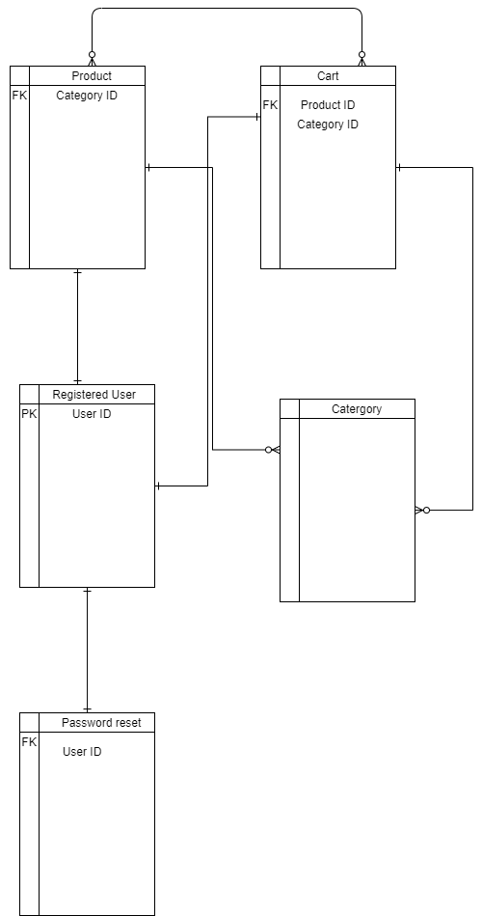

*Figure 1 – Entity Relationship Diagram*

Context Flow Diagram

Context Diagrams and Data-Flow Diagrams were created for systems analysis and design.  But like many analysis tools they have been leveraged for other purposes.  For example, they can also be leveraged to capture and communicate the interactions and flow of data between business processes. So, they don’t have to be restricted to systems analysis.

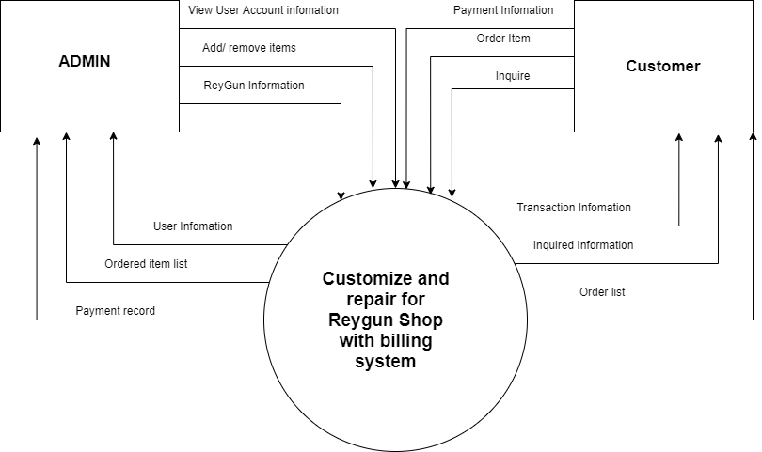

Billing System for Reygun Shop

*Figure 2 – Context Flow Diagram*

Data Flow Diagram

A data flow diagram (DFD) maps out the flow of information for any process or system. It uses defined symbols like rectangles, circles and arrows, plus short text labels, to show data inputs, outputs, storage points and the routes between each destination. Data flowcharts can range from simple, even hand-drawn process overviews, to in-depth, multi-level DFDs that dig progressively deeper into how the data is handled. They can be used to analyse an existing system or model a new one. Like all the best diagrams and charts, a DFD can often visually “say” things that would be hard to explain in words, and they work for both technical and non technical audiences, from developer to CEO. That’s why DFDs remain so popular after all these years. While they work well for data flow software and systems, they are less applicable nowadays to visualizing interactive, real-time or database-oriented software or systems.

-Ed Yourdon and Larry Constantine

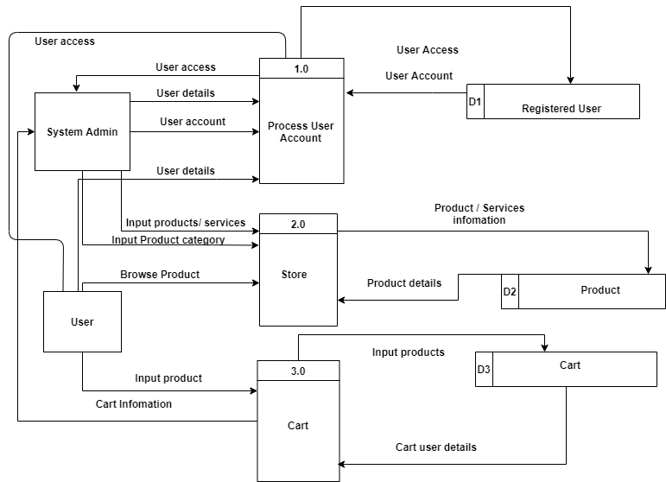

*Figure 3 - Data Flow Diagram Level 0*

HIPO Chart

The HIPO (Hierarchy Input Process Output) is a tool that is used in documenting and or planning a computer program. A HIPO chart consists of a hierarchy chart that represents the program’s control structure and a set of Input, Process and Output charts that describes the inputs and outputs, and the functions or processes performed by each module

WILL, (1998)

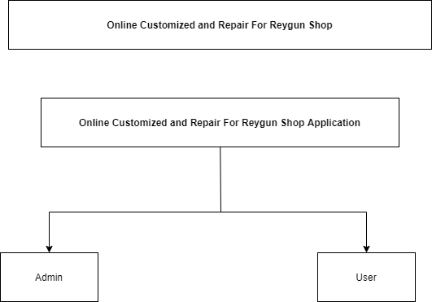

Billing System for Reygun Shop

Billing System for Reygun Shop

*Figure 4 – Hipo System*

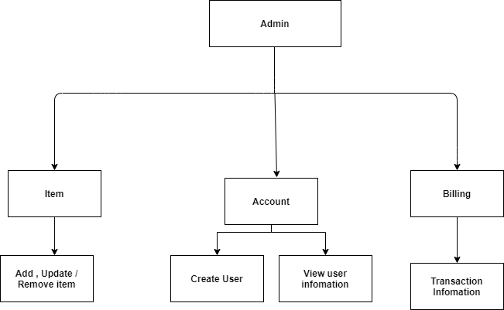

*Figure 5 – Hipo Admin*

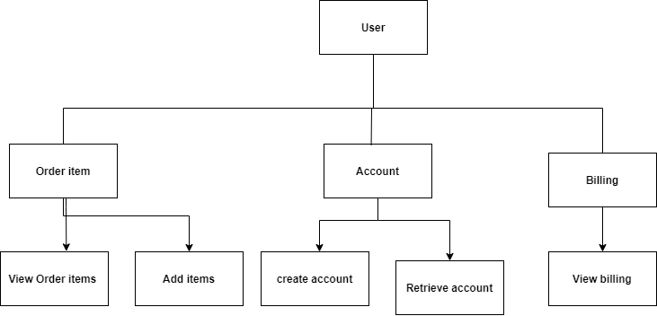

*Figure 6 – Hipo User*

Hardware and Software Requirements

Hardware Requirements

Hardware requirements are the physical components needed in order to run web-based application. The developers have carefully assessed the requirements of the hardware for the web-based application to perform its processes with ease. To develop the implement project, the following hardware requirements are:

*Table 1. Hardware Requirements*

|  |  |
| --- | --- |
| Minimum Requirements | Recommended Requirements |
| Desktop / laptop | Windows |
| Memory : 1GB | Memory : 4GB or higher |
| Processor Speed : 1.0Ghz | Processor Speed : Intel core i3 or higher |

Software Requirements

Software requirements are the programs needed in order to run the web-based application. The developers assessed and researched different software and chose the optimum and considerable components. To develop the implemented project, the following software requirements are:

*Table 2. Software Requirements*

|  |  |
| --- | --- |
| Minimum Requirements | Recommended Requirements |
| Inter core I3 | Intel core i5 3rrd gen or high and 3.0Ghz |

# Results and Discussions

Introduction

This chapter aims to show the results of the performance analysis of the developed system for Reygun Shop. Performance analysis is done to ensure all of the objectives of the study are met. Determining the accuracy of the process the developers gathers software testing to the employee of the company. Testing is one way of determining if some need further improvement.

Experimental

The following tests are done to analyse the system performance developed for Reygun Shop.

Security Testing

Security testing is used to determine if the system can protect and verify the confidentiality of the files that is within the system and protect data from unauthorized access/users that can affect the performance and functionality of the system.

The developers try to access unauthorized to see if we can affect the functionality of the system even if we are unauthorized.

**User’s Acceptance Testing**

This test is done by the future users of the Billing System for Reygun Shop to make sure that the developed system can handle all sorts of scenario. The future users will be oriented by the developers on how the system will work. And the results processed by the system will be checked by the developers if it had met the objectives of

the system.

**Alpha testing**

The developers use Alpha Testing that performed usually by asking survey to internal employees of the organization to determine the critical issues or fixes can be addressed by developers immediately and it ensure the quality of the process at the organization. The participants of this study is the Manager and staff of the company.

Result and Analysis

The developers analyzed the results of the test though the statistical interpretation: Weighted Mean and Likert Scale.

Weighted Mean

The weighted mean is similar to an ordinary [arithmetic mean](https://en.wikipedia.org/wiki/Arithmetic_mean) (the most common type of [average](https://en.wikipedia.org/wiki/Average)), except that instead of each of the data points contributing equally to the final average, some data points contribute more than others. The notion of weighted mean plays a role in [descriptive statistics](https://en.wikipedia.org/wiki/Descriptive_statistics) and also occurs in a more general form in several other areas of mathematics. (Wikipedia, 2019)

WM = (F5*5) + (F5*4) + (F5*4) + (F5*4) + (F5*4) / N

WM = Weighted Mean

F = Frequency of the response

L = Response

N = Number of Correspondents

Example:

WM = (10*5) + (5*4) + (5*4) + (5*4) + (5*4) / 25

WM = 50 + 20 + 20 + 20 +20

WM = 130/25

WM = 5.2

Likert Scale

A Likert is a [psychometric](https://en.wikipedia.org/wiki/Psychometrics) scale commonly involved in research that employs [questionnaires](https://en.wikipedia.org/wiki/Questionnaire). It is the most widely used approach to scaling responses in survey research, such that the term is often used interchangeably with [rating scale](https://en.wikipedia.org/wiki/Rating_scale), although there are other types of rating scales

The scale is named after its inventor, [psychologist](https://en.wikipedia.org/wiki/Psychologist) [Rensis Likert](https://en.wikipedia.org/wiki/Rensis_Likert). Likert distinguished between a scale proper, which emerges from collective responses to a set of items, and the format in which responses are scored along a range. Technically speaking, a Likert scale refers only to the former. The difference between these two concepts has to do with the distinction Likert made between the underlying phenomenon being investigated and the means of capturing variation those points to the underlying phenomenon. (Wikipedia, 2019)

*Table 3 - Likert Scale*

|  |  |  |
| --- | --- | --- |
| Sample Mean | Weighted Mean/ Interval | Interpretation |
| 5 | 4.51 – 5.00 | Excellent |
| 4 | 3.51 – 4.50 | Very Good |
| 3 | 2.51 – 3.50 | Good |
| 2 | 1.51 – 2.50 | Fair |
| 1 | 1.00 – 1.50 | Poor |

The table shows that the weighted mean used are 5, 4, 3, 2, and 1 where 5 is the highest and 1 is the lowest. The interpretation used are Excellent for the weight of 5 which mean that the respondent is very much satisfied in the system. Very Satisfactory for the weight of 4 which mean that the respondent is has exceeded the minimum requirements. Satisfactory for the weight of 3 which mean that the system is just enough or average. Fair for the weight of 2, which mean that the system does not meet the maximum standard requirements. Poor for the weight of 1 which means that the module did not function well and need improvements.

Result and Interpretations

The weighted average for each criterion has been computed and interpreted. The following are the results of the testing of the Billing System for Reygun Shop.

For Manager

*Table 4 – Manage*r *Survey Result*

|  |  |  |
| --- | --- | --- |
|  | Weighted Mean | Interpretation |
| As a tool to have an reliable customer details | 4.5 | Very Good |
| Working System Functionality | 5 | Very Good |
| To help Improve daily productivity | 4 | Good |
| Average Weighted Mean | 4.5 | Excellent |

As the Manager test the developed system, the table shows that the average weighted mean of 4.5 and interpreted as Excellent.

For Staff

*Table 5 – Staff Survey Result*

|  |  |  |
| --- | --- | --- |
|  | Weighted Mean | Interpretation |
| Help to gain more customer | 4 | Very Good |
| To help taking order simultaneously | 5 | Very Good |
| Working System Functionalities | 4 | Very Good |
| To help improve Productivity | 5 | Good |
| Average Weighted Mean | 4.5 | Very Good |

As the Staff test the developed system, the table shows that the average weighted mean of 4.5 and interpreted as Very Good.

Summary

This chapter shows and explains the performance analysis such as unit testing that the developers conducted in order to test the performance of the developed system. The table shows the interpretation about the developed system. In addition the table shows that the developed system is innovative while the website speed to the customer needed a little bit of improvement.

# Conclusions and Recommendations

Billing System for Reygun Shop is developed to make a solution to the problem that encounters by the said company. Such as inconvenient payment method, customer need to call the company to check the status of their ordered product, the staff can’t take order simultaneously.

The developers developed a convenient online payment transaction to help the customer to company transaction faster and accurate at the same time. The developers aim that customer do not need to go to the bank or go to the company just to pay for their desired ordered product. The customers just need to input the credit card in the online payment transaction.

The developers aim is to help the customer to know the status of their order product. The developers developed a module that will help the customer to track the product ordered anytime without calling the company. This will help both customer and company not to take so much time and effort.

The developers aim is to help the company increase their customer and customer order by developing an online website. This website will help the company to take order simultaneously. The old ordering process is customer need to call the staff just to order a product and sometimes the staff line is busy because it is taking other order from another customer.

# References

Aldin Niklas, Brehmer Per-Olof & Johansson Anders (2004). Business development with electronic commerce: Refinement and repositioning.

Burleson Winslow (2005). Developing Creativity, Motivation, and Self-Actualization with Learning Systems.

Geissler Gary L. (2001). Building customer relationships online: The Website designers' perspective.

Chaffey Dave, Chadwick F.E., Johnston K. & Mayer R. (2009). Internet marketing: strategy, implementation and practice(4th edition).

Kotler Philip (2003). Marketing Insights from A to Z: 80 Concepts That Managers Need to Know. San Francisco: Jossey-Bass.

Dobrila Andrea (2018). Disadvantages of listing your restaurant on online food portals.

Lacson A., Pasadilla G.O. (2006). E-commerce in the Philippines: a preliminary stocktaking.

Camagni Roberto (2002). On the Concept of Territorial Competitiveness: Sound or Misleading?.

Reynolds George Walter, Stair Ralph M. (1999). Principles of Information Systems: A Managerial Approach.

Philippine Daily Inquirer (2013). More Filipinoes now shopping online.

Appendices

Appendix A. Project acceptance and certificates

C E R T I F I C A T I O N

This is to certify that Reygun Shop is allowing the following students of Bachelor of Science in Information Technology of STI College Global City to use the company data and sample forms in the development of the system “Billing System for Reygun Shop”

1. Lloren, Rica Jane

2. Maravilla Sebastien William

3. Roldan, Danille Ivan

4. Ybid, Mark Joseph

This certification is being issued upon the request of the above students mentioned for the purpose stated herein.

_____________________

Leizel Mendoza De Chavez

Manager

To whom it may concern,

We, the fourth year Bachelor of Information Technology students of STI College Global City would like to seek permission from your company to conduct interview pertinent to our documentation and system development requirement to IT Special Project (Thesis).

This is geared towards developing a Web based System that will be beneficial to the company in the future. Any restrictions pertaining to the confidentiality of your information will be highly respected.

We look forward to your generous and kind approval on this matter. Again, accept our sincere thanks and appreciation.

Respectfully yours,

Lloren, Rica Jane Maravilla Sebastien William

.

Roldan, Danille Ivan Ybid, Mark Joseph

Approved By:

Mark Frederick V. Salonga

Project Coordinator

appendix b. transcript of interview

Transcript of interview in Reygun customize and repair

Person Interviewed: Reynante Mendoza

Interviewer:

Lloren, Rica Jane

Maravilla, Sebastien William

Roldan, Danille Ivan

Ybid, Mark Joseph

Position: Secretary, Owner

Schedule: January 9, 2020

Location: 330 Abraham St. C5 Palar Village Barangay Pinagsama Taguig City

Q: When did the Reygun Shop build?

A: On October 21, 2016

Q: Who is the Owner of the shop?

A: Reynante Mendoza

Q: How many employees of staff of the Reygun?

A: 6 staff

Q: What are the positions of the staffs?

A: 2 machinist, 2 finishing, 1 gun coating, and secretary

Q: What is the address of the shop?

A: 330 Abraham St. C5 Palar Village Barangay pinagsama Taguig City

Q: What is the office ours of the shop?

A: Monday to Saturday 8:00 am to 6:00 pm, Sunday closed

Q: What are the services of the shop?

A: Customization, color coating, and repairing.

Q: Where do you record customer information?

A: In the Log book

Q: Do you have any other branch?

A: Yes, one in Bacoor Cavite

Q: How do they pay?

A: Over the counter

Q: Type of payment? Do you have a down payment for unit?

A: Cash. Yes, 50%

Q: What are the requirements needed for the services?

A: License of the gun

Q: How long each services does it take to finish?

A: It depends, on what kind of service. Color coating takes 2 to 3 days, customization takes 1 week if fully paid or being prioritized and 1 month if not. Repairing takes 2 days otherwise 1 week when there is many parts that needed to be repair

Q: What kind of guns can you provide with your services?

A: All kind of guns, single stock, high capacity

Q: When is your peak season?

A: In December and January, shoot fest. And the shop is closed if there is a gun ban

Q: How much discount can the customer get?

A: 10%

APPENDIX C. PROJECT INVOLVEMENT FORM

PROJECT INVOLVEMENT FORM

|  |  |
| --- | --- |
| Billing System for Reygun Shop | |
| Date of Defense: November 12, 2020  Time: 7:00 AM | Campus: STI College Global City |
| Adviser: Mr. Dexter B. Oseña | Signature: |

|  |
| --- |
| Rica Jane Lloren Signature: |
| Chapter(s)/ Sub-topic(s) written in the documentation:  Chapter 1  Chapter 5  Business Process |
| Module(s) developed in the system:  Topic(s) to be discussed during Defense: |
| Other Contributions:  Company Interviewer |
| Sebastien William Maravilla Signature: |
| Chapter(s)/ Sub-topic(s) written in the documentation:  Chapter 1  Chapter 3  Business Process |
| Module(s) developed in the system:  All System Module  Topic(s) to be discussed during Defense: |
| Other Contributions:  Researcher |
| Danille Ivan Roldan Signature: |
| Chapter(s)/ Sub-topic(s) written in the documentation:  Chapter 1  Chapter 3  Business Process |
| Module(s) developed in the system:  Topic(s) to be discussed during Defense: |
| Other Contributions:  Researcher |
| Mark Joseph Ybid Signature: |
| Chapter(s)/ Sub-topic(s) written in the documentation:  Chapter 2  Chapter 4  Background of the Study |
| Module(s) developed in the system:  System Design  Topic(s) to be discussed during Defense: |
| Other Contributions:  Company Interviewer |

Appendix D. Gantt Chart

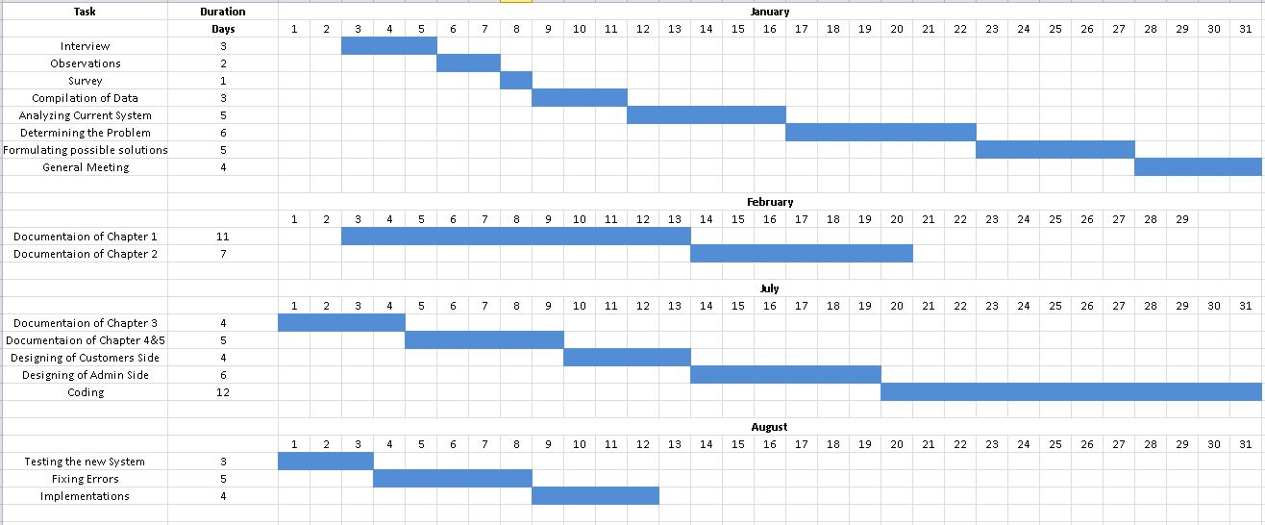

*Figure 7 – Gantt chart*

appendix E. sample forms

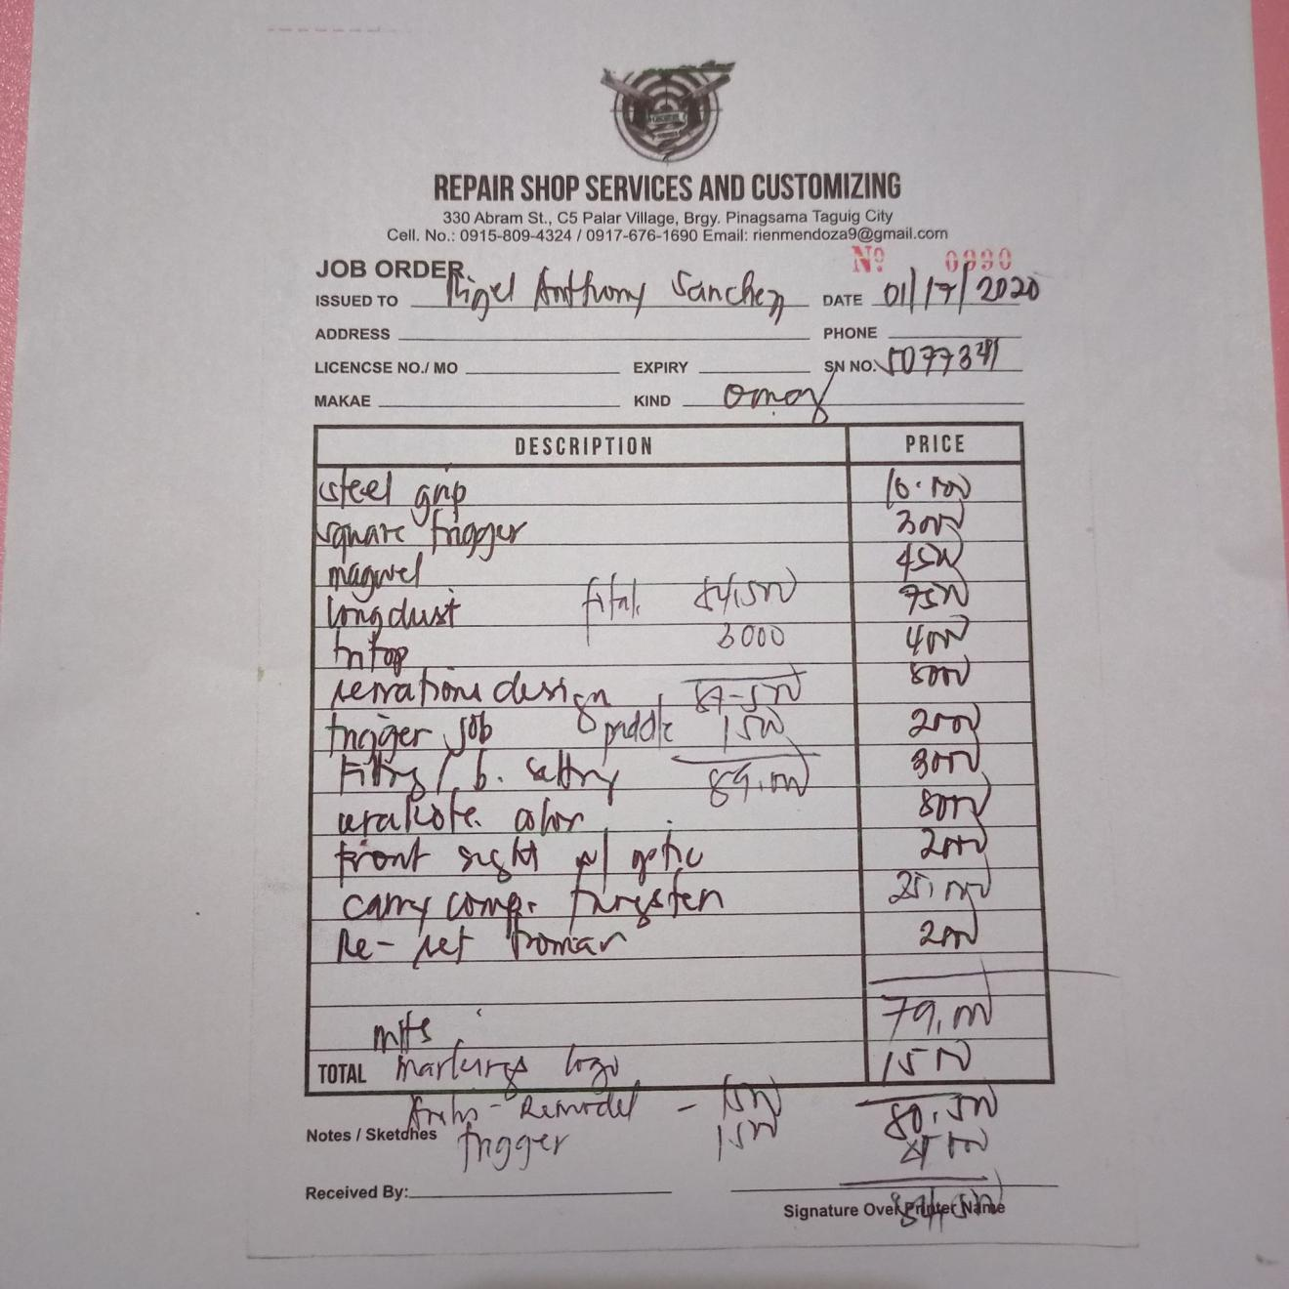*figure 8 - job order*

*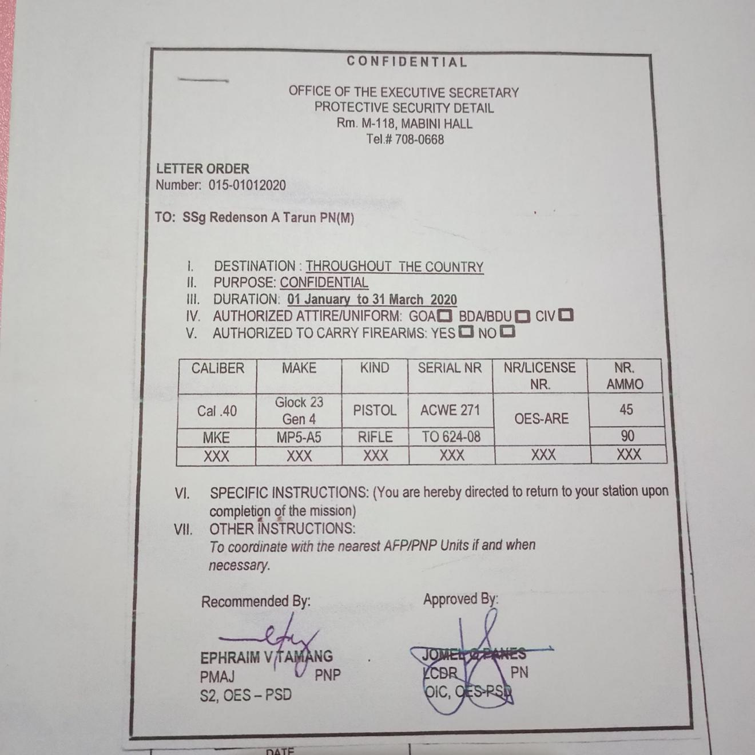figure 9 – letter order*

*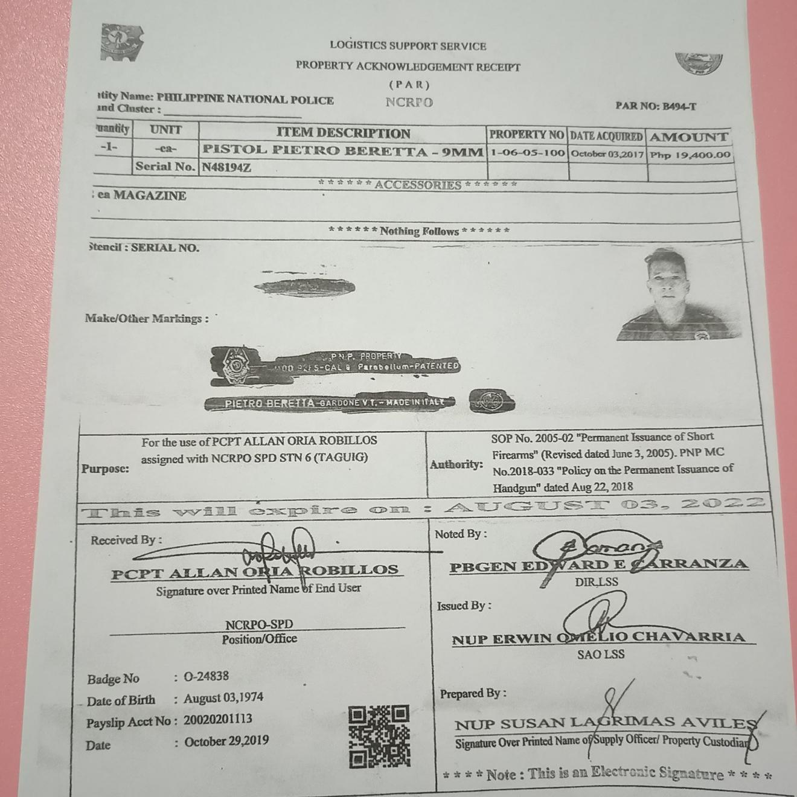figure 10 – mission order*

*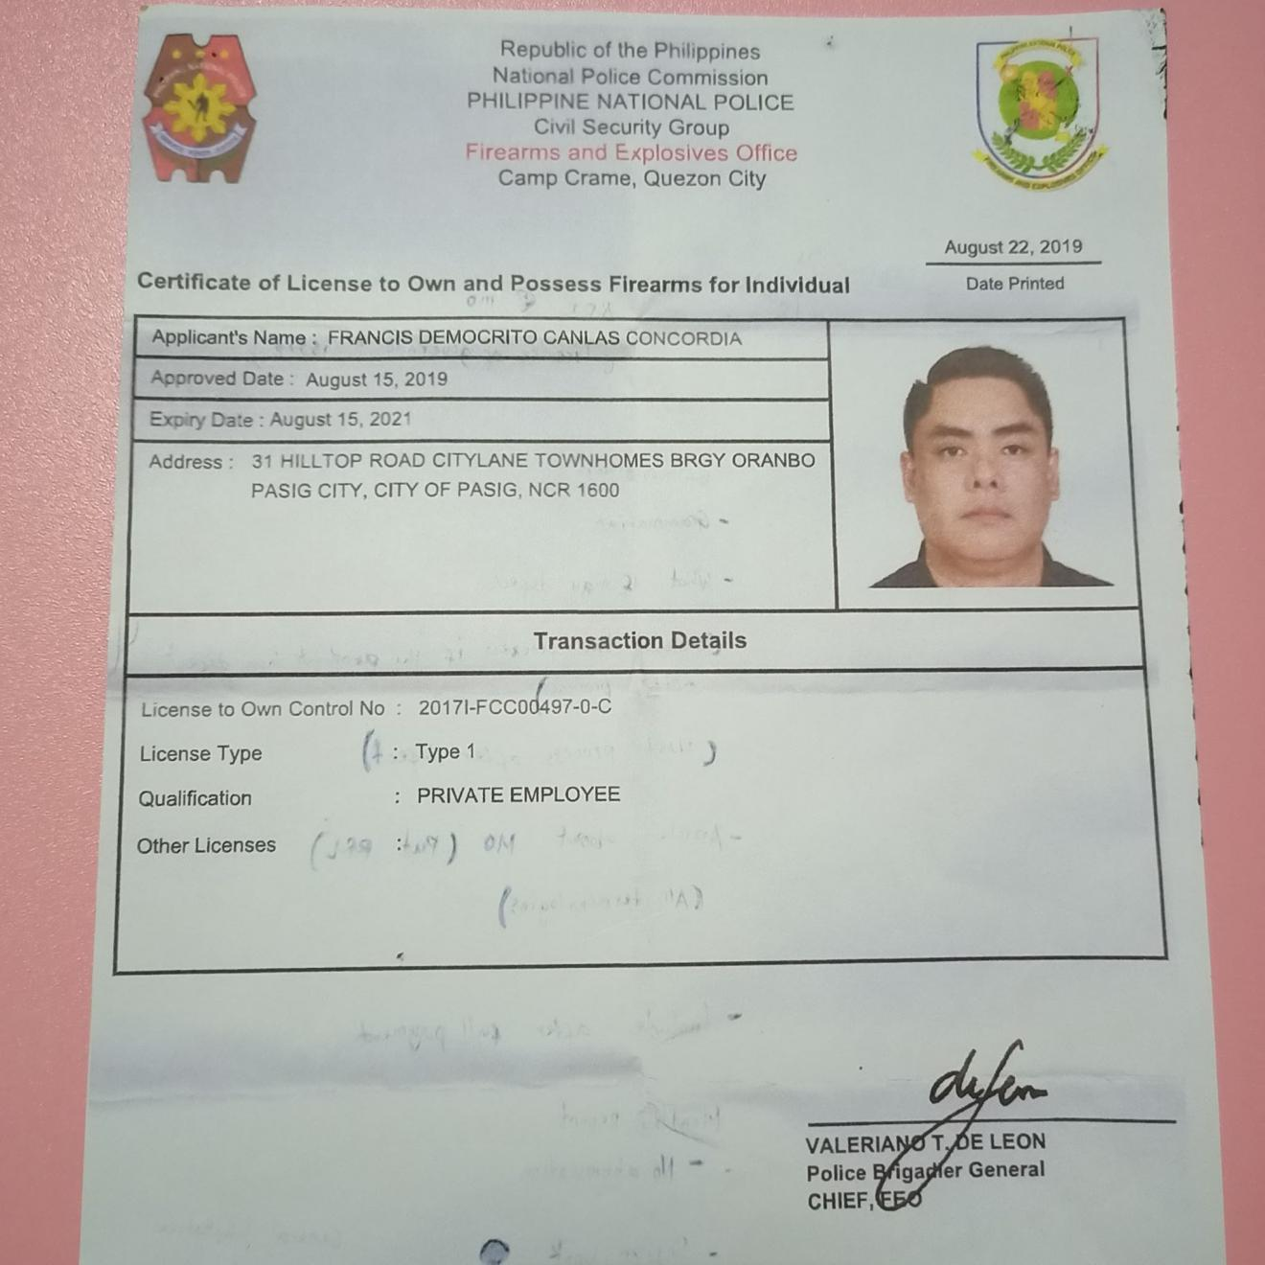figure 11 – certificate of license to own and possess firearms for individual*

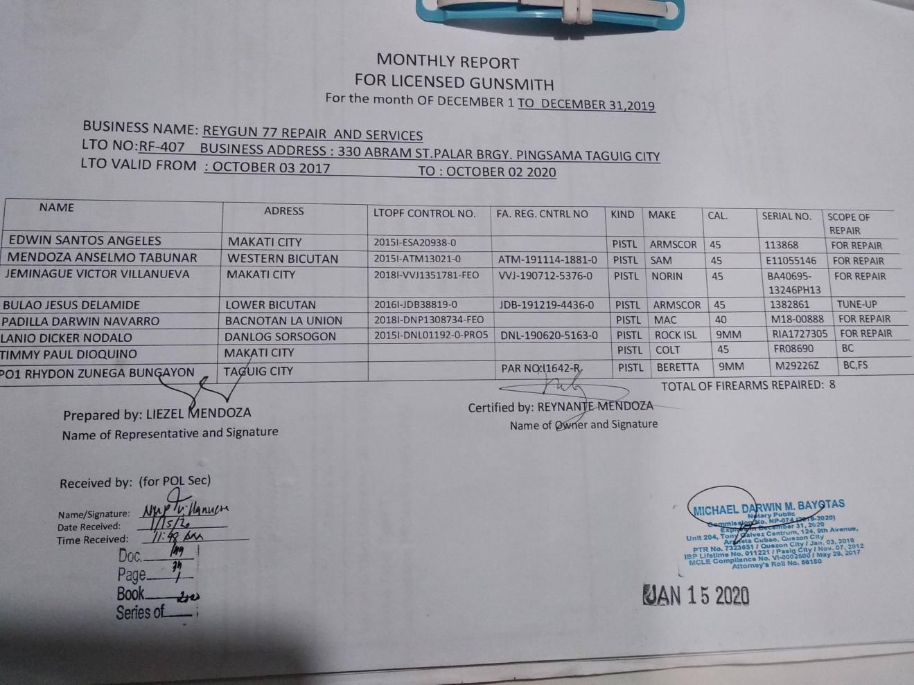*figure 12 – monthly report*

*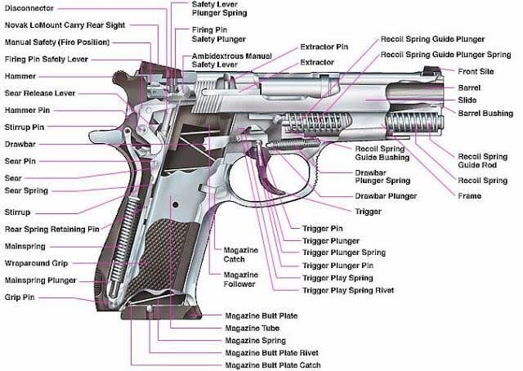FIGURE 13 – GUN PARTS*

appendix f. screen design

*Figure 14 - Login.php*

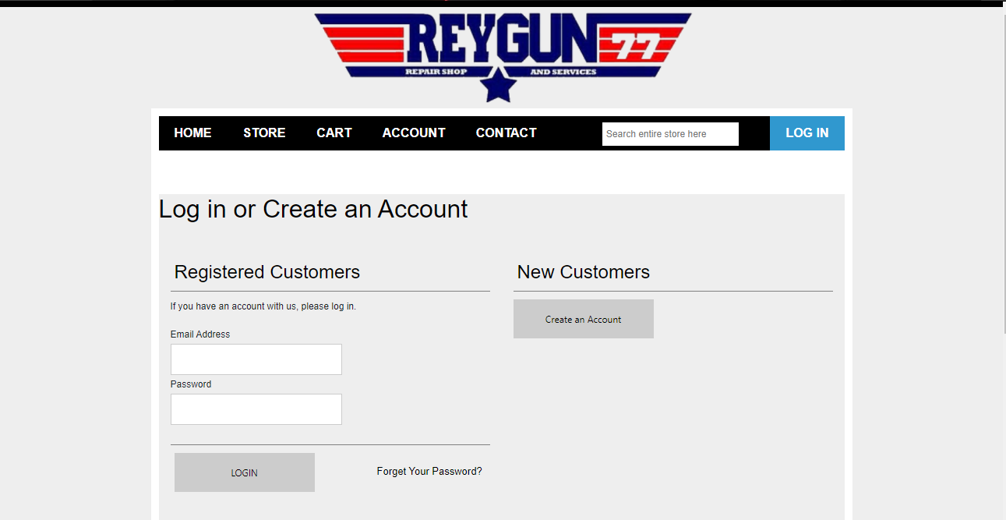

*Figure 15 - Index.php 1*

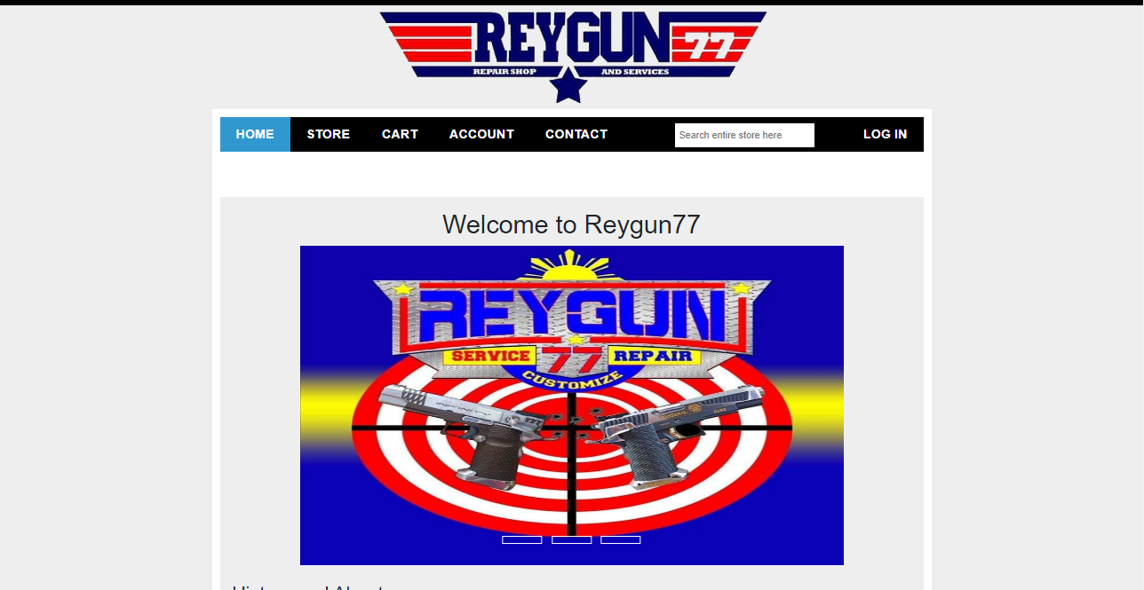

*Figure 16 - Index.php 2* 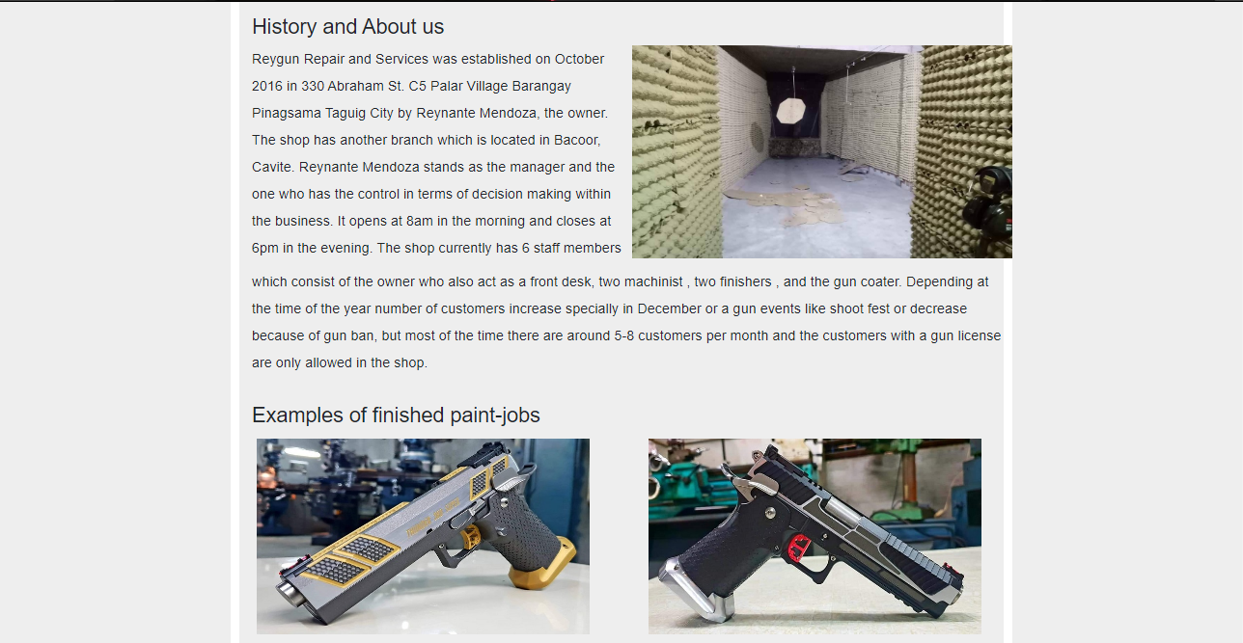

*Figure 17 - Index.php 3*



*Figure 18 - Store.php 1*

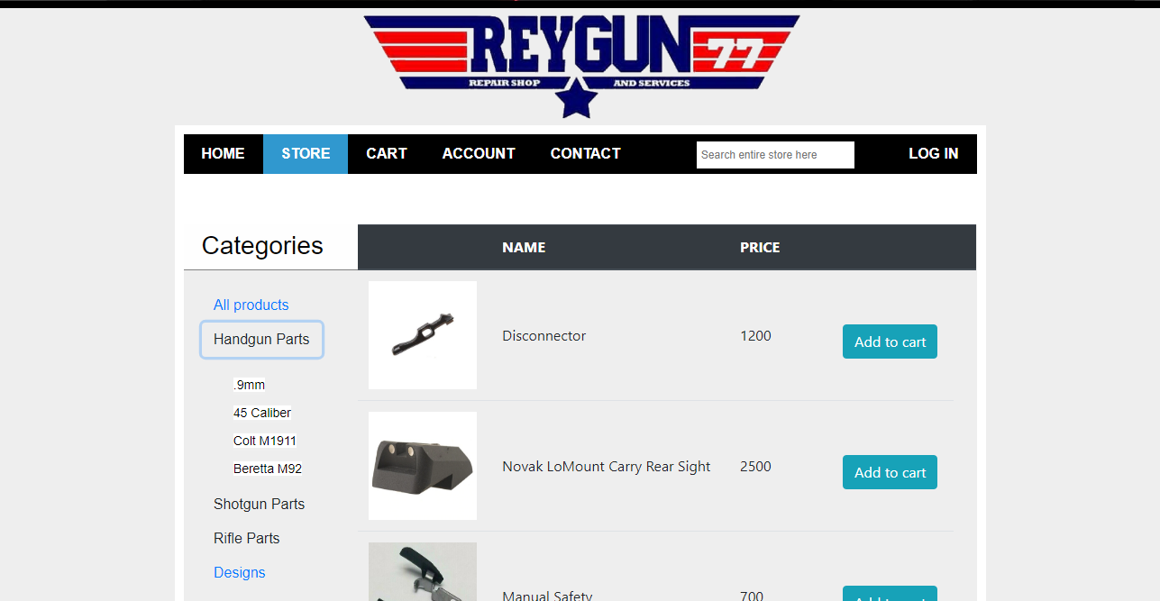

*Figure 19 - Store.php 2*

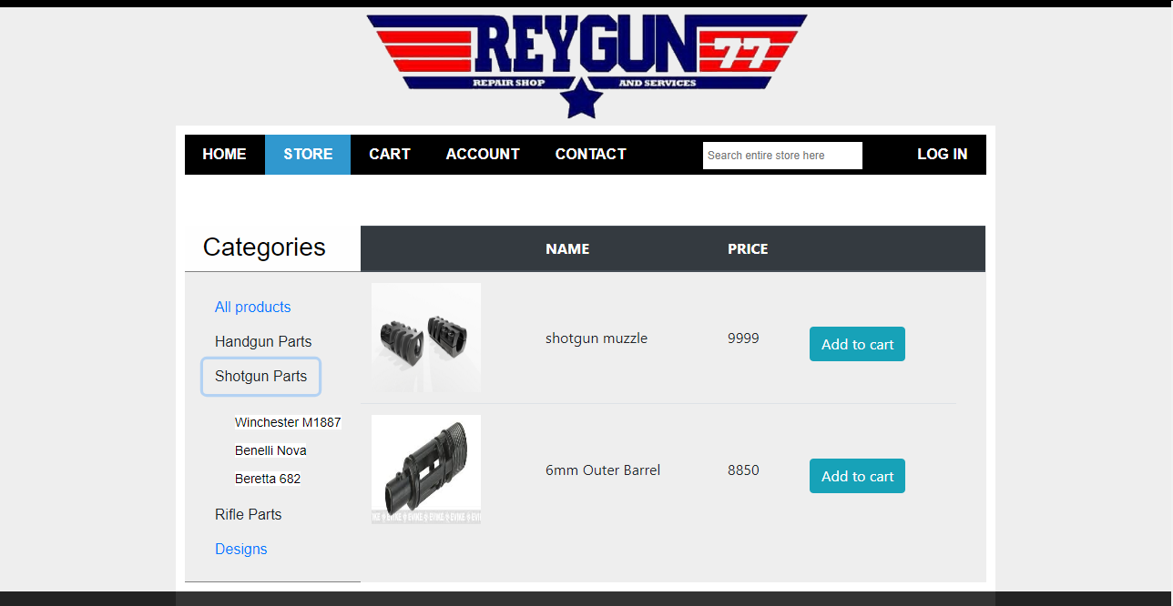

*Figure 20 - Store.php 3*

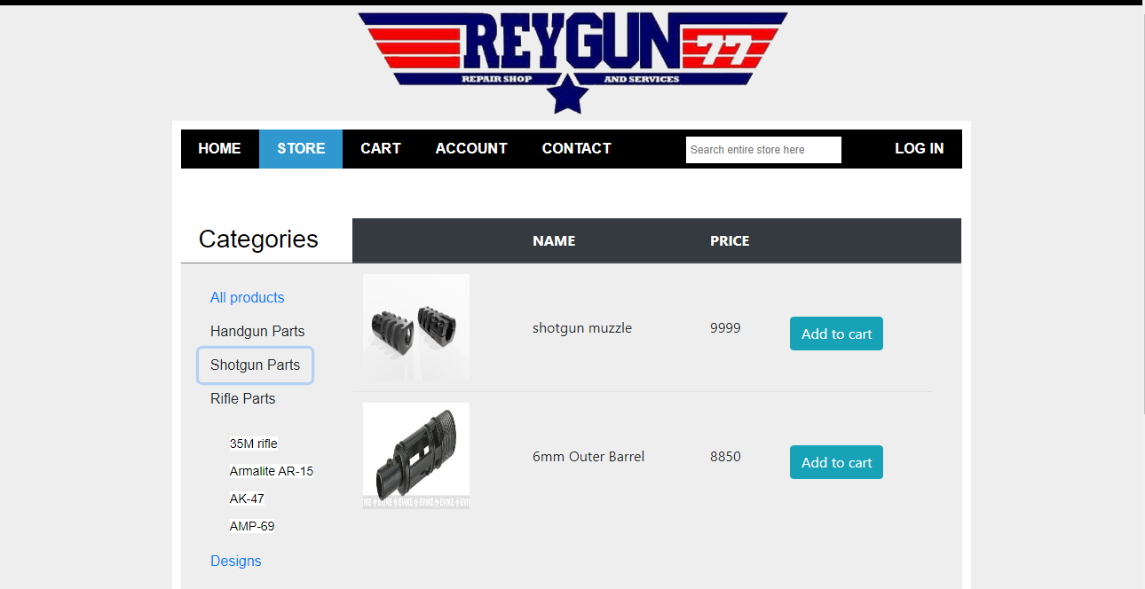

*Figure 21 - Store.php 4*

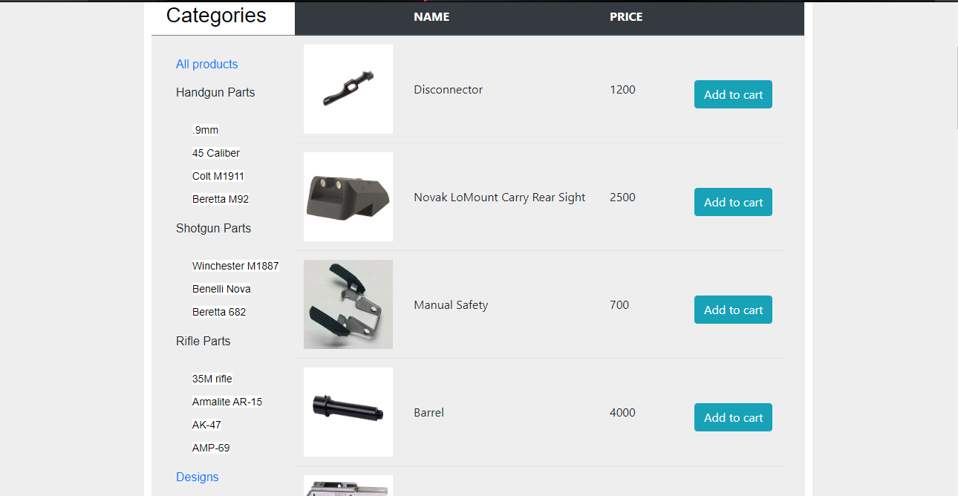

*Figure 22 - Cart.php*

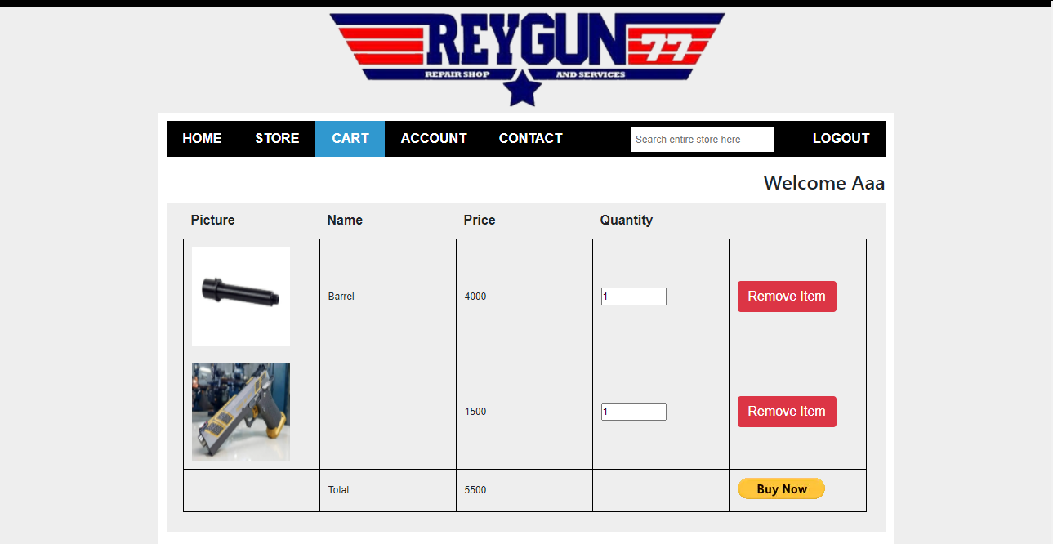

*Figure 23 - Account.php*

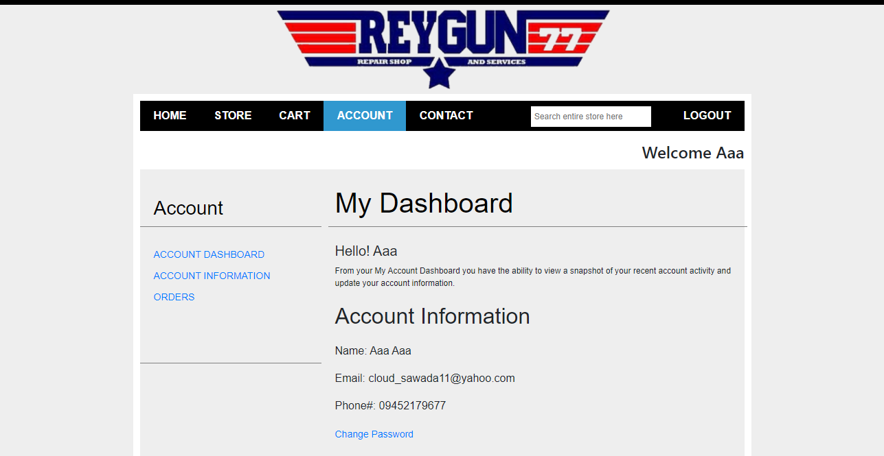

*Figure 24 - Ai.php*

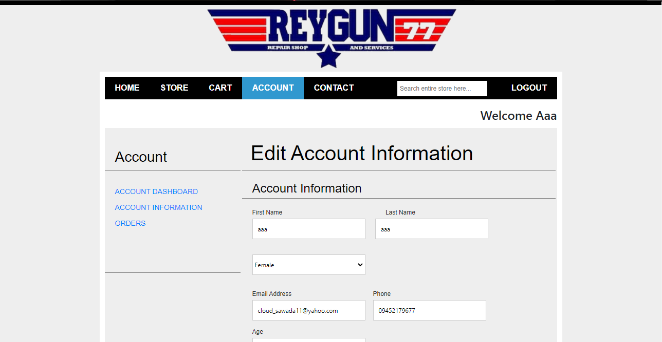

*Figure 25 - Orders.php*

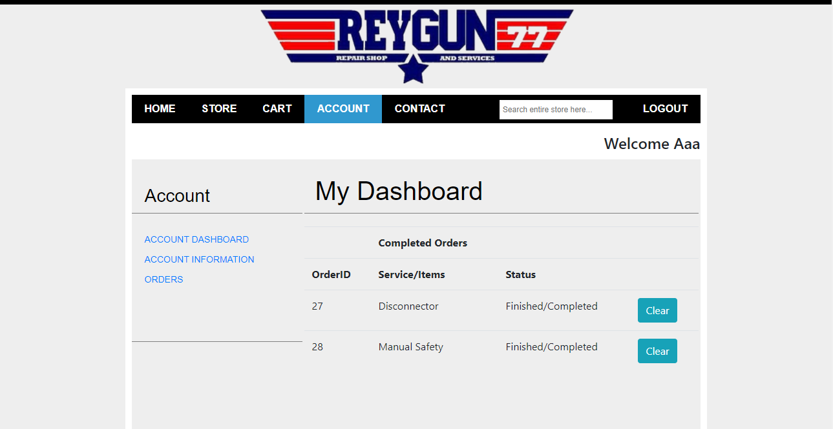

*Figure 26 - Contact.php*

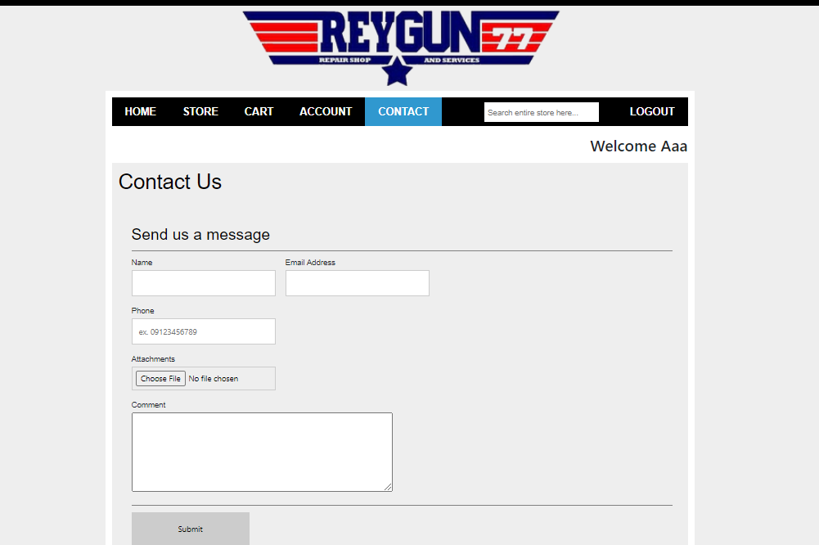

*Figure 27 - Register.php*

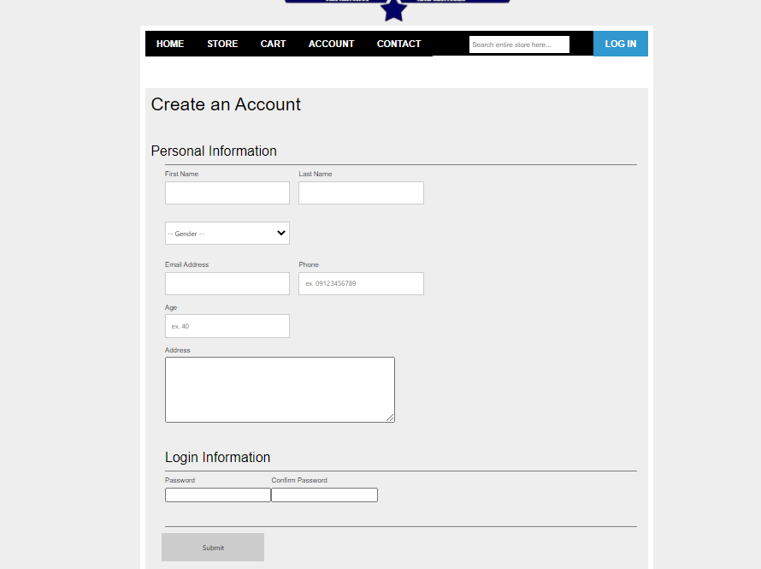

*Figure 28 - Forgotpass.php*

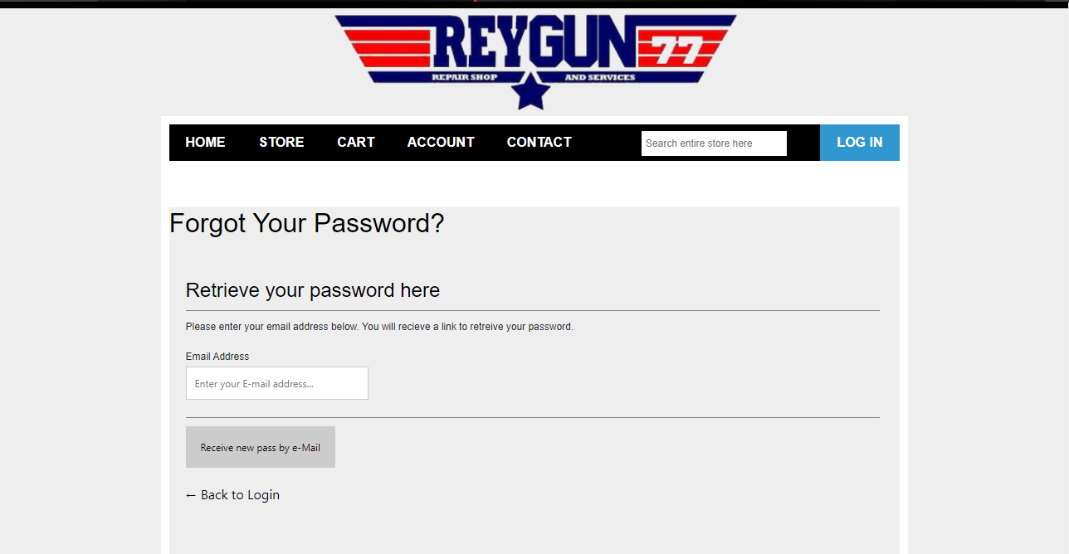

*Figure 29 - Create-new-pass.php*

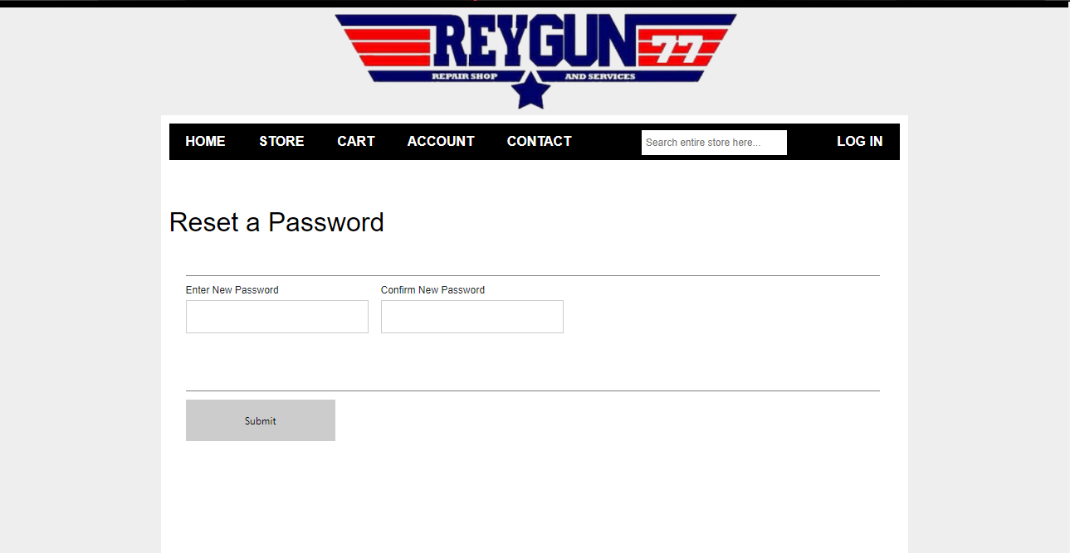

ADMIN

*Figure 30 - Store.php*

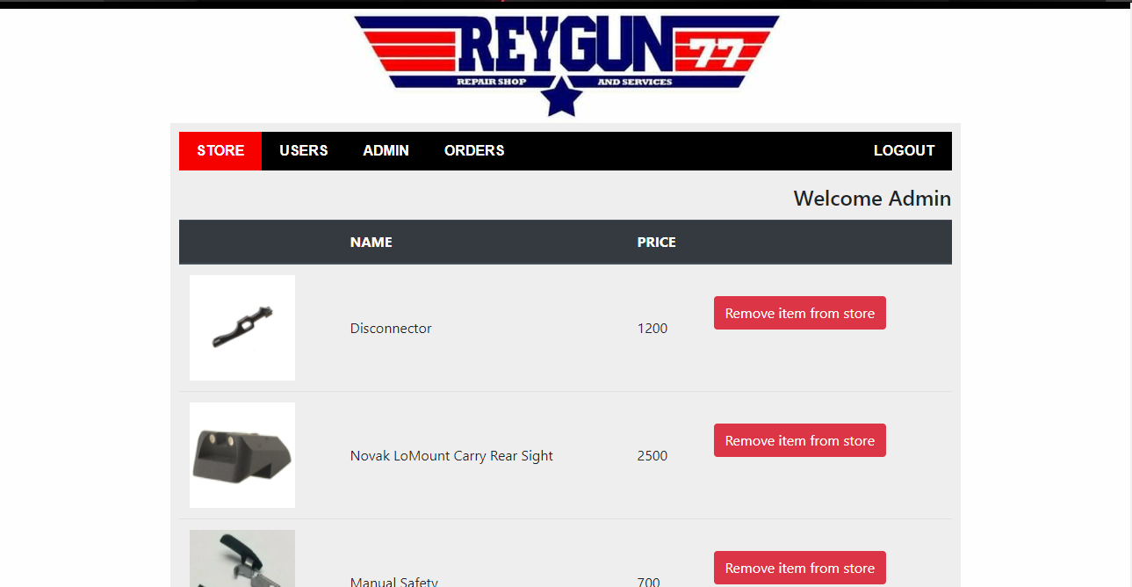

*Figure 31 - Users.php*

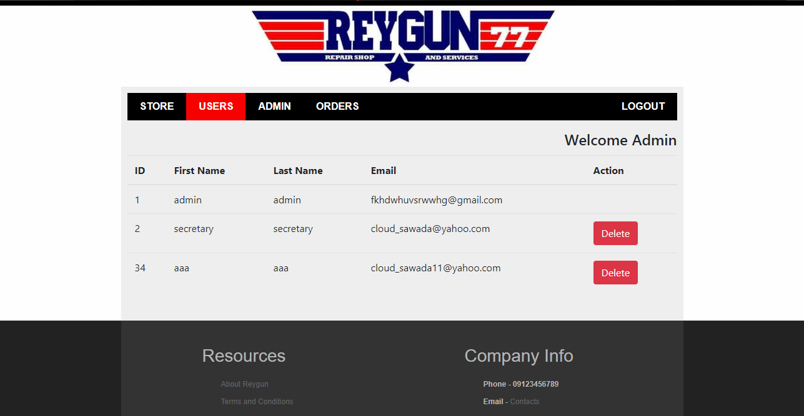

*Figure 32 - adminIndex.php*

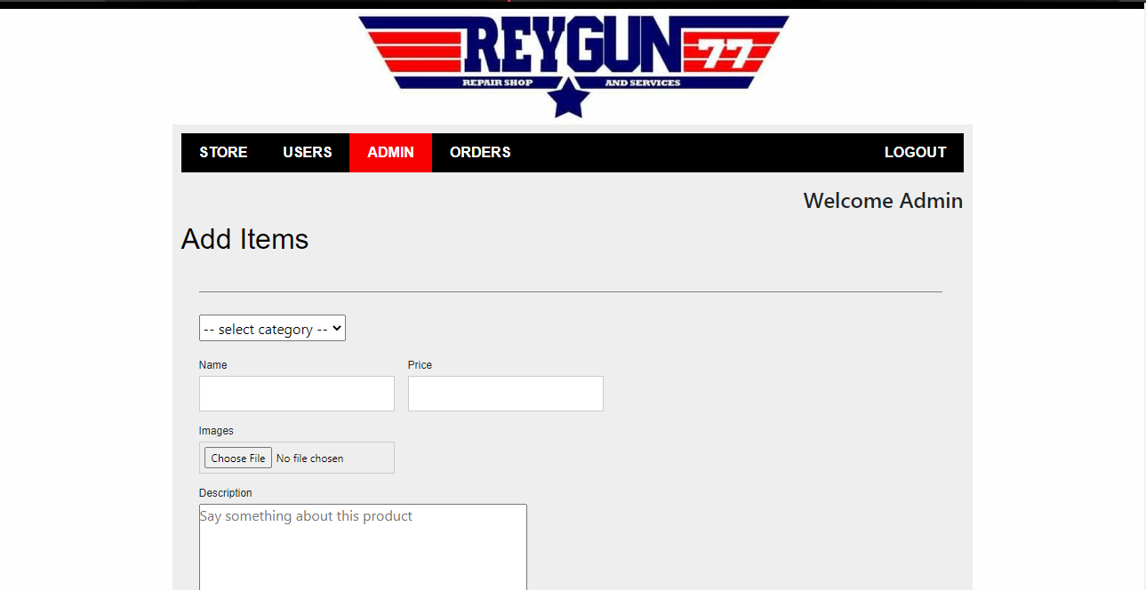

*Figure 33 - Orders.php*

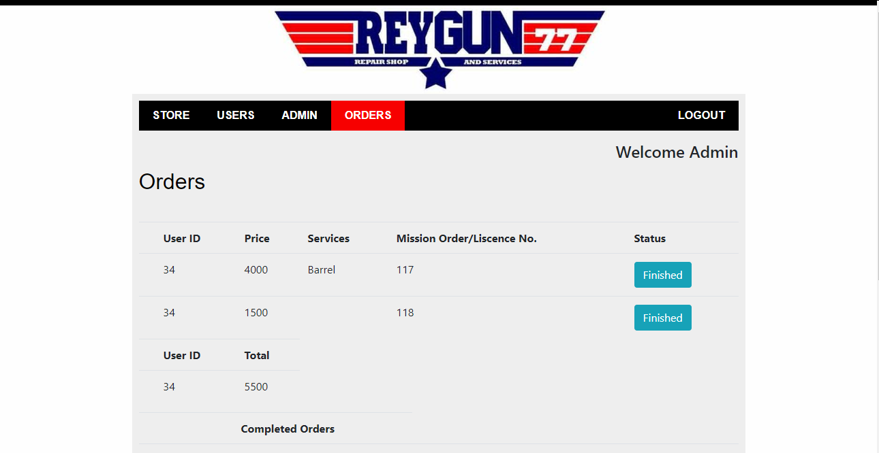

Appendix g. Actual Thesis Expenses

THESIS EXPENSES

|  |  |  |  |
| --- | --- | --- | --- |
| Quantity | Specifics | Approximate Cost | Actual Cost |
| 1 | Grammarian | 1000 | 1000 |
|  |  |  |  |
|  |  |  |  |
|  |  |  |  |
|  |  |  |  |
|  |  |  |  |
|  |  |  |  |
|  |  |  |  |
|  |  |  |  |
|  |  |  |  |
|  |  |  |  |
|  |  |  |  |
|  |  |  |  |
|  |  |  |  |
|  |  |  |  |
|  |  |  |  |
|  |  |  |  |
|  |  |  |  |
|  |  |  |  |
|  |  |  |  |
|  |  |  |  |
|  |  |  |  |

Prepared by:

Rica Jane F. Lloren Sebastien William C. Maravilla

Danille Ivan J. Roldan Mark Joseph B. Ybid

Noted by:

Nelie F. Lloren Janet C. Maravilla

Leonora J. Roldan Gloria B. Ybid

Approved by:

Dexter B. Oseña Mark Frederick V. Salonga

appendix h. database schema and tables

Table Name: registered Users

|  |  |  |  |
| --- | --- | --- | --- |
| Field Name | Data Type | Size | Description |
| id | int | 11 | Users unique id |
| firstName | varchar | 25 | First name |
| lastName | varchar | 25 | Last name |
| gender | varchar | 20 | Gender |
| email | tinytext | Null | Email Address |
| phone | varchar | 11 | phone Number |
| age | int | 3 | Age |
| address | text | Null | Address |
| password | longtext | null | Password |

Table Name: products

|  |  |  |  |
| --- | --- | --- | --- |
| Field Name | Data Type | Size | Description |
| id | int | 11 | Products unique ID |
| productImg | varchar | 500 | Products image |
| productName | varchar | 100 | Products name |
| productDescription | varchar | 500 | Products description |
| productPrice | Int | 11 | Products price |
| productCategory | varchar | 50 | Products category |

Table Name: cart

|  |  |  |  |
| --- | --- | --- | --- |
| Field Name | Data Type | Size | Description |
| id | int | 11 | Cart unique ID |
| cartImg | Text | Null | Product img in cart |
| cartName | varchar | 50 | product name in cart |
| cartDesc | Text | Null | Product desc in cart |
| cartPrice | Int | 11 | Product price in cart |
| cartCategory | Text | Null | Product category |
| cartUser | int | 11 | RegisteredUser FK |

Table Name: pwdreset

|  |  |  |  |
| --- | --- | --- | --- |
| Field Name | Data Type | Size | Description |
| pwdResetID | Int | 11 | pwdReset ID |
| pwdResetEmail | Text | Null | Users Email to reset |
| pwdResetSelector | Text | Null | Email verification |
| pwdResetToken | Longtext | Null | Token for pwdReset |
| pwdResetExpire | text | Null | Selector and Token expiration time |

Table Name: completeorder

|  |  |  |  |
| --- | --- | --- | --- |
| Field Name | Data Type | Size | Description |
| Id | int | 11 | Complete order unique id |
| ordererID | Int | 5 | id of the customer that ordered the item, FK |
| service | varchar | 50 | Name of product/service, FK |
| status | varchar | 50 | Status of the service |

appendix i. SURVEY QUESTIONAIRES

Billing System for Reygun Shop

Survey Questionnaire

Name(Optional):___________________________________Date:_______________________

This survey aims to assess the degree of user’s satisfaction and as well as to enable the planning for the continuous system improvement.

|  |  |  |
| --- | --- | --- |
| Sample Mean | Weighted Mean/ Interval | Interpretation |
| 5 | 4.51 – 5.00 | Excellent |
| 4 | 3.51 – 4.50 | Very Good |
| 3 | 2.51 – 3.50 | Good |
| 2 | 1.51 – 2.50 | Fair |
| 1 | 1.00 – 1.50 | Poor |

For Admin

*For Manager*

|  |  |  |
| --- | --- | --- |
|  | Weighted Mean | Interpretation |
| As a tool to have an reliable customer details |  |  |
| As a tool to create a generated report |  |  |
| Working System Functionality |  |  |
| To help Improve daily productivity |  |  |
| Average Weighted Mean |  |  |

Billing System for Reygun Shop

Survey Questionnaire

Name(Optional):__________________________________Date:__________________________

This survey aims to assess the degree of user’s satisfaction and as well as to enable the planning for the continuous system improvement.

|  |  |  |
| --- | --- | --- |
| Sample Mean | Weighted Mean/ Interval | Interpretation |
| 5 | 4.51 – 5.00 | Excellent |
| 4 | 3.51 – 4.50 | Very Good |
| 3 | 2.51 – 3.50 | Good |
| 2 | 1.51 – 2.50 | Fair |
| 1 | 1.00 – 1.50 | Poor |

.

For Staff

*For Staff*

|  |  |  |
| --- | --- | --- |
|  | Weighted Mean | Interpretation |
| Help to gain more customer |  |  |
| To help taking order simultaneously |  |  |
| Working System Functionalities |  |  |
| To help improve Productivity |  |  |
| Average Weighted Mean |  |  |

Appendix J. survey result and tally

For Manager

|  |  |  |
| --- | --- | --- |
|  | Weighted Mean | Interpretation |
| As a tool to have an reliable customer details | 4.5 | Very Good |
| Working System Functionality | 5 | Very Good |
| To help Improve daily productivity | 4 | Good |
| Average Weighted Mean | 4.5 | Excellent |

For Staff

|  |  |  |
| --- | --- | --- |
|  | Weighted Mean | Interpretation |
| Help to gain more customer | 4 | Very Good |
| To help taking order simultaneously | 5 | Very Good |
| Working System Functionalities | 4 | Very Good |
| To help improve Productivity | 5 | Good |
| Average Weighted Mean | 4.5 | Very Good |

appendix k. source code

Dbh.inc.php

<?php

$servername = "localhost";

$dbUsername = "root";

$dbPassword = "1234567";

$dbDatabase = "itswebsite";

$mysqli = new mysqli($servername, $dbUsername, $dbPassword, $dbDatabase);

if(!$mysqli){

die("connection failed: " .mysqli_connect_error());

}

Login.inc.php

<?php

if(isset($_POST['btnLogin'])){

require 'dbh.inc.php';

$mailuid = $_POST['email'];

$password = $_POST['pass'];

if(empty($mailuid) ||empty($password)){

header("Location: login.php?error=emptyfields");

exit();

}

else {

$sql = "SELECT * FROM registeredusers where email=? OR firstName=?;";

$stmt = mysqli_stmt_init($mysqli);

if(!mysqli_stmt_prepare($stmt, $sql)){

header("Location: login.php?error=sqlerror123");

exit();

}

else {

mysqli_stmt_bind_param($stmt, "ss", $mailuid, $mailuid,);

mysqli_stmt_execute($stmt);

$result = mysqli_stmt_get_result($stmt);

if($row = mysqli_fetch_assoc($result)) {

$pwdCheck = password_verify($password, $row['password']);

if($pwdCheck == false){

header("Location: login.php?error=wrongPassword");

exit();

}

else if($pwdCheck == true){

session_start();

$_SESSION[userID] = $row['id'];

$_SESSION[userEmail] = $row['email'];

$_SESSION[username] = $row['firstName'];

$_SESSION[lastname] = $row['lastName'];

header("Location: index.php?login=sucess");

exit();

}

else {

header("Location: login.php?error=wrongPassword");

exit();

}

}

else {

header("Location: login.php?error=sqlerror");

exit();

}

}

}

}

else {

header("Location: login.php");

exit();

}

Logout.inc.php

<?php

if(isset($_POST['btnLogin'])){

require 'dbh.inc.php';

$mailuid = $_POST['email'];

$password = $_POST['pass'];

if(empty($mailuid) ||empty($password)){

header("Location: login.php?error=emptyfields");

exit();

}

else {

$sql = "SELECT * FROM registeredusers where email=? OR firstName=?;";

$stmt = mysqli_stmt_init($mysqli);

if(!mysqli_stmt_prepare($stmt, $sql)){

header("Location: login.php?error=sqlerror123");

exit();

}

else {

mysqli_stmt_bind_param($stmt, "ss", $mailuid, $mailuid,);

mysqli_stmt_execute($stmt);

$result = mysqli_stmt_get_result($stmt);

if($row = mysqli_fetch_assoc($result)) {

$pwdCheck = password_verify($password, $row['password']);

if($pwdCheck == false){

header("Location: login.php?error=wrongPassword");

exit();

}

else if($pwdCheck == true){

session_start();

$_SESSION[userID] = $row['id'];

$_SESSION[userEmail] = $row['email'];

$_SESSION[username] = $row['firstName'];

$_SESSION[lastname] = $row['lastName'];

header("Location: index.php?login=sucess");

exit();

}

else {

header("Location: login.php?error=wrongPassword");

exit();

}

}

else {

header("Location: login.php?error=sqlerror");

exit();

}

}

}

}

else {

header("Location: login.php");

exit();

}

INDEX.PHP

<?php

require 'includes/dbh.inc.php';

session_start();

?>

<!DOCTYPE html>

<html>

<head>

<link rel="stylesheet" type="text/css" href="css/mainindexx.css">

<link rel="stylesheet" href="https://stackpath.bootstrapcdn.com/bootstrap/4.3.1/css/bootstrap.min.css" integrity="sha384-ggOyR0iXCbMQv3Xipma34MD+dH/1fQ784/j6cY/iJTQUOhcWr7x9JvoRxT2MZw1T" crossorigin="anonymous">

<script src="https://ajax.googleapis.com/ajax/libs/jquery/3.4.1/jquery.min.js"></script>

<script src="https://maxcdn.bootstrapcdn.com/bootstrap/3.4.1/js/bootstrap.min.js"></script>

<title>WEB</title>

</head>

<body>

<div class="space">

</div>

<div class="header">

<div class="logo_container">

<ul>

<li class="logo"><a href="index.php">LOGO</a></li>

</ul>

</div>

</div>

<div class="body">

<div class="inner_body">

<div class="outernav">

<ul class="navigations">

<a class="nav1" href="index.php"><li>HOME</li></a>

<a class="nav2"href="store.php?id=AllProducts"><li>STORE</li></a>

<a class="nav3"href="cart.php"><li>CART</li></a>

<a class="nav5"href="account.php"><li>ACCOUNT</li></a>

<a class="nav6"href="contact.php"><li>CONTACT</li></a>

<?php

if(isset($_SESSION['userID'])){

echo'<form class="XD" action="includes/logout.inc.php" method="POST">

<button class="logbtn"><a class="nav4" href="login.php" onClick="return confirmation()"><li>LOGOUT</li></a></button>

</form>';

}

else {

echo'<form class="XD" action="login.php" method="POST">

<button class="logbtn"><a class="nav4" href="login.php"><li>LOG IN</li></a></button>

</form>';

}

?>

<script>

function confirmation()

{

var x = confirm("Do you want to Logout?");

if(x==true){

return true;

}

else {

return false;

}

}

</script>

<div class="wrapper">

<div class="inner_wrapper">

<div class="sb">

<input type="text" placeholder="Search entire store here">

<i class="fas fa-search"></i>

</div>

</div>

</div>

</ul>

<?php

if(isset($_SESSION['userID'])){ ?>

<li class="welcome"> <h4>Welcome <?php echo ucfirst($_SESSION['username'])?> </h4></li>

<?php

$userxx = $_SESSION['username'];

if($userxx == 'admin') {

header("Location: adminside/adminIndex.php"); //NEW PAGE 'adminINDEX.php'

exit();

}

}

else {

}

?>

</div>

<div class="contents">

<div class="ch">

<h2>Welcome to Reygun77</h2>

</div>

<div class="slidershow middle">

<div class="slides">

<input type="radio" name="r" id="r1" checked>

<input type="radio" name="r" id="r2">

<input type="radio" name="r" id="r3">

<div class="slide s1">

<img src="images/logo.jpg" alt="">

</div>

<div class="slide">

<img src="images/sr.jpg" alt="">

</div>

<div class="slide">

<img src="images/3.jpg" alt="">

</div>

</div>

<div class="navigation">

<label for="r1" class="bar"></label>

<label for="r2" class="bar"></label>

<label for="r3" class="bar"></label>

</div>

</div>

<div class="title">

<h4> History and About us </h4>

<img src="images/sr.jpg" alt="" id="imgfloat">

<h6 style="line-height:2">

Reygun Repair and Services was established on October 2016 in 330 Abraham St. C5 Palar Village Barangay Pinagsama Taguig City by Reynante Mendoza, the owner. The shop has another branch which is located in Bacoor, Cavite. Reynante Mendoza stands as the manager and the one who has the control in terms of decision making within the business. It opens at 8am in the morning and closes at 6pm in the evening. The shop currently has 6 staff members</h6>

<h6 id="bottomheader" style="line-height:2">

which consist of the owner who also act as a front desk, two machinist , two finishers , and the gun coater. Depending at the time of the year number of customers increase specially in December or a gun events like shoot fest or decrease because of gun ban, but most of the time there are around 5-8 customers per month and the customers with a gun license are only allowed in the shop.

</h6>

<br>

<div id="a">

<h4> Examples of finished paint-jobs </h4>

<img src="images/1.jpg" alt="" id="img1">

<img src="images/2.jpg" alt="" id="img2">

<img src="images/3.jpg" alt="" id="img3">

</div>

<br>

<h4>Requirements for MIL (Military)/PNP (Philippine National Police)/LEA (Law Enforcement Agency) </h4>

<br>

<p>1. MIL (Military)/PNP (Philippine National Police)/LEA (Law Enforcement Agency) ID</p>

<br>

<p>2. Acknowledgement receipt of equipment (ARE)</p>

<br>

<p>3. Mission Order</p>

<br>

<h4>Requirements for civilian customers</h4>

<br>

<p>1. Valid ID</p>

<br>

<p>2. License to own and possess firearms (LTOPF)</p>

<br>

<p>3. Permit to carry firearms outside residence (PTCFOR)</p>

<br>

<h4>4 Cardinal Rules of gun safety</h4>

<br>

<p>1. Consider every gun as loaded.</p>

<br>

<p>2. Do not point your gun to anything you don't want to destroy.</p>

<br>

<p>3. Do not insert your trigger finger unless you are ready to fire.</p>

<br>

<p>4. Be sure of your target and what is in front and behind it.</p>

</div>

</div>

</div>

</div>

<div class="footer">

<div class="footercontent">

<div class="resources">

<h3>Resources</h3>

<ul class="list">

<li><a class="" href="about.php">About Reygun</a></li>

<li><a class="" href="term.php">Terms and Conditions</a></li>

<li><a class=""href="policy.php">Privacy Policy</a></li>

</ul>

</div>

<div class="companyinfo">

<h3>Company Info</h3>

<ul class="list2">

<li>Phone - 09123456789</li>

<li>Email - <a class="" href="contact.php"> Contacts</a></li>

<li>Hours</li>

<p>Monday - Friday 8am - 6pm GMT<br>

</p>

</ul>

</div>

</div>

</div>

</body>

</html>

MAININDEXX.CSS

*{

margin: 0;

padding: 0;

list-style: none;

text-decoration: none;

}

.space{

background-color: black;

width: 100%;

height: 7px;

}

.XD{

float:right;

}

.h4 {

float:right;

}

.welcome {

float:right;

}

.header{

background-color: #EEEEEE;

width: 100%;

height: 130px;

display: block;

}

.logo a{

background-image: url("../images/allahuakbar.png");

background-size: 500px;

background-repeat: no-repeat;

width: 500px;

height: 130px;

display: block;

margin: 0 auto;

color: white;

/*margin: 0 0 0 300px ;*/

/*background-color:red;*/

text-indent: -99999px;

position: relative;

}

.body{

background-color: #EEEEEE;

min-height: calc(100vh - 280px);

width: 100%;

display: block;

}

.inner_body{

/*height: 610px;*/

height: 1500px;

margin: 0 auto;

display: table;

width: 900px;

padding: 10px;

background-color: #FFFFFF;

position: relative;

}

.outernav{

display: block;

width: 100%;

height:50px;

margin-bottom: 50px;

padding: 0px;

}

.navigations {

width: 100%;

background-color:black;

display:table;

position: relative;

}

.navigations a {

padding: 10px 20px;

display: inline-block;

font-family: Helvetica;

font-size: 16px;

font-weight: bold;

}

.nav1 {

background-color: #3098cf;

color: white;

}

.nav2{

background-color: black;

color: white;

}

.nav3{

background-color: black;

color: white;

}

.nav4{

background-color: black;

color: white;

}

.logbtn {

display: inline-block;

font-family: Helvetica;

font-size: 16px;

font-weight: bold;

border: none;

}

.logbtn:hover {

background-color: white;

color: black;

border-radius: 0px;

transition: 0.5s;

}

.nav5{

background-color: black;

color: white;

}

.nav6{

background-color: black;

color: white;

}

.nav1:hover{

background-color: white;

color: black;

border-radius: 0px;

transition: 0.5s;

}

.nav2:hover{

background-color: white;

color: black;

border-radius: 0px;

transition: 0.5s;

}

.nav3:hover{

background-color: white;

color: black;

border-radius: 0px;

transition: 0.5s;

}

.nav4:hover{

background-color: white;

color: black;

border-radius: 0px;

transition: 0.5s;

}

.nav5:hover{

background-color: white;

color: black;

border-radius: 0px;

transition: 0.5s;

}

.nav6:hover{

background-color: white;

color: black;

border-radius: 0px;

transition: 0.5s;

}

.wrapper{

width: 175px;

display: inline-block;

margin-left: 65px;

}

.inner_wrapper{

}

.sb{

}

.sb input[type="text"]{

box-sizing: border-box;

padding: 5px;

border: none;

border-radius: 0;

font-size: 12px;

color: black;

font-family: Helvetica;

outline: none;

height: 30px;

width: 175px;

background-color: white;

}

.sb input[type="text"]:hover {

transition: 0.5s;

background-color: #EEEEEE;

color: #3098cf;

}

.contents {

background: #EEEEEE;

/*min-height: calc(100vh - 150px);*/

padding: 15px;

height: 2350px;

width: 100%;

display:block;

}

#bottomheader {

width:100%;

}

#imgfloat {

float: right;

width: 50%;

}

#a {

display:block;

margin-bottom: 10px;

}

#img1 {

width: 45%;

height: 45%;

float: left;

padding: 5px;

}

#img2 {

width:45%;

height: 45%;

float: right;

margin-right: 30px;

padding: 5px;

}

#img3 {

width: 45%;

height: 45%;

margin-left:230px;

margin-top:10px;

padding: 5px;

}

.title {

font-family: Helvetica;

display: block;

}

.title p {

font-size: 15px;

}

.title h6 {

display: block;

width: 50%;

}

.ch {

font-family: Helvetica;

display: block;

}

.ch h2 {

text-align: center;

}

.slidershow {

width: 680px;

height: 400px;

overflow: hidden;

display: block;

margin: 0 auto;

}

.middle {

position: absolute;

top: 15%;

left: 50%;

transform: translate(-50%,-50%);

}

.navigation {

position: absolute;

bottom: 20px;

left: 50%;

transform: translateX(-50%);

display: flex;

}

.bar {

width: 50px;

height: 10px;

border: 2px solid #fff;

margin: 6px;

cursor: pointer;

transition: 0.4s;

}

.bar:hover {

background: #fff;

}

input[name="r"] {

position: absolute;

visibility: hidden;

}

.title {

font-family: Helvetica;

display: block;

position: absolute;

top: 24%;

}

.slides {

width: 500%;

height: 100%;

display: flex;

}

.slide {

width: 20%;

transition: 0.6s;

}

.slide img {

width: 100%;

height: 100%;

}

#r1:checked ~ .s1 {

margin-left: 0;

}

#r2:checked ~ .s1 {

margin-left: -20%;

}

#r3:checked ~ .s1 {

margin-left: -40%;

}

.footer {

background-color: #222222;

width: 100%;

height: 250px;

display: block;

}

.footercontent {

height: 250px;

width: 900px;

background-color: #333333;

margin: 0 auto;

}

.resources {

display: inline-block;

/*background-color: yellow;*/

width: 50%;

height: 100%;

position: relative;

}

.resources h3 {

font-family: Helvetica;

margin-left: 130px;

margin-top: 40px;

color: #B6B6B6;

}

.list {

margin-left: 160px;

margin-top: 20px;

font-family: Helvetica;

font-size: 12px;

}

.list a {

color: #666666;

}

.list li {

margin-bottom: 10px;

}

.list a:hover {

transition: 0.5s;

color: white;

}

.companyinfo {

display: inline-block;

/*background-color: orange;*/

width: 34%;

height: 250px;

position: absolute;

}

.companyinfo h3 {

font-family: Helvetica;

margin-left: 100px;

margin-top: 40px;

color: #B6B6B6;

}

.list2 {

margin-left: 130px;

margin-top: 20px;

font-family: Helvetica;

font-size: 12px;

}

.list2 li {

color: #B6B6B6;

font-weight: bold;

margin-bottom: 10px;

}

.list2 p {

display: inline-block;

}

.list2 a {

color: #666666;

font-weight: lighter;

}

.list2 a:hover {

transition: 0.5s;

color: white;

}

.list2 p {

color: #B6B6B6;

}

Login.php

<?php

require 'includes/dbh.inc.php';

session_start();

?>

<!DOCTYPE html>

<html>

<head>

<link rel="stylesheet" type="text/css" href="css/loginform.css">

<link rel="stylesheet" href="https://stackpath.bootstrapcdn.com/bootstrap/4.3.1/css/bootstrap.min.css" integrity="sha384-ggOyR0iXCbMQv3Xipma34MD+dH/1fQ784/j6cY/iJTQUOhcWr7x9JvoRxT2MZw1T" crossorigin="anonymous">

<script src="https://ajax.googleapis.com/ajax/libs/jquery/3.4.1/jquery.min.js"></script>

<script src="https://maxcdn.bootstrapcdn.com/bootstrap/3.4.1/js/bootstrap.min.js"></script>

<script src="javas/modal.js"></script>

<title>WEB</title>

</head>

<?php

if($_SERVER['REQUEST_METHOD'] == 'POST') {

if(isset($_POST['btnLogin'])){

require 'includes/login.inc.php';

}

else if(isset($_POST['btnRegister'])){

header("Location: register.php");

}

}

?>

<body>

<div class="space">

</div>

<form action="login.php" method="post" autocomplete="off">

<div class="header">

<div class="logo_container" >

<ul>

<li class="logo"><a href="index.php">LOGO</a></li>

</ul>

</div>

</div>

<div class="body">

<div class="inner_body">

<div class="outernav">

<ul class="navigations">

<a class="nav1" href="index.php"><li>HOME</li></a>

<a class="nav2"href="store.php?id=AllProducts"><li>STORE</li></a>

<a class="nav3"href="cart.php"><li>CART</li></a>

<a class="nav5"href="account.php"><li>ACCOUNT</li></a>

<a class="nav6"href="contact.php"><li>CONTACT</li></a>

</form>

<?php

if(isset($_SESSION['userID'])){

echo'<form class="XD" action="includes/logout.inc.php" method="POST">

<button class="logbtn"><a class="nav4" href="login.php" onClick="return confirmation()"><li>LOGOUT</li></a></button>

</form>';

}

else {

echo'<form class="XD" action="login.php" method="POST">

<button class="logbtn"><a class="nav4" href="login.php"><li>LOG IN</li></a></button>

</form>';

}

?>

<script>

function confirmation()

{

var x = confirm("Do you want to Logout?");

if(x==true){

return true;

}

else {

return false;

}

}

</script>

<div class="wrapper">

<div class="inner_wrapper">

<div class="sb">

<input type="text" placeholder="Search entire store here">

<i class="fas fa-search"></i>

</div>

</div>

</div>

</ul>

</div>

<div class="contents">

<div class="titlename">

<h1>Log in or Create an Account</h1>

</div>

<div class="rc">

<h4>Registered Customers</h4>

<div class="rccon">

<p>If you have an account with us, please log in.</p>

<h5>Email Address</h5>

<div class="emailadd">

<input type="text" placeholder="" name="email" >

</div>

<h5>Password</h5>

<div class="password">

<input type="password" placeholder="" name="pass" >

</div>

</div>

<button class="loginbtn" name="btnLogin">LOGIN</button>

<div class="forgetpass">

<a class="fp" href="forgotpass.php">Forget Your Password?</a>

</div>

</div>

<div class="nc">

<h4>New Customers</h4>

<div class="nccon">

<button class="regbtn" name="btnRegister">Create an Account</button>

</div>

</div>

</div>

</div>

</div>

<div class="footer">

<div class="footercontent">

<div class="resources">

<h3>Resources</h3>

<ul class="list">

<li><a class="" href="about.php">About Reygun</a></li>

<li><a class="" href="term.php">Terms and Conditions</a></li>

<li><a class=""href="policy.php">Privacy Policy</a></li>

</ul>

</div>

<div class="companyinfo">

<h3>Company Info</h3>

<ul class="list2">

<li>Phone - 09123456789</li>

<li>Email - <a class="" href="contact.php"> Contacts</a></li>

<li>Hours</li>

<p>Monday - Friday 8am - 6pm GMT<br>

</p>

</ul>

</div>

</div>

</div>

</body>

</html>

Loginform.css

*{

margin: 0;

padding: 0;

list-style: none;

text-decoration: none;

}

.space{

background-color: black;

width: 100%;

height: 7px;

}

.XD {

float: right;

}

.header{

background-color: #EEEEEE;

width: 100%;

height: 130px;

display: block;

}

.logo a{

background-image: url("../images/allahuakbar.png");

background-size: 500px;

background-repeat: no-repeat;

width: 500px;

height: 130px;

display: block;

margin: 0 auto;

color: white;

/*margin: 0 0 0 300px ;*/

/*background-color:red;*/

text-indent: -99999px;

position: relative;

}

.body{

background-color: #EEEEEE;

min-height: calc(100vh - 290px);

width: 100%;

display: block;

}

.inner_body{

height: 610px;

margin: 0 auto;

display: table;

width: 900px;

padding: 10px;

background-color: white;

position: relative;

}

.outernav{

display: block;

width: 100%;

height:50px;

margin-bottom: 50px;

padding: 0px;

}

.navigations {

width: 100%;

background-color:black;

display:table;

}

.navigations a {

padding: 10px 20px;

display: inline-block;

font-family: Helvetica;

font-size: 16px;

font-weight: bold;

}

.nav1 {

background-color: black;

color: white;

}

.nav2{

background-color: black;

color: white;

}

.nav3{

background-color: black;

color: white;

}

.nav4{

background-color: #3098cf;

color: white;

}

.logbtn {

display: inline-block;

font-family: Helvetica;

font-size: 16px;

font-weight: bold;

border: none;

}

.logbtn:hover {

background-color: white;

color: black;

border-radius: 0px;

transition: 0.5s;

}

.modal {

display: none; /* Hidden by default */

position: fixed; /* Stay in place */

z-index: 1; /* Sit on top */

padding-top: 230px; /* Location of the box */

left: 0;

top: 0;

width: 100%; /* Full width */

height: 100%; /* Full height */

overflow: auto; /* Enable scroll if needed */

background-color: rgb(0,0,0); /* Fallback color */

background-color: rgba(0,0,0,0.4); /* Black w/ opacity */

}

.modal-content {

background-color: #fefefe;

margin: auto;

padding: 10px;

border: 1px solid #888;

width: 300px;

height: 150px;

font-family: Helvetica;

}

.close {

color: #aaaaaa;

float: right;

font-size: 28px;

font-weight: bold;

}

.close:hover,.close:focus {

color: #000;

text-decoration: none;

cursor: pointer;

}

.modal-content p {

text-align: center;

margin-top: 25px;

font-weight: bold;

font-size: 20px;

}

.modal-content button {

font-family: Helvetica;

font-size: 16px;

width: 70px;

height: 40px;

margin-left: 50px;

margin-top: 30px;

border: none;

background-color: #CCCCCC;

}

.modal-content button:hover {

transition: 0.5s;

background-color: #3098cf;

color: white;

}

.modal-content a {

color: black;

}

.nav5{

background-color: black;

color: white;

}

.nav6{

background-color: black;

color: white;

}

.nav1:hover{

background-color: white;

color: black;

border-radius: 0px;

transition:0.5s;

}

.nav2:hover{

background-color: white;

color: black;

border-radius: 0px;

transition: 0.5s;

}

.nav3:hover{

background-color: white;

color: black;

border-radius: 0px;

transition: 0.5s;

}

.nav4:hover{

background-color: white;

color: black;

border-radius: 0px;

transition: 0.5s;

}

.nav5:hover{

background-color: white;

color: black;

border-radius: 0px;

transition: 0.5s;

}

.nav6:hover{

background-color: white;

color: black;

border-radius: 0px;

transition: 0.5s;

}

.wrapper{

width: 175px;

display: inline-block;

margin-left: 65px;

}

.inner_wrapper{

}

.sb{

}

.sb input[type="text"]{

box-sizing: border-box;

padding: 5px;

border: none;

border-radius: 0;

font-size: 12px;

color: black;

font-family: Helvetica;

outline: none;

height: 30px;

width: 175px;

background-color: white;

}

.sb input[type="text"]:hover {

transition: 0.5s;

background-color: #EEEEEE;

color: #3098cf;

}

.contents {

background: #EEEEEE;

min-height: calc(100vh - 290px);

width: 100%;

display:block;

position: relative;

}

.titlename {

display: block;

}

.titlename h1 {

font-family: Helvetica;

font-size: 32px;

color: black;

}

.rc {

display: inline-block;

width: 50%;

height: 472px;

position: relative;

}

.rc h4 {

font-family: Helvetica;

color: black;

margin-top: 40px;

margin-left: 20px;

margin-bottom: 10px;

}

.rccon {

display: table;

width: 410px;

height: 150px;

border-top-style: solid;

border-top-color: gray;

border-top-width: 1px;

border-bottom-style: solid;

border-bottom-color: gray;

border-bottom-width: 1px;

margin: 0 auto;

padding-top: 10px;

/*background-color: orange;*/

}

.rccon p {

margin-bottom: 20px;

font-family: Helvetica;

font-size: 12px;

}

.rccon h5 {

margin-bottom: 5px;

font-family: Helvetica;

font-size: 12px;

}

.emailadd input[type="text"]{

margin-bottom: 5px;

box-sizing: border-box;

border: 1px solid #CCCCCC;

border-radius: 0px;

font-size: 12px;

color: black;

width: 220px;

padding: 10px;

}

.emailadd input[type="text"]:hover {

transition: 0.5s;

border: 1px solid gray;

}

.password input[type="password"]{

margin-bottom: 25px;

box-sizing: border-box;

border: 1px solid #CCCCCC;

border-radius: 0px;

font-size: 12px;

color: black;

width: 220px;

padding: 10px;

}

.password input[type="password"]:hover {

transition: 0.5s;

border: 1px solid gray;

}

.loginbtn {

border: none;

background-color: #CCCCCC;

font-size: 12px;

color: black;

width: 180px;

height: 50px;

cursor: pointer;

margin: 10px 0 0 20px;

display: inline-block;

}

.loginbtn:hover {

transition: 0.5s;

background-color: #3098cf;

color: white;

}

.forgetpass a{

position:absolute;

top: 300px;

left: 280px;

display: table-cell;

color: black;

font-family: Helvetica;

font-size: 13px;

}

.fp:hover {

color: #3098cf;

transition: 0.3s;

}

.nc {

display: inline-block;

width: 50%;

height: 472px;

position: absolute;

}

.nc h4 {

font-family: Helvetica;

color: black;

margin-top: 40px;

margin-left: 20px;

margin-bottom: 10px;

}

.nccon {

display: table;

width: 410px;

height: 150px;

border-top-style: solid;

border-top-color: gray;

border-top-width: 1px;

margin: 0 auto;

padding-top: 10px;

}

.regbtn {

border: none;

background-color: #CCCCCC;

font-size: 12px;

color: black;

width: 180px;

height: 50px;

cursor: pointer;

}

.regbtn:hover {

transition: 0.5s;

background-color: #3098cf;

color: white;

}

.footer {

background-color: #222222;

width: 100%;

height: 250px;

display: block;

}

.footercontent {

height: 250px;

width: 900px;

background-color: #333333;

margin: 0 auto;

}

.resources {

display: inline-block;

width: 50%;

height: 100%;

position: relative;

}

.resources h3 {

font-family: Helvetica;

margin-left: 130px;

margin-top: 40px;

color: #B6B6B6;

}

.list {

margin-left: 160px;

margin-top: 20px;

font-family: Helvetica;

font-size: 12px;

}

.list a {

color: #666666;

}

.list li {

margin-bottom: 10px;

}

.list a:hover {

transition: 0.5s;

color: white;

}

.companyinfo {

display: inline-block;

width: 34%;

height: 250px;

position: absolute;

}

.companyinfo h3 {

font-family: Helvetica;

margin-left: 100px;

margin-top: 40px;

color: #B6B6B6;

}

.list2 {

margin-left: 130px;

margin-top: 20px;

font-family: Helvetica;

font-size: 12px;

}

.list2 li {

color: #B6B6B6;

font-weight: bold;

margin-bottom: 10px;

}

.list2 p {

display: inline-block;

}

.list2 a {

color: #666666;

font-weight: lighter;

}

.list2 a:hover {

transition: 0.5s;

color: white;

}

.list2 p {

color: #B6B6B6;

}

Register.inc.php

<?php

if(isset($_POST['register'])){

require 'dbh.inc.php';

$firstName = $_POST['fname'];

$lastName = $_POST['lname'];

$mail = $_POST['email'];

$pass = $_POST['password'];

$repeatPass = $_POST['confirmPass'];

$gender = $_POST['gender'];

$phone = $_POST['phone'];

$address = $_POST['address'];

$age = $_POST['age'];

if(strtolower($firstName) == 'admin' || strtolower($firstName) == 'secretary'){

header("Location: ../register.php?error=Unavailable");

exit();

}

if(empty($firstName) ||empty($lastName) ||empty($mail) ||empty($pass) ||empty($repeatPass)

||$gender == '-- Gender --'||empty($phone)||empty($address)||empty($age)){

header("Location: ../register.php?error=emptyfields&firstname=".$firstName."&lastname=".$lastName."&email=".$mail);

exit();

}

else if(!filter_var($mail, FILTER_VALIDATE_EMAIL)){

header("Location: ../register.php?error=invalidemail&firstname=".$firstName."&lastname=".$lastName);

exit();

}

else if(!preg_match("/^[a-zA-Z0-9]*/", $firstName && $lastName)){

header("Location: ../register.php?error=invalidfirstname=||lastname=&email=".$mail);

exit();

}

else if($pass != $repeatPass){

header("Location: ../register.php?error=passwordcheck&firstname=".$firstName."&lastname=".$lastName."&email=".$mail);

exit();

}

else {

$sql = "SELECT email FROM registeredusers WHERE email=?";

$stmt = mysqli_stmt_init($mysqli);

if(!mysqli_stmt_prepare($stmt, $sql)){

header("Location: ../register.php?error=sqlerror");

exit();

}

else {

mysqli_stmt_bind_param($stmt, "s", $mail);

mysqli_stmt_execute($stmt);

mysqli_stmt_store_result($stmt);

$resultCheck = mysqli_stmt_num_rows($stmt);

if($resultCheck > 0){

header("Location: ../register.php?error=emailtaken");

exit();

}

else {

$sql = "INSERT INTO registeredusers (firstName,lastName,gender,email,phone,age,address,password) VALUES (?,?,?,?,?,?,?,?)";

$stmt = mysqli_stmt_init($mysqli);

if(!mysqli_stmt_prepare($stmt, $sql)){

header("Location: ../register.php?error=sqlerror");

exit();

}

else {

$hashpassw = password_hash($pass, PASSWORD_DEFAULT);

mysqli_stmt_bind_param($stmt, "sssssiss", $firstName, $lastName,$gender, $mail,$phone,$age,$address,$hashpassw);

mysqli_stmt_execute($stmt);

header("Location: ../register.php?signup=success");

exit();

}

}

}

}

mysqli_stmt_close($stmt);

mysqli_close($mysqli);

}

else {

header("Location: ../register.php=");

exit();

}

Register.php

<?php

require 'includes/dbh.inc.php';

session_start();

?>

<!DOCTYPE html>

<html>

<head>

<link rel="stylesheet" type="text/css" href="css/registerr.css">

<link rel="stylesheet" href="https://stackpath.bootstrapcdn.com/bootstrap/4.3.1/css/bootstrap.min.css" integrity="sha384-ggOyR0iXCbMQv3Xipma34MD+dH/1fQ784/j6cY/iJTQUOhcWr7x9JvoRxT2MZw1T" crossorigin="anonymous">

<script src="https://ajax.googleapis.com/ajax/libs/jquery/3.4.1/jquery.min.js"></script>

<script src="https://maxcdn.bootstrapcdn.com/bootstrap/3.4.1/js/bootstrap.min.js"></script>

<title>WEB</title>

</head>

<body>

<div class="space">

</div>

<div class="header">

<div class="logo_container">

<ul>

<li class="logo"><a href="index.php">LOGO</a></li>

</ul>

</div>

</div>

<div class="body">

<div class="inner_body">

<div class="outernav">

<ul class="navigations">

<a class="nav1" href="index.php"><li>HOME</li></a>

<a class="nav2"href="store.php?id=AllProducts"><li>STORE</li></a>

<a class="nav3"href="cart.php"><li>CART</li></a>

<a class="nav5"href="account.php"><li>ACCOUNT</li></a>

<a class="nav6"href="contact.php"><li>CONTACT</li></a>

<?php

if(isset($_SESSION['userID'])){

echo'<form class="XD" action="includes/logout.inc.php" method="POST">

<button class="logbtn"><a class="nav4" href="login.php"><li>LOGOUT</li></a></button>

</form>';

}

else {

echo'<form class="XD" action="login.php" method="POST">

<button class="logbtn"><a class="nav4" href="login.php"><li>LOG IN</li></a></button>

</form>';

}

?>

<div class="wrapper">

<div class="inner_wrapper">

<div class="sb">

<input type="text" placeholder="Search entire store here...">

</div>

</div>

</div>

</ul>

</div>

<div class="contents">

<form class="form-signup" action="includes/register.inc.php" method="POST">

<div class="titlename">

<h1>Create an Account</h1>

</div>

<?php

$fullUrl = "http://$_SERVER[HTTP_HOST]$_SERVER[REQUEST_URI]";

if(strpos($fullUrl, "signup=success")== true) {

echo "Registration Success!";

}

else if(strpos($fullUrl, "emailtaken")== true) {

echo "Email is already Taken";

}

?>

<div class="ca">

<h4>Personal Information</h4>

<div class="cacon">

<div class="firstname">

<h5>First Name</h5>

<input type="text" name="fname" placeholder="">

</div>

<div class="lastname">

<h5>Last Name</h5>

<input type="text" name="lname" placeholder="">

</div>

<div class="cb">

<select name="gender">

<option selected-disabled> -- Gender -- </option>

<option value="Male">Male</option>

<option value="Female">Female</option>

<option value="LQBTQ">LGBTQ</option>

<option value="Others">Not sure</option>

</select>

</div>

</div>

<div class="cacon2">

<div class="emailadd">

<h5>Email Address</h5>

<input type="text" name="email" placeholder="">

</div>

<div class="phone">

<h5>Phone</h5>

<input type="tel" name="phone" maxlength="11" placeholder="ex. 09123456789">

</div>

<div class="age">

<h5>Age</h5>

<input type="tel" name="age" maxlength="3" placeholder="ex. 40">

</div>

<div class="ta">

<h5>Address</h5>

<textarea rows="5" name="address" cols="50">

</textarea>

</div>

<h4>Login Information</h4>

<div class="cacon3">

<div class="password">

<h5>Password</h5>

<input type="password" name="password" placeholder="">

</div>

<div class="confirmpass">

<h5>Confirm Password</h5>

<input type="password" name="confirmPass" placeholder="">

</div>

</div>

</div>

<button class="submitbtn" name="register">Submit</button>

<div class="back">

<a class="btl" href="login.php">&#x2190; Back</a>

</div>

</div>

</div>

</div>

</form>

</div>

<div class="footer">

<div class="footercontent">

<div class="resources">

<h3>Resources</h3>

<ul class="list">

<li><a class="" href="about.php">About Reygun</a></li>

<li><a class="" href="term.php">Terms and Conditions</a></li>

<li><a class=""href="policy.php">Privacy Policy</a></li>

</ul>

</div>

<div class="companyinfo">

<h3>Company Info</h3>

<ul class="list2">

<li>Phone - 09123456789</li>

<li>Email - <a class="" href="contact.php"> Contacts</a></li>

<li>Hours</li>

<p>Monday - Friday 8am - 6pm GMT<br>

</p>

</ul>

</div>

</div>

</div>

</body>

</html>

Registerrr.css

*{

margin: 0;

padding: 0;

list-style: none;

text-decoration: none;

}

.space{

background-color: black;

width: 100%;

height: 7px;

}

.XD {

float: right;

}

.header{

background-color: #EEEEEE;

width: 100%;

height: 130px;

display: block;

}

.logo a{

background-image: url("../images/allahuakbar.png");

background-size: 500px;

background-repeat: no-repeat;

width: 500px;

height: 130px;

display: block;

margin: 0 auto;

color: white;

text-indent: -99999px;

position: relative;

}

.body{

background-color: #EEEEEE;

min-height: calc(100vh - 290px);

width: 100%;

display: block;

}

.inner_body{

height: 710px;

margin: 0 auto;

display: table;

width: 900px;

padding: 10px;

background-color: white;

position: relative;

}

.outernav{

display: block;

width: 100%;

height:50px;

margin-bottom: 50px;

padding: 0px;

}

.navigations {

width: 100%;

background-color:black;

display:table;

}

.navigations a {

padding: 10px 20px;

display: inline-block;

font-family: Helvetica;

font-size: 16px;

font-weight: bold;

}

.nav1 {

background-color: black;

color: white;

}

.nav2{

background-color: black;

color: white;

}

.nav3{

background-color: black;

color: white;

}

.nav4{

background-color: #3098cf;

color: white;

}

.logbtn {

display: inline-block;

font-family: Helvetica;

font-size: 16px;

font-weight: bold;

border: none;

}

.logbtn:hover {

background-color: white;

color: black;

border-radius: 0px;

transition: 0.5s;

}

.nav5{

background-color: black;

color: white;

}

.nav6{

background-color: black;

color: white;

}

.nav1:hover{

background-color: white;

color: black;

border-radius: 0px;

transition:0.5s;

}

.nav2:hover{

background-color: white;

color: black;

border-radius: 0px;

transition: 0.5s;

}

.nav3:hover{

background-color: white;

color: black;

border-radius: 0px;

transition: 0.5s;

}

.nav4:hover{

background-color: white;

color: black;

border-radius: 0px;

transition: 0.5s;

}

.nav5:hover{

background-color: white;

color: black;

border-radius: 0px;

transition: 0.5s;

}

.nav6:hover{

background-color: white;

color: black;

border-radius: 0px;

transition: 0.5s;

}

/*.navigation a{

margin: 0;

padding: 0;

display: inline-block;

font-size: 12px;

font-family: Helvetica;

font-weight: bold;

border-radius: 0px;

background-color: black;

height: 100%;

}*/

.wrapper{

width: 175px;

display: inline-block;

margin-left: 65px;

}

.inner_wrapper{

}

.sb{

}

.sb input[type="text"]{

box-sizing: border-box;

padding: 5px;

border: none;

border-radius: 0;

font-size: 12px;

color: black;

font-family: Helvetica;

outline: none;

height: 30px;

width: 175px;

background-color: white;

}

.sb input[type="text"]:hover {

transition: 0.5s;

background-color: #EEEEEE;

color: #3098cf;

}

.contents {

background: #EEEEEE;

padding: 10px 0 10px 10px;

min-height: calc(100vh - 290px);

width: 100%;

display:block;

position: relative;

}

.titlename {

display: block;

}

.titlename h1 {

font-family: Helvetica;

font-size: 32px;

color: black;

}

.ca {

display: inline-block;

width: 95%;

height: 472px;

position: relative;

}

.ca h4 {

font-family: Helvetica;

color: black;

margin-top: 40px;

margin-left: 0px;

margin-bottom: 10px;

}

.cacon {

display: table;

width: 100%;

height: 140px;

border-top-style: solid;

border-top-color: gray;

border-top-width: 1px;

margin: 0 auto;

margin-left: 25px;

padding-top: 10px;

}

.cacon h5 {

margin-bottom: 5px;

font-family: Helvetica;

font-size: 12px;

}

.firstname {

display: inline-block;

}

.firstname input[type="text"]{

margin-bottom: 15px;

margin-right: 15px;

box-sizing: border-box;

border: 1px solid #CCCCCC;

border-radius: 0px;

font-size: 12px;

color: black;

width: 220px;

padding: 10px;

}

.firstname input[type="text"]:hover {

transition: 0.5s;

border: 1px solid gray;

}

.lastname {

display: inline-block;

}

.lastname input[type="text"]{

margin-bottom: 15px;

box-sizing: border-box;

border: 1px solid #CCCCCC;

border-radius: 0px;

font-size: 12px;

color: black;

width: 220px;

padding: 10px;

}

.lastname input[type="text"]:hover {

transition: 0.5s;

border: 1px solid gray;

}

.cb select {

width: 220px;

height: 30px;

margin-bottom: 20px;

margin-top: 15px;

font-size: 12px;

box-sizing: border-box;

border: 1px solid #CCCCCC;

border-radius: 0px;

height: 40px;

}

.cb select:hover {

transition: 0.5s;

border: 1px solid gray;

}

.cacon2 {

display: table;

width: 100%;

height: 100px;

margin: 0 auto;

margin-left: 25px;

padding-top: 10px;

}

.cacon2 h5 {

margin-bottom: 5px;

font-family: Helvetica;

font-size: 12px;

}

.emailadd {

display: inline-block;

}

.emailadd input[type="text"]{

margin-bottom: 15px;

box-sizing: border-box;

border: 1px solid #CCCCCC;

border-radius: 0px;

font-size: 12px;

color: black;

width: 220px;

padding: 10px;

margin-right: 15px;

}

.emailadd input[type="text"]:hover {

transition: 0.5s;

border: 1px solid gray;

}

.phone {

display: inline-block;

}

.phone input[type="tel"]{

margin-bottom: 15px;

box-sizing: border-box;

border: 1px solid #CCCCCC;

border-radius: 0px;

font-size: 12px;

color: black;

width: 220px;

padding: 10px;

}

.phone input[type="tel"]:hover {

transition: 0.5s;

border: 1px solid gray;

}

.age input[type="tel"]{

margin-bottom: 15px;

box-sizing: border-box;

border: 1px solid #CCCCCC;

border-radius: 0px;

font-size: 12px;

color: black;

width: 220px;

padding: 10px;

}

.age input[type="tel"]:hover {

transition: 0.5s;

border: 1px solid gray;

}

.cacon3 {

display: table;

width: 100%;

height: 100px;

border-top-style: solid;

border-top-color: gray;

border-top-width: 1px;

border-bottom-style: solid;

border-bottom-color: gray;

border-bottom-width: 1px;

margin: 0 auto;

margin-left: 0px;

padding-top: 10px;

}

.cacon3 h5 {

margin-bottom: 5px;

font-family: Helvetica;

font-size: 12px;

}

.password {

display: inline-block;

}

.password input[type="text"]{

margin-bottom: 15px;

margin-right: 15px;

box-sizing: border-box;

border: 1px solid #CCCCCC;

border-radius: 0px;

font-size: 12px;

color: black;

width: 220px;

padding: 10px;

}

.password input[type="text"]:hover {

transition: 0.5s;

border: 1px solid gray;

}

.confirmpass {

display: inline-block;

}

.confirmpass input[type="text"]{

margin-bottom: 15px;

box-sizing: border-box;

border: 1px solid #CCCCCC;

border-radius: 0px;

font-size: 12px;

color: black;

width: 220px;

padding: 10px;

}

.submitbtn {

border: none;

background-color: #CCCCCC;

font-size: 12px;

color: black;

width: 180px;

height: 50px;

cursor: pointer;

margin: 10px 0 20px 20px;

display: inline-block;

}

.submitbtn:hover {

transition: 0.5s;

background-color: #3098cf;

color: white;

}

.back {

margin-left: 20px;

}

.back a {

color: black;

font-family: Helvetica;

font-size: 12px;

}

.back a:hover {

transition: 0.5s;

background-color: white;

color: #3098cf;

}

.footer {

background-color: #222222;

width: 100%;

height: 250px;

display: block;

}

.footercontent {

height: 250px;

width: 900px;

background-color: #333333;

margin: 0 auto;

}

.resources {

display: inline-block;

width: 50%;

height: 100%;

position: relative;

}

.resources h3 {

font-family: Helvetica;

margin-left: 130px;

margin-top: 40px;

color: #B6B6B6;

}

.list {

margin-left: 160px;

margin-top: 20px;

font-family: Helvetica;

font-size: 12px;

}

.list a {

color: #666666;

}

.list li {

margin-bottom: 10px;

}

.list a:hover {

transition: 0.5s;

color: white;

}

.companyinfo {

display: inline-block;

width: 34%;

height: 250px;

position: absolute;

}

.companyinfo h3 {

font-family: Helvetica;

margin-left: 100px;

margin-top: 40px;

color: #B6B6B6;

}

.list2 {

margin-left: 130px;

margin-top: 20px;

font-family: Helvetica;

font-size: 12px;

}

.list2 li {

color: #B6B6B6;

font-weight: bold;

margin-bottom: 10px;

}

.list2 p {

display: inline-block;

}

.list2 a {

color: #666666;

font-weight: lighter;

}

.list2 a:hover {

transition: 0.5s;

color: white;

}

.list2 p {

color: #B6B6B6;

}

Store.inc.php

<?php

require 'dbh.inc.php';

session_start();

if(isset($_SESSION['userID'])) {

if(isset($_GET['addCart'])){

$id = $_GET['addCart'];

$cartUser = $_SESSION['userID'];

$mysqli->query("INSERT INTO cart (cartImg, cartName, cartDesc, cartPrice, cartCategory, cartUser) SELECT productImg,

productName, productDescription, productPrice, productCategory, $cartUser FROM products WHERE id = $id") or

die($mysqli->error);

echo $id;

header("Location: ../cart.php");

}

}

else {

header("Location: ../store.php?id=AllProducts");

}

Store.php

<?php

require 'includes/dbh.inc.php';

session_start();

?>

<!DOCTYPE html>

<html>

<head>

<link rel="stylesheet" type="text/css" href="css/store.css">

<link rel="stylesheet" href="https://stackpath.bootstrapcdn.com/bootstrap/4.3.1/css/bootstrap.min.css" integrity="sha384-ggOyR0iXCbMQv3Xipma34MD+dH/1fQ784/j6cY/iJTQUOhcWr7x9JvoRxT2MZw1T" crossorigin="anonymous">

<script src="https://ajax.googleapis.com/ajax/libs/jquery/3.4.1/jquery.min.js"></script>

<script src="https://maxcdn.bootstrapcdn.com/bootstrap/3.4.1/js/bootstrap.min.js"></script>

<title>WEB</title>

</head>

<body>

<div class="space">

</div>

<div class="header">

<div class="logo_container">

<ul>

<li class="logo"><a href="index.php">LOGO</a></li>

</ul>

</div>

</div>

<div class="body">

<div class="inner_body">

<div class="outernav">

<ul class="navigations">

<a class="nav1" href="index.php"><li>HOME</li></a>

<a class="nav2"href="store.php?id=AllProducts"><li>STORE</li></a>

<a class="nav3"href="cart.php"><li>CART</li></a>

<a class="nav5"href="account.php"><li>ACCOUNT</li></a>

<a class="nav6"href="contact.php"><li>CONTACT</li></a>

<?php

if(isset($_SESSION['userID'])){

echo'<form class="XD" action="includes/logout.inc.php" method="POST">

<button class="logbtn"><a class="nav4" href="login.php" onClick="return confirmation()"><li>LOGOUT</li></a></button>

</form>';

}

else {

echo'<form class="XD" action="login.php" method="POST">

<button class="logbtn"><a class="nav4" href="login.php"><li>LOG IN</li></a></button>

</form>';

}

?>

<script>

function confirmation()

{

var x = confirm("Do you want to Logout?");

if(x==true){

return true;

}

else {

return false;

}

}

</script>

<div class="wrapper">

<div class="inner_wrapper">

<div class="sb">

<input type="text" placeholder="Search entire store here">

<i class="fas fa-search"></i>

</div>

</div>

</div>

</ul>

<?php

if(isset($_SESSION['userID'])){ ?>

<li class="welcome"> <h4>Welcome <?php echo ucfirst($_SESSION['username'])?> </h4></li>

<?php

$userxx = $_SESSION['username'];

if($userxx == 'admin') {

header("Location: adminside/adminIndex.php"); //NEW PAGE 'adminINDEX.php'

exit();

}

}

else {

}

?>

</div>

<?php

$result = $mysqli->query('SELECT * from products')or die($mysqli->error);

$resultcat = $mysqli->query('SELECT * from category') or die($mysqli->error);

$getCategory = 0;

?>

<div class="contents">

<div class="cat">

<h3>Categories</h3>

<div class="catcon">

<ul class="lis">

<li>

<button class="btn1" name="allProducts"><a href="store.php?id=AllProducts">All products</a></button><br>

<button class="btn1" name="handgun"><a href="store.php?id=Handgun">Handgun Parts</a></button><br>

<button class="btn2" name="shotgun"><a href="store.php?id=Shotgun">Shotgun Parts</a></button><br>

<button class="btn3" name="rifle"><a href="store.php?id=Rifle">Rifle Parts </a></button><br>

<button class="btn4" name="designs"><a href="store.php?id=Designs">Designs</a></button><br>

</li>

</ul>

</div>

</div>

<div class="con"> <!--class="row justify-content-center" -->

<table class="table">

<thead class="thead-dark">

<tr>

<th></th>

<th>NAME </th>

<!--<th>DESCRIPTION </th> -->

<th>PRICE </th>

<th> </th>

<th> </th>

</tr>

</thead>

<?php

$getCategory = $_GET['id'];

if($getCategory == 'AllProducts'){

$getCategory = $_GET['id'];

while($row = $result->fetch_assoc()): ?>

<tr>

<td> <img src="<?php echo $row['productImg'];?>" height="120" width="120"></td>

<td> <br><br><?php echo $row['productName'];?></td>

<td> <br><br><?php echo $row['productPrice'];?></td>

<td> <br><br>

<a href="includes/store.inc.php?addCart=<?php echo $row['id']; ?>"

class= "btn btn-info">Add to cart</a></td>

</tr>

<?php endwhile?>

<?php }

else {

$showProducts = $mysqli->query("SELECT * FROM products WHERE productCategory = '$getCategory'") or die($mysqli->error);

while($row = $showProducts->fetch_assoc()): ?>

<tr>

<td> <img src="<?php echo $row['productImg'];?>" height="120" width="120"></td>

<td> <br><br><?php echo $row['productName'];?></td>

<td> <br><br><?php echo $row['productPrice'];?></td>

<td> <br><br>

<a href="includes/store.inc.php?addCart=<?php echo $row['id']; ?>"

class= "btn btn-info">Add to cart</a></td>

</tr>

<?php endwhile?>

<?php } ?>

</table>

</div>

</div>

</div>

</div>

<div class="footer">

<div class="footercontent">

<div class="resources">

<h3>Resources</h3>

<ul class="list">

<li><a class="" href="about.php">About Reygun</a></li>

<li><a class="" href="term.php">Terms and Conditions</a></li>

<li><a class=""href="policy.php">Privacy Policy</a></li>

</ul>

</div>

<div class="companyinfo">

<h3>Company Info</h3>

<ul class="list2">

<li>Phone - 09123456789</li>

<li>Email - <a class="" href="contact.php"> Contacts</a></li>

<li>Hours</li>

<p>Monday - Friday 8am - 6pm GMT<br>

</p>

</ul>

</div>

</div>

</div>

</body>

</html>

Store.css

*{

margin: 0;

padding: 0;

list-style: none;

text-decoration: none;

}

.space{

background-color: black;

width: 100%;

height: 7px;

}

.XD {

float: right;

}

.h4 {

float:right;

}

.welcome {

float:right;

}

.logbtn {

display: inline-block;

font-family: Helvetica;

font-size: 16px;

font-weight: bold;

border: none;

}

.logbtn:hover {

background-color: white;

color: black;

border-radius: 0px;

transition: 0.5s;

}

.header{

background-color: #EEEEEE;

width: 100%;

height: 130px;

display: block;

}

.logo a{

background-image: url("../images/allahuakbar.png");

background-size: 500px;

background-repeat: no-repeat;

width: 500px;

height: 130px;

display: block;

margin: 0 auto;

color: white;

/*margin: 0 0 0 300px ;*/

/*background-color:red;*/

text-indent: -99999px;

position: relative;

}

.body{

background-color: #EEEEEE;

min-height: calc(100vh - 290px);

width: 100%;

display: block;

}

.inner_body{

margin: 0 auto;

display: table;

width: 900px;

padding: 10px;

background-color: white;

position: relative;

}

.outernav{

display: block;

width: 100%;

height:50px;

margin-bottom: 50px;

padding: 0px;

}

.navigations {

width: 100%;

background-color:black;

display:table;

position: relative;

}

.navigations a {

padding: 10px 20px;

display: inline-block;

font-family: Helvetica;

font-size: 16px;

font-weight: bold;

}

.nav1 {

background-color: black;

color: white;

}

.nav2{

background-color: #3098cf;

color: white;

}

.nav3{

background-color: black;

color: white;

}

.nav4{

background-color: black;

color: white;

}

.nav5{

background-color: black;

color: white;

}

.nav6{

background-color: black;

color: white;

}

.nav1:hover{

background-color: white;

color: black;

border-radius: 0px;

transition:0.5s;

}

.nav2:hover{

background-color: white;

color: black;

border-radius: 0px;

transition: 0.5s;

}

.nav3:hover{

background-color: white;

color: black;

border-radius: 0px;

transition: 0.5s;

}

.nav4:hover{

background-color: white;

color: black;

border-radius: 0px;

transition: 0.5s;

}

.nav5:hover{

background-color: white;

color: black;

border-radius: 0px;

transition: 0.5s;

}

.nav6:hover{

background-color: white;

color: black;

border-radius: 0px;

transition: 0.5s;

}

/*.navigation a{

margin: 0;

padding: 0;

display: inline-block;

font-size: 12px;

font-family: Helvetica;

font-weight: bold;

border-radius: 0px;

background-color: black;

height: 100%;

}*/

.wrapper{

width: 175px;

display: inline-block;

margin-left: 65px;

}

.inner_wrapper{

}

.sb{

}

.sb input[type="text"]{

box-sizing: border-box;

padding: 5px;

border: none;

border-radius: 0;

font-size: 12px;

color: black;

font-family: Helvetica;

outline: none;

height: 30px;

width: 175px;

background-color: white;

}

.sb input[type="text"]:hover {

transition: 0.5s;

background-color: #EEEEEE;

color: #3098cf;

}

.fa-search{

position: absolute;

transform: translateY(-50%);

top: 50%;

right: -80px;

}

.contents {

background: #EEEEEE;

width: 100%;

display:block;

}

.cat {

display: inline-block;

background-color: #FEFEFE;

width: 22%;

position: relative;

}

.cat h3{

font-family: Helvetica;

color: black;

margin-top: 7px;

margin-left: 20px;

margin-bottom: 10px;

}

.catcon {

display: table;

width: 100%;

border-top-style: solid;

border-top-color: gray;

border-top-width: 1px;

border-bottom-style: solid;

border-bottom-color: gray;

border-bottom-width: 1px;

margin: 0 auto;

background-color: #EEEEEE;

}

.lis {

margin-left: 20px;

margin-top: 20px;

font-family: Helvetica;

font-size: 14px;

}

.btn1 a{

background-color: white;

color: black;

}

.btn1 {

margin-bottom: 10px;

border: none;

}

.btn2 a{

background-color: white;

color: black;

}

.btn2 {

margin-bottom: 10px;

border: none;

}

.btn3 a{

background-color: white;

color: black;

}

.btn3 {

margin-bottom: 10px;

border: none;

}

.btn4 a{

background-color: white;

color: black;

}

.btn4 {

margin-bottom: 10px;

border: none;

}

.lis li {

margin-bottom: 10px;

}

.con {

display: inline-block;

background-color: #EEEEEE;

width: 78%;

/* height: 472px; */

float: right;

}

.footer {

background-color: #222222;

width: 100%;

height: 250px;

display: block;

}

.footercontent {

height: 250px;

width: 900px;

background-color: #333333;

margin: 0 auto;

}

.resources {

display: inline-block;

/*background-color: yellow;*/

width: 50%;

height: 100%;

position: relative;

}

.resources h3 {

font-family: Helvetica;

margin-left: 130px;

margin-top: 40px;

color: #B6B6B6;

}

.list {

margin-left: 160px;

margin-top: 20px;

font-family: Helvetica;

font-size: 12px;

}

.list a {

color: #666666;

}

.list li {

margin-bottom: 10px;

}

.list a:hover {

transition: 0.5s;

color: white;

}

.companyinfo {

display: inline-block;

/*background-color: orange;*/

width: 34%;

height: 250px;

position: absolute;

}

.companyinfo h3 {

font-family: Helvetica;

margin-left: 100px;

margin-top: 40px;

color: #B6B6B6;

}

.list2 {

margin-left: 130px;

margin-top: 20px;

font-family: Helvetica;

font-size: 12px;

}

.list2 li {

color: #B6B6B6;

font-weight: bold;

margin-bottom: 10px;

}

.list2 p {

display: inline-block;

}

.list2 a {

color: #666666;

font-weight: lighter;

}

.list2 a:hover {

transition: 0.5s;

color: white;

}

.list2 p {

color: #B6B6B6;

}

Cart.inc.php

<?php

require 'dbh.inc.php';

session_start();

if(isset($_GET['RemoveCart'])){

$id = $_GET['RemoveCart'];

$mysqli->query("DELETE FROM cart WHERE id = $id") or

die($mysqli->error);

echo $id;

header("Location: ../cart.php");

}

Cart.php

<?php

require 'includes/dbh.inc.php';

session_start();

?>

<!DOCTYPE html>

<html>

<head>

<link rel="stylesheet" type="text/css" href="css/cart.css">

<link rel="stylesheet" href="https://stackpath.bootstrapcdn.com/bootstrap/4.3.1/css/bootstrap.min.css" integrity="sha384-ggOyR0iXCbMQv3Xipma34MD+dH/1fQ784/j6cY/iJTQUOhcWr7x9JvoRxT2MZw1T" crossorigin="anonymous">

<script src="https://ajax.googleapis.com/ajax/libs/jquery/3.4.1/jquery.min.js"></script>

<script src="https://maxcdn.bootstrapcdn.com/bootstrap/3.4.1/js/bootstrap.min.js"></script>

<title>WEB</title>

</head>

<body>

<div class="space">

</div>

<div class="header">

<div class="logo_container">

<ul>

<li class="logo"><a href="index.php">LOGO</a></li>

</ul>

</div>

</div>

<div class="body">

<div class="inner_body">

<div class="outernav">

<ul class="navigations">

<a class="nav1" href="index.php"><li>HOME</li></a>

<a class="nav2"href="store.php?id=AllProducts"><li>STORE</li></a>

<a class="nav3"href="cart.php"><li>CART</li></a>

<a class="nav5"href="account.php"><li>ACCOUNT</li></a>

<a class="nav6"href="contact.php"><li>CONTACT</li></a>

<?php

if(isset($_SESSION['userID'])){

echo'<form class="XD" action="includes/logout.inc.php" method="POST">

<button class="logbtn"><a class="nav4" href="login.php" onClick="return confirmation()"><li>LOGOUT</li></a></button>

</form>';

}

else {

echo'<form class="XD" action="login.php" method="POST">

<button class="logbtn"><a class="nav4" href="login.php"><li>LOG IN</li></a></button>

</form>';

}

?>

<script>

function confirmation()

{

var x = confirm("Do you want to Logout?");

if(x==true){

return true;

}

else {

return false;

}

}

</script>

<div class="wrapper">

<div class="inner_wrapper">

<div class="sb">

<input type="text" placeholder="Search entire store here">

<i class="fas fa-search"></i>

</div>

</div>

</div>

</ul>

<?php

if(isset($_SESSION['userID'])){ ?>

<li class="welcome"> <h4>Welcome <?php echo ucfirst($_SESSION['username'])?> </h4></li>

<?php

$userxx = $_SESSION['username'];

if($userxx == 'admin') {

header("Location: adminside/adminIndex.php"); //NEW PAGE 'adminINDEX.php'

exit();

}

}

else {

header("Location: login.php?=notLoggedin");

}

?>

</div>

<div class="contents">

<table class="tablexx"> <!-- red -->

<tr>

<th>Picture</th>

<th>Name</th>

<th>Price</th>

<th>Quantity</th>

<!-- <th>Amount</th> -->

<th></th>

</tr>

<tr>

<?php

$cartUser = $_SESSION['userID'];

$resultxxx = $mysqli->query("SELECT * FROM cart WHERE cartUser = $cartUser") or die($mysqli->error);

while($row = $resultxxx->fetch_assoc()):

?>

<td><img src="<?php echo $row['cartImg']?>" height="120" width="120"></td>

<td><?php echo $row['cartName']?></td>

<td><?php echo $row['cartPrice']?></td>

<form action="" method="POST">

<td><input type="number" name="qnty" min="1" max="99999" value="1" readonly>

<!-- <input type="submit" name="y" value="calculate"></td>

<td> -->

</form>

<td><a href="includes/cart.inc.php?RemoveCart=<?php echo $row['id']; ?>"

class= "btn btn-danger">Remove Item</a></td>

</tr>

<?php endwhile ?>

<td> </td>

<td> Total: </td>

<td>

<?php

$sql = "SELECT sum(cartPrice) AS total from cart WHERE cartUser = $cartUser";

$stmt = $mysqli->query($sql);

$row = $stmt->fetch_assoc();

echo $row['total'];

?>

</td>

<td> </td>

<td>

<form action="https://www.paypal.com/cgi-bin/webscr" method="post" target="_top">

<input type="hidden" name="cmd" value="_s-xclick">

<input type="hidden" name="hosted_button_id" value="NZWAJANH4QHSE">

<input type="image" src="https://www.paypalobjects.com/en_US/i/btn/btn_buynow_LG.gif" border="0" name="submit" alt="PayPal - The safer, easier way to pay online!">

<img alt="" border="0" src="https://www.paypalobjects.com/en_US/i/scr/pixel.gif" width="1" height="1">

</form>

</td>

</table>

<br>

</div>

</div>

</div>

<div class="footer">

<div class="footercontent">

<div class="resources">

<h3>Resources</h3>

<ul class="list">

<li><a class="" href="about.php">About Reygun</a></li>

<li><a class="" href="term.php">Terms and Conditions</a></li>

<li><a class=""href="policy.php">Privacy Policy</a></li>

</ul>

</div>

<div class="companyinfo">

<h3>Company Info</h3>

<ul class="list2">

<li>Phone - 09123456789</li>

<li>Email - <a class="" href="contact.php"> Contacts</a></li>

<li>Hours</li>

<p>Monday - Friday 8am - 6pm GMT<br>

</p>

</ul>

</div>

</div>

</div>

</body>

</html>

Cart.css

*{

margin: 0;

padding: 0;

list-style: none;

text-decoration: none;

}

.space{

background-color: black;

width: 100%;

height: 7px;

}

.XD{

float:right;

}

.h4 {

float:right;

}

.welcome {

float:right;

}

.logbtn {

display: inline-block;

font-family: Helvetica;

font-size: 16px;

font-weight: bold;

border: none;

}

.logbtn:hover {

background-color: white;

color: black;

border-radius: 0px;

transition: 0.5s;

}

.header{

background-color: #EEEEEE;

width: 100%;

height: 130px;

display: block;

}

.logo a{

background-image: url("../images/allahuakbar.png");

background-size: 500px;

background-repeat: no-repeat;

width: 500px;

height: 130px;

display: block;

margin: 0 auto;

color: white;

/*margin: 0 0 0 300px ;*/

/*background-color:red;*/

text-indent: -99999px;

position: relative;

}

.body{

background-color: #EEEEEE;

min-height: calc(100vh - 290px);

width: 100%;

display: block;

}

.inner_body{

height: 610px;

margin: 0 auto;

display: table;

width: 900px;

padding: 10px;

background-color: white;

position: relative;

}

.outernav{

display: block;

width: 100%;

height:50px;

margin-bottom: 50px;

padding: 0px;

}

.navigations {

width: 100%;

background-color:black;

display:table;

position: relative;

}

.navigations a {

padding: 10px 20px;

display: inline-block;

font-family: Helvetica;

font-size: 16px;

font-weight: bold;

}

.nav1 {

background-color: black;

color: white;

}

.nav2{

background-color: black;

color: white;

}

.nav3{

background-color: #3098cf;

color: white;

}

.nav4{

background-color: black;

color: white;

}

.nav5{

background-color: black;

color: white;

}

.nav6{

background-color: black;

color: white;

}

.nav1:hover{

background-color: white;

color: black;

border-radius: 0px;

transition:0.5s;

}

.nav2:hover{

background-color: white;

color: black;

border-radius: 0px;

transition: 0.5s;

}

.nav3:hover{

background-color: white;

color: black;

border-radius: 0px;

transition: 0.5s;

}

.nav4:hover{

background-color: white;

color: black;

border-radius: 0px;

transition: 0.5s;

}

.nav5:hover{

background-color: white;

color: black;

border-radius: 0px;

transition: 0.5s;

}

.nav6:hover{

background-color: white;

color: black;

border-radius: 0px;

transition: 0.5s;

}

/*.navigation a{

margin: 0;

padding: 0;

display: inline-block;

font-size: 12px;

font-family: Helvetica;

font-weight: bold;

border-radius: 0px;

background-color: black;

height: 100%;

}*/

.wrapper{

width: 175px;

display: inline-block;

margin-left: 65px;

}

.inner_wrapper{

}

.sb{

}

.sb input[type="text"]{

box-sizing: border-box;

padding: 5px;

border: none;

border-radius: 0;

font-size: 12px;

color: black;

font-family: Helvetica;

outline: none;

height: 30px;

width: 175px;

background-color: white;

}

.sb input[type="text"]:hover {

transition: 0.5s;

background-color: #EEEEEE;

color: #3098cf;

}

.fa-search{

position: absolute;

transform: translateY(-50%);

top: 50%;

right: -80px;

}

.contents {

background: #EEEEEE;

min-height: calc(100vh - 290px);

width: 100%;

display:block;

}

.tablexx {

/*background-color: red;*/

width: 95%;

border-collapse: collapse;

text-align: left;

margin-top: 33px;

margin-left: 20px;

table-layout: fixed;

}

td {

border: 1px solid black;

font-size: 12px;

overflow:hidden;

}

th, td {

padding: 10px;

font-family: Helvetica;

}

input[type=number]{

width: 80px;

}

.adder {

border: none;

background-color: #CCCCCC;

font-size: 12px;

color: black;

width: 100px;

height: 50px;

cursor: pointer;

display: inline-block;

}

.adder:hover {

transition: 0.5s;

background-color: #3098cf;

color: white;

}

.footer {

background-color: #222222;

width: 100%;

height: 250px;

display: block;

}

.footercontent {

height: 250px;

width: 900px;

background-color: #333333;

margin: 0 auto;

}

.resources {

display: inline-block;

/*background-color: yellow;*/

width: 50%;

height: 100%;

position: relative;

}

.resources h3 {

font-family: Helvetica;

margin-left: 130px;

margin-top: 40px;

color: #B6B6B6;

}

.list {

margin-left: 160px;

margin-top: 20px;

font-family: Helvetica;

font-size: 12px;

}

.list a {

color: #666666;

}

.list li {

margin-bottom: 10px;

}

.list a:hover {

transition: 0.5s;

color: white;

}

.companyinfo {

display: inline-block;

/*background-color: orange;*/

width: 34%;

height: 250px;

position: absolute;

}

.companyinfo h3 {

font-family: Helvetica;

margin-left: 100px;

margin-top: 40px;

color: #B6B6B6;

}

.list2 {

margin-left: 130px;

margin-top: 20px;

font-family: Helvetica;

font-size: 12px;

}

.list2 li {

color: #B6B6B6;

font-weight: bold;

margin-bottom: 10px;

}

.list2 p {

display: inline-block;

}

.list2 a {

color: #666666;

font-weight: lighter;

}

.list2 a:hover {

transition: 0.5s;

color: white;

}

.list2 p {

color: #B6B6B6;

}

Contact-us.inc.php

<?php

if(isset($_POST['clientSubmit'])){

require '../mail/phpmailer/PHPMailerAutoload.php';

$to = $_POST['clientEmail'];

$clientName = $_POST['clientName'];

$message = '<p>'.$_POST['clientComment'].'</p>';

$message .= '<p>sender '.$to.'</p>';

$subject = 'client '.$clientName.' feedback ';

$sentTo = $to;

$mail = new PHPMailer;

$mail->isSMTP();

$mail->Host='smtp.gmail.com';

$mail->Port=587;

$mail->SMTPAuth=true;

$mail->SMTPSecure='tls';

$mail->isSMTP();

$mail->Username='fkhdwhuvsrwwhg@gmail.com'; //gmail username

$mail->Password='2133141390'; //gmaill password

$mail->setFrom('fkhdwhuvsrwwhg@gmail.com'); //basta katulad nung gmail username ewan ko di ko rin ma gets

$mail->addAddress('fkhdwhuvsrwwhg@gmail.com'); //kung kanino issend ung email

$mail->addReplyTo('fkhdwhuvsrwwhg@gmail.com'); //kung kanino pwede mag reply

$mail->isHTML(true);

$mail->Subject=$subject;

$mail->Body=$message;

/* if(empty($to)||empty($message)||empty($clientName)){

header("Location: ../contact.php?error=emptyfields");

} */

if(!$mail->send()){

header("Location: ../contact.php?error");

}

else {

header("Location: ../contact.php?feedback=success");

}

}

else {

header("Location: ../contact.php");

}

?>

Contact.php

<?php

require 'includes/dbh.inc.php';

session_start();

?>

<!DOCTYPE html>

<html>

<head>

<link rel="stylesheet" type="text/css" href="css/contact.css">

<link rel="stylesheet" href="https://stackpath.bootstrapcdn.com/bootstrap/4.3.1/css/bootstrap.min.css" integrity="sha384-ggOyR0iXCbMQv3Xipma34MD+dH/1fQ784/j6cY/iJTQUOhcWr7x9JvoRxT2MZw1T" crossorigin="anonymous">

<script src="https://ajax.googleapis.com/ajax/libs/jquery/3.4.1/jquery.min.js"></script>

<script src="https://maxcdn.bootstrapcdn.com/bootstrap/3.4.1/js/bootstrap.min.js"></script>

<title>WEB</title>

</head>

<body>

<div class="space">

</div>

<div class="header">

<div class="logo_container">

<ul>

<li class="logo"><a href="index.php">LOGO</a></li>

</ul>

</div>

</div>

<div class="body">

<div class="inner_body">

<div class="outernav">

<ul class="navigations">

<a class="nav1" href="index.php"><li>HOME</li></a>

<a class="nav2"href="store.php?id=AllProducts"><li>STORE</li></a>

<a class="nav3"href="cart.php"><li>CART</li></a>

<a class="nav5"href="account.php"><li>ACCOUNT</li></a>

<a class="nav6"href="contact.php"><li>CONTACT</li></a>

<?php

if(isset($_SESSION['userID'])){

echo'<form class="XD" action="includes/logout.inc.php" method="POST">

<button class="logbtn"><a class="nav4" href="login.php" onClick="return confirmation()"><li>LOGOUT</li></a></button>

</form>';

}

else {

echo'<form class="XD" action="login.php" method="POST">

<button class="logbtn"><a class="nav4" href="login.php"><li>LOG IN</li></a></button>

</form>';

}

?>

<script>

function confirmation()

{

var x = confirm("Do you want to Logout?");

if(x==true){

return true;

}

else {

return false;

}

}

</script>

<div class="wrapper">

<div class="inner_wrapper">

<div class="sb">

<input type="text" placeholder="Search entire store here...">

</div>

</div>

</div>

</ul>

<?php

if(isset($_SESSION['userID'])){ ?>

<li class="welcome"> <h4>Welcome <?php echo ucfirst($_SESSION['username'])?> </h4></li>

<?php

$userxx = $_SESSION['username'];

if($userxx == 'admin') {

header("Location: adminside/adminIndex.php"); //NEW PAGE 'adminINDEX.php'

exit();

}

}

else {

}

?>

</div>

<div class="contents">

<div class="titlename">

<h1>Contact Us</h1>

</div>

<div class="ca">

<h4>Send us a message</h4>

<form action="includes/contact-us.inc.php" method="POST">

<div class="cacon">

<div class="name">

<h5>Name</h5>

<input type="text" name="clientName" placeholder="">

</div>

<div class="emailadd">

<h5>Email Address</h5>

<input type="text" name="clientEmail" placeholder="">

</div>

<div class="phone">

<h5>Phone</h5>

<input type="tel" maxlength="11" name="clientPhone" placeholder="ex. 09123456789">

</div>

<h5>Attachments</h5>

<div class="attacher">

<input type="file" name="clientAttachment" class="" >

</div>

<div class="ta">

<h5>Comment</h5>

<textarea rows="5" name="clientComment" cols="50">

</textarea>

</div>

</div>

<input type="submit" class="submitbtn" name="clientSubmit" value="Submit">

</form>

<h3>Shipping Address</h3>

<p>330 Abraham<br> St. C5 Palar Village<br> Barangay Pinagsama<br> Taguig City</p>

</div>

</div>

</div>

<div class="footer">

<div class="footercontent">

<div class="resources">

<h3>Resources</h3>

<ul class="list">

<li><a class="" href="about.php">About Reygun</a></li>

<li><a class="" href="term.php">Terms and Conditions</a></li>

<li><a class=""href="policy.php">Privacy Policy</a></li>

</ul>

</div>

<div class="companyinfo">

<h3>Company Info</h3>

<ul class="list2">

<li>Phone - 09123456789</li>

<li>Email - <a class="" href="contact.php"> Contacts</a></li>

<li>Hours</li>

<p>Monday - Friday 8am - 6pm GMT<br>

</p>

</ul>

</div>

</div>

</div>

</body>

</html>

Contact.css

*{

margin: 0;

padding: 0;

list-style: none;

text-decoration: none;

}

.space{

background-color: black;

width: 100%;

height: 7px;

}

.XD {

float:right;

}

.h4 {

float:right;

}

.welcome {

float:right;

}

.header{

background-color: #EEEEEE;

width: 100%;

height: 130px;

display: block;

}

.logo a{

background-image: url("../images/allahuakbar.png");

background-size: 500px;

background-repeat: no-repeat;

width: 500px;

height: 130px;

display: block;

margin: 0 auto;

color: white;

/*margin: 0 0 0 300px ;*/

/*background-color:red;*/

text-indent: -99999px;

position: relative;

}

.body{

background-color: #EEEEEE;

min-height: calc(100vh - 290px);

width: 100%;

display: block;

}

.inner_body{

height: 600px;

margin: 0 auto;

display: table;

width: 900px;

padding: 10px;

background-color: white;

position: relative;

margin-bottom: 10px;

}

.outernav{

display: block;

width: 100%;

height:50px;

margin-bottom: 50px;

padding: 0px;

}

.navigations {

width: 100%;

background-color:black;

display:table;

position: relative;

}

.navigations a {

padding: 10px 20px;

display: inline-block;

font-family: Helvetica;

font-size: 16px;

font-weight: bold;

}

.nav1 {

background-color: black;

color: white;

}

.nav2{

background-color: black;

color: white;

}

.nav3{

background-color: black;

color: white;

}

.nav4{

background-color: black;

color: white;

}

.logbtn {

display: inline-block;

font-family: Helvetica;

font-size: 16px;

font-weight: bold;

border: none;

}

.logbtn:hover {

background-color: white;

color: black;

border-radius: 0px;

transition: 0.5s;

}

.nav5{

background-color: black;

color: white;

}

.nav6{

background-color: #3098cf;

color: white;

}

.nav1:hover{

background-color: white;

color: black;

border-radius: 0px;

transition:0.5s;

}

.nav2:hover{

background-color: white;

color: black;

border-radius: 0px;

transition: 0.5s;

}

.nav3:hover{

background-color: white;

color: black;

border-radius: 0px;

transition: 0.5s;

}

.nav4:hover{

background-color: white;

color: black;

border-radius: 0px;

transition: 0.5s;

}

.nav5:hover{

background-color: white;

color: black;

border-radius: 0px;

transition: 0.5s;

}

.nav6:hover{

background-color: white;

color: black;

border-radius: 0px;

transition: 0.5s;

}

/*.navigation a{

margin: 0;

padding: 0;

display: inline-block;

font-size: 12px;

font-family: Helvetica;

font-weight: bold;

border-radius: 0px;

background-color: black;

height: 100%;

}*/

.wrapper{

width: 175px;

display: inline-block;

margin-left: 65px;

}

.inner_wrapper{

}

.sb{

}

.sb input[type="text"]{

box-sizing: border-box;

padding: 5px;

border: none;

border-radius: 0;

font-size: 12px;

color: black;

font-family: Helvetica;

outline: none;

height: 30px;

width: 175px;

background-color: white;

}

.sb input[type="text"]:hover {

transition: 0.5s;

background-color: #EEEEEE;

color: #3098cf;

}

.contents {

background: #EEEEEE;

padding:10px 0 10px 10px;

min-height: calc(100vh - 290px);

width: 100%;

display: block;

}

.titlename {

display: block;

/*background-color: red;*/

}

.titlename h1 {

font-family: Helvetica;

font-size: 32px;

color: black;

}

.ca {

display: inline-block;

/*background-color: pink;*/

width: 95%;

height: 472px;

position: relative;

}

.ca h4 {

font-family: Helvetica;

color: black;

margin-top: 40px;

margin-left: 20px;

margin-bottom: 10px;

}

.ca h3 {

font-family: Helvetica;

color: black;

margin-left: 20px;

margin-bottom: 10px;

}

.ca p {

font-family: Helvetica;

color: black;

margin-left: 20px;

margin-bottom: 10px;

font-size: 12px;

}

.cacon {

display: table;

width: 100%;

height: 140px;

border-top-style: solid;

border-top-color: gray;

border-top-width: 1px;

border-bottom-style: solid;

border-bottom-color: gray;

border-bottom-width: 1px;

margin: 0 auto;

margin-left: 20px;

padding-top: 10px;

/*background-color: orange;*/

}

.cacon h5 {

margin-bottom: 5px;

font-family: Helvetica;

font-size: 12px;

}

.name {

display: inline-block;

}

.name input[type="text"]{

margin-bottom: 15px;

margin-right: 15px;

box-sizing: border-box;

border: 1px solid #CCCCCC;

border-radius: 0px;

font-size: 12px;

color: black;

width: 220px;

padding: 10px;

}

.name input[type="text"]:hover {

transition: 0.5s;

border: 1px solid gray;

}

.emailadd {

display: inline-block;

}

.emailadd input[type="text"]{

margin-bottom: 15px;

box-sizing: border-box;

border: 1px solid #CCCCCC;

border-radius: 0px;

font-size: 12px;

color: black;

width: 220px;

padding: 10px;

}

.emailadd input[type="text"]:hover {

transition: 0.5s;

border: 1px solid gray;

}

.phone input[type="tel"]{

margin-bottom: 15px;

box-sizing: border-box;

border: 1px solid #CCCCCC;

border-radius: 0px;

font-size: 12px;

color: black;

width: 220px;

padding: 10px;

}

.phone input[type="tel"]:hover {

transition: 0.5s;

border: 1px solid gray;

}

.attacher {

margin-bottom: 15px;

box-sizing: border-box;

border: 1px solid #CCCCCC;

border-radius: 0px;

font-size: 12px;

color: black;

width: 220px;

padding: 5px;

}

.attacher:hover {

transition: 0.5s;

border: 1px solid gray;

}

.ta {

margin-bottom: 15px;

}

.submitbtn {

border: none;

background-color: #CCCCCC;

font-size: 12px;

color: black;

width: 180px;

height: 50px;

cursor: pointer;

margin: 10px 0 20px 20px;

display: inline-block;

}

.submitbtn:hover {

transition: 0.5s;

background-color: #3098cf;

color: white;

}

.footer {

background-color: #222222;

width: 100%;

height: 250px;

display: block;

}

.footercontent {

height: 250px;

width: 900px;

background-color: #333333;

margin: 0 auto;

}

.resources {

display: inline-block;

/*background-color: yellow;*/

width: 50%;

height: 100%;

position: relative;

}

.resources h3 {

font-family: Helvetica;

margin-left: 130px;

margin-top: 40px;

color: #B6B6B6;

}

.list {

margin-left: 160px;

margin-top: 20px;

font-family: Helvetica;

font-size: 12px;

}

.list a {

color: #666666;

}

.list li {

margin-bottom: 10px;

}

.list a:hover {

transition: 0.5s;

color: white;

}

.companyinfo {

display: inline-block;

/*background-color: orange;*/

width: 34%;

height: 250px;

position: absolute;

}

.companyinfo h3 {

font-family: Helvetica;

margin-left: 100px;

margin-top: 40px;

color: #B6B6B6;

}

.list2 {

margin-left: 130px;

margin-top: 20px;

font-family: Helvetica;

font-size: 12px;

}

.list2 li {

color: #B6B6B6;

font-weight: bold;

margin-bottom: 10px;

}

.list2 p {

display: inline-block;

}

.list2 a {

color: #666666;

font-weight: lighter;

}

.list2 a:hover {

transition: 0.5s;

color: white;

}

.list2 p {

color: #B6B6B6;

}

Account.php

<?php

require 'includes/dbh.inc.php';

session_start();

?>

<!DOCTYPE html>

<html>

<head>

<link rel="stylesheet" type="text/css" href="css/accountS.css">

<link rel="stylesheet" href="https://stackpath.bootstrapcdn.com/bootstrap/4.3.1/css/bootstrap.min.css" integrity="sha384-ggOyR0iXCbMQv3Xipma34MD+dH/1fQ784/j6cY/iJTQUOhcWr7x9JvoRxT2MZw1T" crossorigin="anonymous">

<script src="https://ajax.googleapis.com/ajax/libs/jquery/3.4.1/jquery.min.js"></script>

<script src="https://maxcdn.bootstrapcdn.com/bootstrap/3.4.1/js/bootstrap.min.js"></script>

<title>WEB</title>

</head>

<body>

<div class="space">

</div>

<div class="header">

<div class="logo_container">

<ul>

<li class="logo"><a href="index.php">LOGO</a></li>

</ul>

</div>

</div>

<div class="body">

<div class="inner_body">

<div class="outernav">

<ul class="navigations">

<a class="nav1" href="index.php"><li>HOME</li></a>

<a class="nav2"href="store.php?id=AllProducts"><li>STORE</li></a>

<a class="nav3"href="cart.php"><li>CART</li></a>

<a class="nav5"href="account.php"><li>ACCOUNT</li></a>

<a class="nav6"href="contact.php"><li>CONTACT</li></a>

<?php

if(isset($_SESSION['userID'])){

echo'<form class="XD" action="includes/logout.inc.php" method="POST">

<button class="logbtn"><a class="nav4" href="login.php" onClick="return confirmation()"><li>LOGOUT</li></a></button>

</form>';

}

else {

echo'<form class="XD" action="login.php" method="POST">

<button class="logbtn"><a class="nav4" href="login.php"><li>LOG IN</li></a></button>

</form>';

}

?>

<script>

function confirmation()

{

var x = confirm("Do you want to Logout?");

if(x==true){

return true;

}

else {

return false;

}

}

</script>

<div class="wrapper">

<div class="inner_wrapper">

<div class="sb">

<input type="text" placeholder="Search entire store here">

<i class="fas fa-search"></i>

</div>

</div>

</div>

</ul>

<?php

if(isset($_SESSION['userID'])){ ?>

<li class="welcome"> <h4>Welcome <?php echo ucfirst($_SESSION['username'])?> </h4></li>

<?php

$userxx = $_SESSION['username'];

if($userxx == 'admin') {

header("Location: adminside/adminIndex.php"); //NEW PAGE 'adminINDEX.php'

exit();

}

}

else {

header("Location: login.php?=notLoggedin");

}

$fnamelmao = $_SESSION['username'];

$lnamelmao = $_SESSION['lastname'];

?>

</div>

<div class="contents">

<div class="acc"> <!--pink -->

<h3>Account</h3>

<div class="accon"> <!--orange -->

<ul class="lis">

<li><a class="" href="account.php">ACCOUNT DASHBOARD</a></li>

<li><a class="" href="ai.php?=edit">ACCOUNT INFORMATION</a></li>

<li><a class=""href="orders.php">ORDERS</a></li>

</ul>

</div>

</div>

<div class="con"> <!--blue -->

<h1>My Dashboard</h1>

<div class="concon"> <!--violet -->

<p id="par1">Hello! <?php echo ucfirst ($fnamelmao); ?></p>

<p id="par2">From your My Account Dashboard you have the ability to view a snapshot of your recent

account activity and update your account information. </p>

<div class="ain">

<h2>Account Information</h2>

</div>

<?php

$id = $_SESSION['userID'];

$result = $mysqli->query("SELECT * FROM registeredusers WHERE id = $id");

while($row = $result->fetch_assoc()): ?>

<div class="aincon">

<p id="par3">Name: <?php echo ucfirst ($fnamelmao)?> <?php echo ucfirst ($lnamelmao)?></p>

<p id="par3">Email: <?php echo $_SESSION['userEmail']; ?></p>

<p id="par3">Phone#: <?php echo $row['phone']; ?></p>

<?php endwhile; ?>

<a class="" href="ai.php">Change Password</a>

</div>

</div>

</div>

</div>

</div>

</div>

<div class="footer">

<div class="footercontent">

<div class="resources">

<h3>Resources</h3>

<ul class="list">

<li><a class="" href="about.php">About Reygun</a></li>

<li><a class="" href="term.php">Terms and Conditions</a></li>

<li><a class=""href="policy.php">Privacy Policy</a></li>

</ul>

</div>

<div class="companyinfo">

<h3>Company Info</h3>

<ul class="list2">

<li>Phone - 09123456789</li>

<li>Email - <a class="" href="contact.php"> Contacts</a></li>

<li>Hours</li>

<p>Monday - Friday 8am - 6pm GMT<br>

</p>

</ul>

</div>

</div>

</div>

</body>

</html>

accountS.css

*{

margin: 0;

padding: 0;

list-style: none;

text-decoration: none;

}

.space{

background-color: black;

width: 100%;

height: 7px;

}

.welcome {

float:right;

}

.logbtn {

display: inline-block;

font-family: Helvetica;

font-size: 16px;

font-weight: bold;

border: none;

}

.logbtn:hover {

background-color: white;

color: black;

border-radius: 0px;

transition: 0.5s;

}

.header{

background-color: #EEEEEE;

width: 100%;

height: 130px;

display: block;

}

.logo a{

background-image: url("../images/allahuakbar.png");

background-size: 500px;

background-repeat: no-repeat;

width: 500px;

height: 130px;

display: block;

margin: 0 auto;

color: white;

/*margin: 0 0 0 300px ;*/

/*background-color:red;*/

text-indent: -99999px;

position: relative;

}

.XD{

float:right;

}

.h4 {

float:right;

}

.acc {

display: inline-block;

/*background-color: pink; */

width: 30%;

height: 472px;

position: relative;

}

.acc h3{

font-family: Helvetica;

color: black;

margin-top: 40px;

margin-left: 20px;

margin-bottom: 10px;

}

.accon {

display: table;

width: 100%;

height: 200px;

border-top-style: solid;

border-top-color: gray;

border-top-width: 1px;

border-bottom-style: solid;

border-bottom-color: gray;

border-bottom-width: 1px;

margin: 0 auto;

padding-top: 10px;

/*background-color: orange;*/

}

.lis {

margin-left: 20px;

margin-top: 20px;

font-family: Helvetica;

font-size: 14px;

}

.lis li {

margin-bottom: 10px;

}

.con {

display: inline-block;

/* background-color: blue; */

width: 70%;

height: 472px;

position: absolute;

}

.con h1 {

font-family: Helvetica;

color: black;

margin-top: 25px;

margin-left: 20px;

margin-bottom: 10px;

}

.concon {

display: table;

width: 610px;

height: 250px;

border-top-style: solid;

border-top-color: gray;

border-top-width: 1px;

margin: 0 auto;

padding-top: 20px;

/* background-color: violet; */

}

#par1 {

font-size: 20px;

font-family: Helvetica;

margin-bottom: 5px;

margin-left: 10px;

}

#par2 {

font-family: Helvetica;

font-size: 12px;

margin-left: 10px;

margin-bottom: 20px;

}

.ain {

font-family: Helvetica;

margin-left: 10px;

margin-bottom: 20px;

}

#par3 {

font-family: Helvetica;

margin-left: 10px;

}

.aincon a {

font-family: Helvetica;

font-size: 14px;

margin-left: 10px;

}

.body{

background-color: #EEEEEE;

min-height: calc(100vh - 290px);

width: 100%;

display: block;

}

.inner_body{

height: 610px;

margin: 0 auto;

display: table;

width: 900px;

padding: 10px;

background-color: white;

position: relative;

}

.outernav{

display: block;

width: 100%;

height:50px;

margin-bottom: 50px;

padding: 0px;

}

.navigations {

width: 100%;

background-color:black;

display:table;

position: relative;

}

.navigations a {

padding: 10px 20px;

display: inline-block;

font-family: Helvetica;

font-size: 16px;

font-weight: bold;

}

.nav1 {

background-color: black;

color: white;

}

.nav2{

background-color: black;

color: white;

}

.nav3{

background-color: black;

color: white;

}

.nav4{

background-color: black;

color: white;

}

.nav5{

background-color: #3098cf;

color: white;

}

.nav6{

background-color: black;

color: white;

}

.nav1:hover{

background-color: white;

color: black;

border-radius: 0px;

transition:0.5s;

}

.nav2:hover{

background-color: white;

color: black;

border-radius: 0px;

transition: 0.5s;

}

.nav3:hover{

background-color: white;

color: black;

border-radius: 0px;

transition: 0.5s;

}

.nav4:hover{

background-color: white;

color: black;

border-radius: 0px;

transition: 0.5s;

}

.nav5:hover{

background-color: white;

color: black;

border-radius: 0px;

transition: 0.5s;

}

.nav6:hover{

background-color: white;

color: black;

border-radius: 0px;

transition: 0.5s;

}

/*.navigation a{

margin: 0;

padding: 0;

display: inline-block;

font-size: 12px;

font-family: Helvetica;

font-weight: bold;

border-radius: 0px;

background-color: black;

height: 100%;

}*/

.wrapper{

width: 175px;

display: inline-block;

margin-left: 65px;

}

.inner_wrapper{

}

.sb{

}

.sb input[type="text"]{

box-sizing: border-box;

padding: 5px;

border: none;

border-radius: 0;

font-size: 12px;

color: black;

font-family: Helvetica;

outline: none;

height: 30px;

width: 175px;

background-color: white;

}

.sb input[type="text"]:hover {

transition: 0.5s;

background-color: #EEEEEE;

color: #3098cf;

}

.contents {

background: #EEEEEE;

min-height: calc(100vh - 290px);

width: 100%;

display:block;

}

.footer {

background-color: #222222;

width: 100%;

height: 250px;

display: block;

}

.footercontent {

height: 250px;

width: 900px;

background-color: #333333;

margin: 0 auto;

}

.resources {

display: inline-block;

/*background-color: yellow;*/

width: 50%;

height: 100%;

position: relative;

}

.resources h3 {

font-family: Helvetica;

margin-left: 130px;

margin-top: 40px;

color: #B6B6B6;

}

.list {

margin-left: 160px;

margin-top: 20px;

font-family: Helvetica;

font-size: 12px;

}

.list a {

color: #666666;

}

.list li {

margin-bottom: 10px;

}

.list a:hover {

transition: 0.5s;

color: white;

}

.companyinfo {

display: inline-block;

/*background-color: orange;*/

width: 34%;

height: 250px;

position: absolute;

}

.companyinfo h3 {

font-family: Helvetica;

margin-left: 100px;

margin-top: 40px;

color: #B6B6B6;

}

.list2 {

margin-left: 130px;

margin-top: 20px;

font-family: Helvetica;

font-size: 12px;

}

.list2 li {

color: #B6B6B6;

font-weight: bold;

margin-bottom: 10px;

}

.list2 p {

display: inline-block;

}

.list2 a {

color: #666666;

font-weight: lighter;

}

.list2 a:hover {

transition: 0.5s;

color: white;

}

.list2 p {

color: #B6B6B6;

}

Reset-password.inc.php

<?php

if(isset($_POST['reset-password-submit'])){

$selector = $_POST["selector"];

$validator = $_POST["validator"];

$password = $_POST["pwd"];

$passwordRepeat = $_POST["pwd-repeat"];

if(empty($password)||empty($passwordRepeat)){

header("Location: ../create-new-password.php?newpwd=empty");

exit();

}

else if($password != $passwordRepeat){

header("Location: ../create-new-password.php?newpwd=pwdnotsame");

exit();

}

$currentDate = date("U");

require 'dbh.inc.php';

$sql = "SELECT * FROM pwdreset WHERE pwdResetSelector=? AND pwdResetExpire >=?";

$stmt = mysqli_stmt_init($mysqli);

if(!mysqli_stmt_prepare($stmt, $sql)){

echo "GAYYY";

exit();

}

else {

mysqli_stmt_bind_param($stmt, "ss", $selector, $currentDate);

mysqli_stmt_execute($stmt);

$result = mysqli_stmt_get_result($stmt);

if(!$row= mysqli_fetch_assoc($result)){

echo 'You need to re-submit your reset request.';

exit();

}

else {

$tokenBin = hex2bin($validator);

$tokenCheck = password_verify($tokenBin, $row["pwdResetToken"]);

if($tokenCheck === false){

echo 'You need to re-submit your reset request.';

exit();

}

else if($tokenCheck === true) {

$tokenEmail = $row['pwdResetEmail'];

$sql = "SELECT * FROM registeredusers WHERE email=?;";

$stmt = mysqli_stmt_init($mysqli);

if(!mysqli_stmt_prepare($stmt, $sql)){

echo "There was an error2";

exit();

}

else {

mysqli_stmt_bind_param($stmt, "s", $tokenEmail);

mysqli_stmt_execute($stmt);

$result = mysqli_stmt_get_result($stmt);

if(!$row = mysqli_fetch_assoc($result)){

echo 'There was an Error555!';

exit();

}

else {

$sql = "UPDATE registeredusers SET password=? WHERE email=?;";

$stmt = mysqli_stmt_init($mysqli);

if(!mysqli_stmt_prepare($stmt, $sql)){

echo "There was an error3";

exit();

}

else {

$newpwdhash = password_hash($password, PASSWORD_DEFAULT);

mysqli_stmt_bind_param($stmt, "ss", $newpwdhash, $tokenEmail);

mysqli_stmt_execute($stmt);

$sql = "DELETE FROM pwdReset WHERE pwdResetEmail=?";

$stmt = mysqli_stmt_init($mysqli);

if(!mysqli_stmt_prepare($stmt, $sql)){

echo "There was an error";

exit();

}

else {

mysqli_stmt_bind_param($stmt, "s", $tokenEmail);

mysqli_stmt_execute($stmt);

header("Location: ../index.php?newpwd=passwordupdated");

}

}

}

}

}

}

}

}

else {

header("location: ../index.php");

}

Forgotpass.php

<?php

require 'includes/dbh.inc.php';

session_start();

?>

<!DOCTYPE html>

<html>

<head>

<link rel="stylesheet" type="text/css" href="css/forgotpass.css">

<link rel="stylesheet" href="https://stackpath.bootstrapcdn.com/bootstrap/4.3.1/css/bootstrap.min.css" integrity="sha384-ggOyR0iXCbMQv3Xipma34MD+dH/1fQ784/j6cY/iJTQUOhcWr7x9JvoRxT2MZw1T" crossorigin="anonymous">

<script src="https://ajax.googleapis.com/ajax/libs/jquery/3.4.1/jquery.min.js"></script>

<script src="https://maxcdn.bootstrapcdn.com/bootstrap/3.4.1/js/bootstrap.min.js"></script>

<title>WEB</title>

</head>

<body>

<div class="space">

</div>

<div class="header">

<div class="logo_container">

<ul>

<li class="logo"><a href="index.php">LOGO</a></li>

</ul>

</div>

</div>

<div class="body">

<div class="inner_body">

<div class="outernav">

<ul class="navigations">

<a class="nav1"href="index.php"><li>HOME</li></a>

<a class="nav2"href="store.php?id=AllProducts"><li>STORE</li></a>

<a class="nav3"href="cart.php"><li>CART</li></a>

<a class="nav5"href="account.php"><li>ACCOUNT</li></a>

<a class="nav6"href="contact.php"><li>CONTACT</li></a>

<?php

if(isset($_SESSION['userID'])){

echo'<form class="XD" action="includes/logout.inc.php" method="POST">

<button class="logbtn"><a class="nav4" href="login.php"><li>LOGOUT</li></a></button>

</form>';

}

else {

echo'<form class="XD" action="login.php" method="POST">

<button class="logbtn"><a class="nav4" href="login.php"><li>LOG IN</li></a></button>

</form>';

}

?>

<div class="wrapper">

<div class="inner_wrapper">

<div class="sb">

<input type="text" placeholder="Search entire store here">

<i class="fas fa-search"></i>

</div>

</div>

</div>

</ul>

</div>

<div class="contents">

<div class="titlename">

<h1>Forgot Your Password?</h1>

<div class="fp">

<?php

if(isset($_GET["reset"])){

if(isset($_GET["reset"])=="success"){

echo '<h1 class="signupsuccess">Check your e-Mail</h1>';

}

else {

echo '<h1 class="signupfailed">Error!</h1>';

}

}

?>

<h4>Retrieve your password here</h4>

<div class="fpcon">

<p>Please enter your email address below. You will recieve a link to retreive your password.</p>

<h5>Email Address</h5>

<form action="includes/reset-request.inc.php" method="POST">

<div class="emailadd">

<input type="text" placeholder="Enter your E-mail address..." name="FPM">

</div>

</div>

<form action="includes/reset-request.inc.php" method="POST">

<button class="submitbtn" name="reset-request-submit">Receive new pass by e-Mail</button>

</form>

<div class="back">

<a class="btl" href="login.php">&#x2190; Back to Login</a>

</div>

</div>

</div>

</div>

</div>

</div>

<div class="footer">

<div class="footercontent">

<div class="resources">

<h3>Resources</h3>

<ul class="list">

<li><a class="" href="about.php">About Reygun</a></li>

<li><a class="" href="term.php">Terms and Conditions</a></li>

<li><a class=""href="policy.php">Privacy Policy</a></li>

</ul>

</div>

<div class="companyinfo">

<h3>Company Info</h3>

<ul class="list2">

<li>Phone - 09123456789</li>

<li>Email - <a class="" href="contact.php"> Contacts</a></li>

<li>Hours</li>

<p>Monday - Friday 8am - 6pm GMT<br>

</p>

</ul>

</div>

</div>

</div>

</body>

</html>

Forgotpass.css

*{

margin: 0;

padding: 0;

list-style: none;

text-decoration: none;

}

.space{

background-color: black;

width: 100%;

height: 7px;

}

.XD {

float: right;

}

.logbtn {

display: inline-block;

font-family: Helvetica;

font-size: 16px;

font-weight: bold;

border: none;

}

.logbtn:hover {

background-color: white;

color: black;

border-radius: 0px;

transition: 0.5s;

}

.header{

background-color: #EEEEEE;

width: 100%;

height: 130px;

display: block;

}

.logo a{

background-image: url("../images/allahuakbar.png");

background-size: 500px;

background-repeat: no-repeat;

width: 500px;

height: 130px;

display: block;

margin: 0 auto;

color: white;

/*margin: 0 0 0 300px ;*/

/*background-color:red;*/

text-indent: -99999px;

position: relative;

}

.body{

background-color: #EEEEEE;

min-height: calc(100vh - 290px);

width: 100%;

display: block;

}

.inner_body{

height: 610px;

margin: 0 auto;

display: table;

width: 900px;

padding: 10px;

background-color: white;

position: relative;

}

.outernav{

display: block;

width: 100%;

height:50px;

margin-bottom: 50px;

padding: 0px;

}

.navigations {

width: 100%;

background-color:black;

display:table;

position: relative;

}

.navigations a {

padding: 10px 20px;

display: inline-block;

font-family: Helvetica;

font-size: 16px;

font-weight: bold;

}

.nav1 {

background-color: black;

color: white;

}

.nav2{

background-color: black;

color: white;

}

.nav3{

background-color: black;

color: white;

}

.nav4{

background-color: #3098cf;

color: white;

}

.nav5{

background-color: black;

color: white;

}

.nav6{

background-color: black;

color: white;

}

.nav1:hover{

background-color: white;

color: black;

border-radius: 0px;

transition:0.5s;

}

.nav2:hover{

background-color: white;

color: black;

border-radius: 0px;

transition: 0.5s;

}

.nav3:hover{

background-color: white;

color: black;

border-radius: 0px;

transition: 0.5s;

}

.nav4:hover{

background-color: white;

color: black;

border-radius: 0px;

transition: 0.5s;

}

.nav5:hover{

background-color: white;

color: black;

border-radius: 0px;

transition: 0.5s;

}

.nav6:hover{

background-color: white;

color: black;

border-radius: 0px;

transition: 0.5s;

}

/*.navigation a{

margin: 0;

padding: 0;

display: inline-block;

font-size: 12px;

font-family: Helvetica;

font-weight: bold;

border-radius: 0px;

background-color: black;

height: 100%;

}*/

.wrapper{

width: 175px;

display: inline-block;

margin-left: 65px;

}

.inner_wrapper{

}

.sb{

}

.sb input[type="text"]{

box-sizing: border-box;

padding: 5px;

border: none;

border-radius: 0;

font-size: 12px;

color: black;

font-family: Helvetica;

outline: none;

height: 30px;

width: 175px;

background-color: white;

}

.fa-search{

position: absolute;

transform: translateY(-50%);

top: 50%;

right: -80px;

}

.contents {

background: #EEEEEE;

min-height: calc(100vh - 290px);

width: 100%;

display:block;

position: relative;

}

.titlename {

display: block;

/*background-color: red;*/

}

.titlename h1 {

font-family: Helvetica;

font-size: 32px;

color: black;

}

.fp {

display: inline-block;

/*background-color: pink;*/

width: 95%;

height: 472px;

position: relative;

}

.fp h4 {

font-family: Helvetica;

color: black;

margin-top: 40px;

margin-left: 20px;

margin-bottom: 10px;

}

.fpcon {

display: table;

width: 100%;

height: 130px;

border-top-style: solid;

border-top-color: gray;

border-top-width: 1px;

border-bottom-style: solid;

border-bottom-color: gray;

border-bottom-width: 1px;

margin: 0 auto;

margin-left: 20px;

padding-top: 10px;

/*background-color: orange;*/

}

.fpcon p {

margin-bottom: 20px;

font-family: Helvetica;

font-size: 12px;

}

.fpcon h5 {

margin-bottom: 5px;

font-family: Helvetica;

font-size: 12px;

}

.emailadd input[type="text"]{

margin-bottom: 5px;

box-sizing: border-box;

border: 1px solid #CCCCCC;

border-radius: 0px;

font-size: 12px;

color: black;

width: 220px;

padding: 10px;

}

.emailadd input[type="text"]:hover {

transition: 0.5s;

border: 1px solid gray;

}

.submitbtn {

border: none;

background-color: #CCCCCC;

font-size: 12px;

color: black;

width: 180px;

height: 50px;

cursor: pointer;

margin: 10px 0 20px 20px;

display: inline-block;

}

.submitbtn:hover {

transition: 0.5s;

background-color: #3098cf;

color: white;

}

.back a {

color: black;

margin:20px;

}

.back a:hover {

transition: 0.5s;

background-color: white;

color: #3098cf;

}

.footer {

background-color: #222222;

width: 100%;

height: 250px;

display: block;

}

.footercontent {

height: 250px;

width: 900px;

background-color: #333333;

margin: 0 auto;

}

.resources {

display: inline-block;

/*background-color: yellow;*/

width: 50%;

height: 100%;

position: relative;

}

.resources h3 {

font-family: Helvetica;

margin-left: 130px;

margin-top: 40px;

color: #B6B6B6;

}

.list {

margin-left: 160px;

margin-top: 20px;

font-family: Helvetica;

font-size: 12px;

}

.list a {

color: #666666;

}

.list li {

margin-bottom: 10px;

}

.list a:hover {

transition: 0.5s;

color: white;

}

.companyinfo {

display: inline-block;

/*background-color: orange;*/

width: 34%;

height: 250px;

position: absolute;

}

.companyinfo h3 {

font-family: Helvetica;

margin-left: 100px;

margin-top: 40px;

color: #B6B6B6;

}

.list2 {

margin-left: 130px;

margin-top: 20px;

font-family: Helvetica;

font-size: 12px;

}

.list2 li {

color: #B6B6B6;

font-weight: bold;

margin-bottom: 10px;

}

.list2 p {

display: inline-block;

}

.list2 a {

color: #666666;

font-weight: lighter;

}

.list2 a:hover {

transition: 0.5s;

color: white;

}

.list2 p {

color: #B6B6B6;

}

Reset-request.inc.php

<?php

if(isset($_POST["reset-request-submit"])) {

$selector = bin2hex(random_bytes(8));

$token = random_bytes(32);

$url = "http://localhost/web/create-new-pass.php?selector=" .$selector. "&validator=" .bin2hex($token);

$expires = date("U") + 1800;

require 'dbh.inc.php';

$userEmail = $_POST['FPM'];

$sql = "DELETE FROM pwdreset WHERE pwdResetEmail=?;";

$stmt = mysqli_stmt_init($mysqli);

if(!mysqli_stmt_prepare($stmt, $sql)){

echo "There was an error1";

exit();

}

else {

mysqli_stmt_bind_param($stmt, "s", $userEmail);

mysqli_stmt_execute($stmt);

}

$sql = "INSERT INTO pwdreset (pwdResetEmail, pwdResetSelector, pwdResetToken, pwdResetExpire) VALUES (?,?,?,?);";

$stmt = mysqli_stmt_init($mysqli);

if(!mysqli_stmt_prepare($stmt, $sql)){

echo "There was an error2";

exit();

}

else {

$hashToken = password_hash($token, PASSWORD_DEFAULT);

mysqli_stmt_bind_param($stmt, "ssss", $userEmail, $selector, $hashToken, $expires);

mysqli_stmt_execute($stmt);

}

mysqli_stmt_close($stmt);

$to = $userEmail;

$subject = 'Reset your password';

$message = '<p>We received a password reset request. The link to reset your password is below. If you didnt

make this request, you can ignore this email</p>';

$message .='<p>Here is your password reset link: </br>';

$message .='<a href="'.$url.'">'.$url.'</a></p>';

$header = "FROM: Reygun77 <fkhdwhuvsrwwhg@gmail.com>\r\n";

$header .= "Reply to: fkhdwhuvsrwwhg@gmail.com\r\n";

$header .= "Content-type:text/html\r\n";

//mail($to, $subject, $message, $header);

require '../mail/phpmailer/PHPMailerAutoload.php';

$mail = new PHPMailer;

$mail->isSMTP();

$mail->Host='smtp.gmail.com';

$mail->Port=587;

$mail->SMTPAuth=true;

$mail->SMTPSecure='tls';

$mail->isSMTP();

$mail->Username='fkhdwhuvsrwwhg@gmail.com'; //gmail username

$mail->Password='2133141390'; //gmaill password

$mail->setFrom('fkhdwhuvsrwwhg@gmail.com'); //basta katulad nung gmail username ewan ko di ko rin ma gets

$mail->addAddress($to); //kung kanino issend ung email

$mail->addReplyTo('fkhdwhuvsrwwhg@gmail.com'); //kung kanino pwede mag reply

$mail->isHTML(true);

$mail->Subject=$subject;

$mail->Body=$message;

if(!$mail->send()){

header("Location: ../forgotpass.php?reset=error");

}

else {

header("Location: ../forgotpass.php?reset=success");

}

mysqli_close($mysqli);

//header("Location: ../forgotpass.php?reset=success");

}

else {

header("Location: ../index.php");

}

Create-new-pass.php

<?php

require 'includes/dbh.inc.php';

session_start();

?>

<!DOCTYPE html>

<html>

<head>

<link rel="stylesheet" type="text/css" href="css/newpasS.css">

<link rel="stylesheet" href="https://maxcdn.bootstrapcdn.com/bootstrap/3.4.1/css/bootstrap.min.css">

<link rel="stylesheet" href="https://stackpath.bootstrapcdn.com/bootstrap/4.3.1/css/bootstrap.min.css" integrity="sha384-ggOyR0iXCbMQv3Xipma34MD+dH/1fQ784/j6cY/iJTQUOhcWr7x9JvoRxT2MZw1T" crossorigin="anonymous">

<script src="https://ajax.googleapis.com/ajax/libs/jquery/3.4.1/jquery.min.js"></script>

<script src="https://maxcdn.bootstrapcdn.com/bootstrap/3.4.1/js/bootstrap.min.js"></script>

<title>WEB</title>

</head>

<body>

<div class="space">

</div>

<div class="header">

<div class="logo_container">

<ul>

<li class="logo"><a href="index.php">LOGO</a></li>

</ul>

</div>

</div>

<div class="body">

<div class="inner_body">

<div class="outernav">

<ul class="navigations">

<a class="nav1" href="index.php"><li>HOME</li></a>

<a class="nav2"href="store.php?id=AllProducts"><li>STORE</li></a>

<a class="nav3"href="cart.php"><li>CART</li></a>

<a class="nav5"href="account.php"><li>ACCOUNT</li></a>

<a class="nav6"href="contact.php"><li>CONTACT</li></a>

<?php

if(isset($_SESSION['userID'])){

echo'<form class="XD" action="includes/logout.inc.php" method="POST">

<button class="logbtn"><a class="nav4" href="login.php"><li>LOGOUT</li></a></button>

</form>';

}

else {

echo'<form class="XD" action="login.php" method="POST">

<button class="logbtn"><a class="nav4" href="login.php"><li>LOG IN</li></a></button>

</form>';

}

?>

<div class="wrapper">

<div class="inner_wrapper">

<div class="sb">

<input type="text" placeholder="Search entire store here...">

</div>

</div>

</div>

</ul>

</div>

<?php

$selector = $_GET["selector"];

$validator = $_GET["validator"];

if(empty($selector)||empty($validator)){

echo 'we could not validate your request';

}

else {

if(ctype_xdigit($selector) !== false && ctype_xdigit($validator)!== false){

?>

<form action="includes/reset-password.inc.php" method="POST">

<input type="hidden" name="selector" value="<?php echo $selector?>">

<input type="hidden" name="validator" value="<?php echo $validator?>">

<div class="contents">

<div class="titlename">

<h1>Reset a Password</h1>

</div>

<div class="np">

<div class="npcon">

<div class="newpass">

<h5>Enter New Password</h5>

<input type="password" name="pwd" placeholder="Password">

</div>

<div class="confirmnew">

<h5>Confirm New Password</h5>

<input type="password" name="pwd-repeat" placeholder="Confirm New Password">

</div>

</div>

<input type="submit" name="reset-password-submit" value="Reset Password">

</div>

</div>

</form>

<?php

}

}

?>

<div class="contents">

<div class="titlename">

<h1>Reset a Password</h1>

</div>

<div class="np">

<div class="npcon">

<div class="newpass">

<h5>Enter New Password</h5>

<input type="password" placeholder="">

</div>

<div class="confirmnew">

<h5>Confirm New Password</h5>

<input type="password" placeholder="">

</div>

</div>

<button class="submitbtn">Submit</button>

</div>

</div>

</div>

<div class="footer">

<div class="footercontent">

<div class="resources">

<h3>Resources</h3>

<ul class="list">

<li><a class="" href="about.php">About Reygun</a></li>

<li><a class="" href="term.php">Terms and Conditions</a></li>

<li><a class=""href="policy.php">Privacy Policy</a></li>

</ul>

</div>

<div class="companyinfo">

<h3>Company Info</h3>

<ul class="list2">

<li>Phone - 09123456789</li>

<li>Email - <a class="" href="contact.php"> Contacts</a></li>

<li>Hours</li>

<p>Monday - Friday 8am - 6pm GMT<br>

</p>

</ul>

</div>

</div>

</div>

</body>

</html>

newpasS.css

*{

margin: 0;

padding: 0;

list-style: none;

text-decoration: none;

}

.space{

background-color: black;

width: 100%;

height: 7px;

}

.XD {

float: right;

}

.logbtn {

display: inline-block;

font-family: Helvetica;

font-size: 16px;

font-weight: bold;

border: none;

}

.logbtn:hover {

background-color: white;

color: black;

border-radius: 0px;

transition: 0.5s;

}

.header{

background-color: #EEEEEE;

width: 100%;

height: 130px;

display: block;

}

.logo a{

background-image: url("../images/allahuakbar.png");

background-size: 500px;

background-repeat: no-repeat;

width: 500px;

height: 130px;

display: block;

margin: 0 auto;

color: white;

/*margin: 0 0 0 300px ;*/

/*background-color:red;*/

text-indent: -99999px;

position: relative;

}

.body{

background-color: #EEEEEE;

min-height: calc(100vh - 290px);

width: 100%;

display: block;

}

.inner_body{

height: 410px;

margin: 0 auto;

display: table;

width: 900px;

padding: 10px;

background-color: white;

position: relative;

margin-bottom: 10px;

}

.outernav{

display: block;

width: 100%;

height:50px;

margin-bottom: 50px;

padding: 0px;

}

.navigations {

width: 100%;

background-color:black;

display:table;

position: relative;

}

.navigations a {

padding: 10px 20px;

display: inline-block;

font-family: Helvetica;

font-size: 16px;

font-weight: bold;

}

.nav1 {

background-color: black;

color: white;

}

.nav2{

background-color: black;

color: white;

}

.nav3{

background-color: black;

color: white;

}

.nav4{

background-color: black;

color: white;

}

.nav5{

background-color: black;

color: white;

}

.nav6{

background-color: black;

color: white;

}

.nav1:hover{

background-color: white;

color: black;

border-radius: 0px;

transition:0.5s;

}

.nav2:hover{

background-color: white;

color: black;

border-radius: 0px;

transition: 0.5s;

}

.nav3:hover{

background-color: white;

color: black;

border-radius: 0px;

transition: 0.5s;

}

.nav4:hover{

background-color: white;

color: black;

border-radius: 0px;

transition: 0.5s;

}

.nav5:hover{

background-color: white;

color: black;

border-radius: 0px;

transition: 0.5s;

}

.nav6:hover{

background-color: white;

color: black;

border-radius: 0px;

transition: 0.5s;

}

/*.navigation a{

margin: 0;

padding: 0;

display: inline-block;

font-size: 12px;

font-family: Helvetica;

font-weight: bold;

border-radius: 0px;

background-color: black;

height: 100%;

}*/

.wrapper{

width: 175px;

display: inline-block;

margin-left: 65px;

}

.inner_wrapper{

}

.sb{

}

.sb input[type="text"]{

box-sizing: border-box;

padding: 5px;

border: none;

border-radius: 0;

font-size: 12px;

color: black;

font-family: Helvetica;

outline: none;

height: 30px;

width: 175px;

background-color: white;

}

.sb input[type="text"]:hover {

transition: 0.5s;

background-color: #EEEEEE;

color: #3098cf;

}

.contents {

/*background: #EEEEEE;*/

min-height: calc(100vh - 290px);

width: 100%;

display: block;

}

.titlename {

display: block;

/*background-color: red;*/

}

.titlename h1 {

font-family: Helvetica;

font-size: 32px;

color: black;

}

.np {

display: inline-block;

width: 95%;

height: 472px;

position: relative;

margin-top: 40px;

}

.npcon {

display: table;

width: 100%;

height: 140px;

border-top-style: solid;

border-top-color: gray;

border-top-width: 1px;

border-bottom-style: solid;

border-bottom-color: gray;

border-bottom-width: 1px;

margin: 0 auto;

margin-left: 20px;

padding-top: 10px;

/*background-color: orange;*/

}

.npcon h5 {

margin-bottom: 5px;

font-family: Helvetica;

font-size: 12px;

}

.newpass {

display: inline-block;

}

.newpass input[type="password"]{

margin-bottom: 15px;

margin-right: 15px;

box-sizing: border-box;

border: 1px solid #CCCCCC;

border-radius: 0px;

font-size: 12px;

color: black;

width: 220px;

padding: 10px;

}

.newpass input[type="password"]:hover {

transition: 0.5s;

border: 1px solid gray;

}

.confirmnew {

display: inline-block;

}

.confirmnew input[type="password"]{

margin-bottom: 15px;

box-sizing: border-box;

border: 1px solid #CCCCCC;

border-radius: 0px;

font-size: 12px;

color: black;

width: 220px;

padding: 10px;

}

.confirmnew input[type="password"]:hover {

transition: 0.5s;

border: 1px solid gray;

}

.submitbtn {

border: none;

background-color: #CCCCCC;

font-size: 12px;

color: black;

width: 180px;

height: 50px;

cursor: pointer;

margin: 10px 0 20px 20px;

display: inline-block;

}

.submitbtn:hover {

transition: 0.5s;

background-color: #3098cf;

color: white;

}

.footer {

background-color: black;

width: 100%;

height: 150px;

display: block;

}

Order.inc.php

<?php

require 'dbh.inc.php';

session_start();

if(isset($_GET['delete'])){

$id = $_GET['delete'];

$mysqli->query("DELETE FROM completeorder WHERE id = $id") or

die($mysqli->error);

header("Location: ../orders.php");

}

else {

header("Location: ../orders.php?id=failed");

}

Orders.php

<?php

require 'includes/dbh.inc.php';

session_start();

?>

<!DOCTYPE html>

<html>

<head>

<link rel="stylesheet" type="text/css" href="css/managedorder.css">

<link rel="stylesheet" href="https://stackpath.bootstrapcdn.com/bootstrap/4.3.1/css/bootstrap.min.css" integrity="sha384-ggOyR0iXCbMQv3Xipma34MD+dH/1fQ784/j6cY/iJTQUOhcWr7x9JvoRxT2MZw1T" crossorigin="anonymous">

<script src="https://ajax.googleapis.com/ajax/libs/jquery/3.4.1/jquery.min.js"></script>

<script src="https://maxcdn.bootstrapcdn.com/bootstrap/3.4.1/js/bootstrap.min.js"></script>

<title>WEB</title>

</head>

<body>

<div class="space">

</div>

<div class="header">

<div class="logo_container">

<ul>

<li class="logo"><a href="index.php">LOGO</a></li>

</ul>

</div>

</div>

<div class="body">

<div class="inner_body">

<div class="outernav">

<ul class="navigations">

<a class="nav1" href="index.php"><li>HOME</li></a>

<a class="nav2"href="store.php?id=AllProducts"><li>STORE</li></a>

<a class="nav3"href="cart.php"><li>CART</li></a>

<a class="nav5"href="account.php"><li>ACCOUNT</li></a>

<a class="nav6"href="contact.php"><li>CONTACT</li></a>

<?php

if(isset($_SESSION['userID'])){

echo'<form class="XD" action="includes/logout.inc.php" method="POST">

<button class="logbtn"><a class="nav4" href="login.php" onClick="return confirmation()"><li>LOGOUT</li></a></button>

</form>';

}

else {

echo'<form class="XD" action="login.php" method="POST">

<button class="logbtn"><a class="nav4" href="login.php"><li>LOG IN</li></a></button>

</form>';

}

?>

<script>

function confirmation()

{

var x = confirm("Do you want to Logout?");

if(x==true){

return true;

}

else {

return false;

}

}

</script>

<div class="wrapper">

<div class="inner_wrapper">

<div class="sb">

<input type="text" placeholder="Search entire store here...">

</div>

</div>

</div>

</ul>

<?php

if(isset($_SESSION['userID'])){ ?>

<li class="welcome"> <h4>Welcome <?php echo ucfirst($_SESSION['username'])?> </h4></li>

<?php

$userxx = $_SESSION['username'];

if($userxx == 'admin') {

header("Location: adminside/adminIndex.php"); //NEW PAGE 'adminINDEX.php'

exit();

}

}

else {

}

?>

</div>

<div class="contents">

<div class="acc">

<h3>Account</h3>

<div class="accon">

<ul class="lis">

<li><a class="" href="account.php">ACCOUNT DASHBOARD</a></li>

<li><a class="" href="ai.php">ACCOUNT INFORMATION</a></li>

<li><a class=""href="orders.php">ORDERS</a></li>

</ul>

</div>

</div>

<div class="con">

<h1>My Dashboard</h1>

<div class="concon">

<?php $result = $mysqli->query('SELECT * from cart')or die($mysqli->error); ?>

<table class="table">

<tr>

<th> </th>

<th>Completed Orders</th>

<th></th>

<th>

<form action="includes/order.inc.php" method="POST">

</form>

</tr>

<tr>

<th>OrderID</th>

<th>Service/Items</th>

<th>Status</th>

<th></th>

</tr>

<tr>

<?php

$id = $_SESSION['userID'];

$sql = "SELECT * FROM completeorder WHERE ordererID = $id";

$stmt = $mysqli->query($sql);

while($row = $stmt->fetch_assoc()): ?>

<td><?php echo $row['id'];?></td>

<td><?php echo $row['service'];?></td>

<td>Finished/Completed</td>

<td><a href="includes/order.inc.php?delete=<?php echo $row['id']?>;"

class= "btn btn-info">Clear</td>

</tr><?php endwhile; ?>

</table>

</div>

</div>

</div>

</div>

<div class="footer">

<div class="footercontent">

<div class="resources">

<h3>Resources</h3>

<ul class="list">

<li><a class="" href="about.php">About Reygun</a></li>

<li><a class="" href="term.php">Terms and Conditions</a></li>

<li><a class=""href="policy.php">Privacy Policy</a></li>

</ul>

</div>

<div class="companyinfo">

<h3>Company Info</h3>

<ul class="list2">

<li>Phone - 09123456789</li>

<li>Email - <a class="" href="contact.php"> Contacts</a></li>

<li>Hours</li>

<p>Monday - Friday 8am - 6pm GMT<br>

</p>

</ul>

</div>

</div>

</div>

</body>

</html>

Managedorder.css

*{

margin: 0;

padding: 0;

list-style: none;

text-decoration: none;

}

.space{

background-color: black;

width: 100%;

height: 7px;

}

.welcome {

float:right;

}

.logbtn {

display: inline-block;

font-family: Helvetica;

font-size: 16px;

font-weight: bold;

border: none;

}

.logbtn:hover {

background-color: white;

color: black;

border-radius: 0px;

transition: 0.5s;

}

.header{

background-color: #EEEEEE;

width: 100%;

height: 130px;

display: block;

}

.logo a{

background-image: url("../images/allahuakbar.png");

background-size: 500px;

background-repeat: no-repeat;

width: 500px;

height: 130px;

display: block;

margin: 0 auto;

color: white;

/*margin: 0 0 0 300px ;*/

/*background-color:red;*/

text-indent: -99999px;

position: relative;

}

.XD{

float:right;

}

.h4 {

float:right;

}

.body{

background-color: #EEEEEE;

min-height: calc(100vh - 380px);

width: 100%;

display: block;

}

.inner_body{

min-height: calc(100vh - 380px);

margin: 0 auto;

display: table;

width: 900px;

padding: 10px;

background-color: white;

position: relative;

}

.outernav{

display: block;

width: 100%;

height:50px;

margin-bottom: 50px;

padding: 0px;

}

.navigations {

width: 100%;

background-color:black;

display:table;

position: relative;

}

.navigations a {

padding: 10px 20px;

display: inline-block;

font-family: Helvetica;

font-size: 16px;

font-weight: bold;

}

.nav1 {

background-color: black;

color: white;

}

.nav2{

background-color: black;

color: white;

}

.nav3{

background-color: black;

color: white;

}

.nav4{

background-color: black;

color: white;

}

.nav5{

background-color: #3098cf;

color: white;

}

.nav6{

background-color: black;

color: white;

}

.nav1:hover{

background-color: white;

color: black;

border-radius: 0px;

transition:0.5s;

}

.nav2:hover{

background-color: white;

color: black;

border-radius: 0px;

transition: 0.5s;

}

.nav3:hover{

background-color: white;

color: black;

border-radius: 0px;

transition: 0.5s;

}

.nav4:hover{

background-color: white;

color: black;

border-radius: 0px;

transition: 0.5s;

}

.nav5:hover{

background-color: white;

color: black;

border-radius: 0px;

transition: 0.5s;

}

.nav6:hover{

background-color: white;

color: black;

border-radius: 0px;

transition: 0.5s;

}

.wrapper{

width: 175px;

display: inline-block;

margin-left: 65px;

}

.inner_wrapper{

}

.sb{

}

.sb input[type="text"]{

box-sizing: border-box;

padding: 5px;

border: none;

border-radius: 0;

font-size: 12px;

color: black;

font-family: Helvetica;

outline: none;

height: 30px;

width: 175px;

background-color: white;

}

.sb input[type="text"]:hover {

transition: 0.5s;

background-color: #EEEEEE;

color: #3098cf;

}

.contents {

background: #EEEEEE;

min-height: calc(100vh - 380px);

width: 100%;

display:block;

position: relative;

}

.acc {

display: inline-block;

/*background-color: pink;*/

width: 30%;

height: 600px;

position: relative;

}

.acc h3{

font-family: Helvetica;

color: black;

margin-top: 40px;

margin-left: 20px;

margin-bottom: 10px;

}

.accon {

display: table;

width: 100%;

height: 200px;

border-top-style: solid;

border-top-color: gray;

border-top-width: 1px;

border-bottom-style: solid;

border-bottom-color: gray;

border-bottom-width: 1px;

margin: 0 auto;

padding-top: 10px;

/*background-color: pink;*/

}

.lis {

margin-left: 20px;

margin-top: 20px;

font-family: Helvetica;

font-size: 14px;

}

.lis li {

margin-bottom: 10px;

}

.con {

display: inline-block;

width: 70%;

min-height: calc(100vh - 380px);

position: absolute;

}

.con h1 {

font-family: Helvetica;

color: black;

margin-top: 25px;

margin-left: 20px;

margin-bottom: 10px;

}

.concon {

display: table;

width: 610px;

height:min-height: calc(100vh - 380px);

border-top-style: solid;

border-top-color: gray;

border-top-width: 1px;

margin: 0 auto;

padding-top: 20px;

/*background-color: pink;*/

}

#par1 {

font-size: 20px;

font-family: Helvetica;

margin-bottom: 5px;

margin-left: 10px;

}

#par2 {

font-family: Helvetica;

font-size: 12px;

margin-left: 10px;

margin-bottom: 20px;

}

.ain {

font-family: Helvetica;

margin-left: 10px;

margin-bottom: 20px;

}

#par3 {

font-family: Helvetica;

margin-left: 10px;

}

.aincon a {

font-family: Helvetica;

font-size: 14px;

margin-left: 10px;

}

.footer {

background-color: #222222;

width: 100%;

height: 250px;

display: block;

}

.footercontent {

height: 250px;

width: 900px;

background-color: #333333;

margin: 0 auto;

}

.resources {

display: inline-block;

/*background-color: yellow;*/

width: 50%;

height: 100%;

position: relative;

}

.resources h3 {

font-family: Helvetica;

margin-left: 130px;

margin-top: 40px;

color: #B6B6B6;

}

.list {

margin-left: 160px;

margin-top: 20px;

font-family: Helvetica;

font-size: 12px;

}

.list a {

color: #666666;

}

.list li {

margin-bottom: 10px;

}

.list a:hover {

transition: 0.5s;

color: white;

}

.companyinfo {

display: inline-block;

/*background-color: orange;*/

width: 34%;

height: 250px;

position: absolute;

}

.companyinfo h3 {

font-family: Helvetica;

margin-left: 100px;

margin-top: 40px;

color: #B6B6B6;

}

.list2 {

margin-left: 130px;

margin-top: 20px;

font-family: Helvetica;

font-size: 12px;

}

.list2 li {

color: #B6B6B6;

font-weight: bold;

margin-bottom: 10px;

}

.list2 p {

display: inline-block;

}

.list2 a {

color: #666666;

font-weight: lighter;

}

.list2 a:hover {

transition: 0.5s;

color: white;

}

.list2 p {

color: #B6B6B6;

}

Ai.inc.php

<?php

require 'dbh.inc.php';

session_start();

$id = $_SESSION['userID'];

if(isset($_POST['update'])){

$newFname = $_POST['updateFname'];

$newLname = $_POST['updateLname'];

$newCat = $_POST['genders'];

$newEmail = $_POST['updateEmail'];

$newPhone = $_POST['updatePhone'];

$newAge = $_POST['updateAge'];

$newAdd = $_POST['updateAddress'];

$mysqli->query("UPDATE registeredusers SET firstName='$newFname' , lastName='$newLname' , gender='$newCat' ,

email='$newEmail' , phone='$newPhone' , age='$newAge' , address='$newAdd' WHERE id = $id") or die($mysqli->error());

header("Location: ../ai.php");

}

Ai.php

<?php

require 'includes/dbh.inc.php';

session_start();

?>

<!DOCTYPE html>

<html>

<head>

<link rel="stylesheet" type="text/css" href="css/accountINFOr.css">

<link rel="stylesheet" href="https://stackpath.bootstrapcdn.com/bootstrap/4.3.1/css/bootstrap.min.css" integrity="sha384-ggOyR0iXCbMQv3Xipma34MD+dH/1fQ784/j6cY/iJTQUOhcWr7x9JvoRxT2MZw1T" crossorigin="anonymous">

<script src="https://ajax.googleapis.com/ajax/libs/jquery/3.4.1/jquery.min.js"></script>

<script src="https://maxcdn.bootstrapcdn.com/bootstrap/3.4.1/js/bootstrap.min.js"></script>

<title>WEB</title>

</head>

<body>

<div class="space">

</div>

<div class="header">

<div class="logo_container">

<ul>

<li class="logo"><a href="index.php">LOGO</a></li>

</ul>

</div>

</div>

<div class="body">

<div class="inner_body">

<div class="outernav">

<ul class="navigations">

<a class="nav1" href="index.php"><li>HOME</li></a>

<a class="nav2"href="store.php?id=AllProducts"><li>STORE</li></a>

<a class="nav3"href="cart.php"><li>CART</li></a>

<a class="nav5"href="account.php"><li>ACCOUNT</li></a>

<a class="nav6"href="contact.php"><li>CONTACT</li></a>

<?php

if(isset($_SESSION['userID'])){

echo'<form class="XD" action="includes/logout.inc.php" method="POST">

<button class="logbtn"><a class="nav4" href="login.php" onClick="return confirmation()"><li>LOGOUT</li></a></button>

</form>';

}

else {

echo'<form class="XD" action="login.php" method="POST">

<button class="logbtn"><a class="nav4" href="login.php"><li>LOG IN</li></a></button>

</form>';

}

?>

<script>

function confirmation()

{

var x = confirm("Do you want to Logout?");

if(x==true){

return true;

}

else {

return false;

}

}

</script>

<div class="wrapper">

<div class="inner_wrapper">

<div class="sb">

<input type="text" placeholder="Search entire store here...">

</div>

</div>

</div>

</ul>

<?php

if(isset($_SESSION['userID'])){ ?>

<li class="welcome"> <h4>Welcome <?php echo ucfirst($_SESSION['username'])?> </h4></li>

<?php

$userxx = $_SESSION['username'];

if($userxx == 'admin') {

header("Location: adminside/adminIndex.php"); //NEW PAGE 'adminINDEX.php'

exit();

}

}

else {

}

?>

</div>

<div class="contents">

<div class="acc">

<h3>Account</h3>

<div class="accon">

<ul class="lis">

<li><a class="" href="account.php">ACCOUNT DASHBOARD</a></li>

<li><a class="" href="ai.php?">ACCOUNT INFORMATION</a></li>

<li><a class=""href="orders.php">ORDERS</a></li>

</ul>

</div>

</div>

<div class="con"> <!-- blue -->

<h1>Edit Account Information</h1>

<div class="concon"> <!-- violet -->

<h4>Account Information</h4>

<div class="cccon"> <!-- yellow -->

<form action="includes/ai.inc.php" method="POST">

<?php

$id = $_SESSION['userID'];

$result = $mysqli->query("SELECT * FROM registeredusers WHERE id = $id");

while($row = $result->fetch_assoc()): ?>

<div class="firstname">

<h5>First Name</h5>

<input type="text" placeholder="" name="updateFname" value="<?php echo $row['firstName']; ?>" >

</div>

<div class="lastname">

<h5>Last Name</h5>

<input type="text" placeholder="" name="updateLname" value="<?php echo $row['lastName']; ?>">

</div>

<div class="cb">

<select name="genders">

<option selected-disabled> <?php echo $row['gender']?> </option>

<option value="Male">Male</option>

<option value="Female">Female</option>

<option value="LGBTQ">LGBTQ</option>

<option value="Not sure">Not sure</option>

</select>

</div>

</div>

<div class="cccon2">

<div class="emailadd" >

<h5>Email Address</h5>

<input type="text" placeholder="" name="updateEmail" value="<?php echo $row['email']; ?>">

</div>

<div class="phone">

<h5>Phone</h5>

<input type="tel" maxlength="11" placeholder="ex. 09123456789" name="updatePhone" value="<?php echo $row['phone']; ?>">

</div>

<div class="age">

<h5>Age</h5>

<input type="tel" maxlength="3" placeholder="ex. 40" name="updateAge" value="<?php echo $row['age']; ?>">

</div>

<div class="ta">

<h5>Address</h5>

<textarea rows="5" cols="50" name="updateAddress"> <?php echo $row['address']; ?>

</textarea>

</div>

</div>

<h4>Change Password</h4>

<div class="cccon3"> <!-- green -->

<div class="currentpass">

<h5>Current Password</h5>

<input type="password" placeholder="">

</div>

<div class="newpass">

<h5>New Password</h5>

<input type="password" placeholder="">

</div>

<div class="confirmpass">

<h5>Confirm New Password</h5>

<input type="password" placeholder="">

</div>

</div>

<?php endwhile; ?>

<button class="savebtn" name="update">Update information</button>

</form>

</div>

</div>

</div>

</div>

<div class="footer">

<div class="footercontent">

<div class="resources">

<h3>Resources</h3>

<ul class="list">

<li><a class="" href="about.php">About Reygun</a></li>

<li><a class="" href="term.php">Terms and Conditions</a></li>

<li><a class=""href="policy.php">Privacy Policy</a></li>

</ul>

</div>

<div class="companyinfo">

<h3>Company Info</h3>

<ul class="list2">

<li>Phone - 09123456789</li>

<li>Email - <a class="" href="contact.php"> Contacts</a></li>

<li>Hours</li>

<p>Monday - Friday 8am - 6pm GMT<br>

</p>

</ul>

</div>

</div>

</div>

</body>

</html>

accountINFOr.css

*{

margin: 0;

padding: 0;

list-style: none;

text-decoration: none;

}

.space{

background-color: black;

width: 100%;

height: 7px;

}

.welcome {

float:right;

}

.logbtn {

display: inline-block;

font-family: Helvetica;

font-size: 16px;

font-weight: bold;

border: none;

}

.logbtn:hover {

background-color: white;

color: black;

border-radius: 0px;

transition: 0.5s;

}

.header{

background-color: #EEEEEE;

width: 100%;

height: 130px;

display: block;

}

.logo a{

background-image: url("../images/allahuakbar.png");

background-size: 500px;

background-repeat: no-repeat;

width: 500px;

height: 130px;

display: block;

margin: 0 auto;

color: white;

/*margin: 0 0 0 300px ;*/

/*background-color:red;*/

text-indent: -99999px;

position: relative;

}

.XD{

float:right;

}

.h4 {

float:right;

}

.body{

background-color: #EEEEEE;

min-height: calc(100vh - 380px);

width: 100%;

display: block;

}

.inner_body{

min-height: calc(100vh - 380px);

margin: 0 auto;

display: table;

width: 900px;

padding: 10px;

background-color: white;

position: relative;

}

.outernav{

display: block;

width: 100%;

height:50px;

margin-bottom: 50px;

padding: 0px;

}

.navigations {

width: 100%;

background-color:black;

display:table;

position: relative;

}

.navigations a {

padding: 10px 20px;

display: inline-block;

font-family: Helvetica;

font-size: 16px;

font-weight: bold;

}

.nav1 {

background-color: black;

color: white;

}

.nav2{

background-color: black;

color: white;

}

.nav3{

background-color: black;

color: white;

}

.nav4{

background-color: black;

color: white;

}

.nav5{

background-color: #3098cf;

color: white;

}

.nav6{

background-color: black;

color: white;

}

.nav1:hover{

background-color: white;

color: black;

border-radius: 0px;

transition:0.5s;

}

.nav2:hover{

background-color: white;

color: black;

border-radius: 0px;

transition: 0.5s;

}

.nav3:hover{

background-color: white;

color: black;

border-radius: 0px;

transition: 0.5s;

}

.nav4:hover{

background-color: white;

color: black;

border-radius: 0px;

transition: 0.5s;

}

.nav5:hover{

background-color: white;

color: black;

border-radius: 0px;

transition: 0.5s;

}

.nav6:hover{

background-color: white;

color: black;

border-radius: 0px;

transition: 0.5s;

}

/*.navigation a{

margin: 0;

padding: 0;

display: inline-block;

font-size: 12px;

font-family: Helvetica;

font-weight: bold;

border-radius: 0px;

background-color: black;

height: 100%;

}*/

.wrapper{

width: 175px;

display: inline-block;

margin-left: 65px;

}

.inner_wrapper{

}

.sb{

}

.sb input[type="text"]{

box-sizing: border-box;

padding: 5px;

border: none;

border-radius: 0;

font-size: 12px;

color: black;

font-family: Helvetica;

outline: none;

height: 30px;

width: 175px;

background-color: white;

}

.sb input[type="text"]:hover {

transition: 0.5s;

background-color: #EEEEEE;

color: #3098cf;

}

.contents {

background: #EEEEEE;

height: 900px;

width: 100%;

display:block;

position: relative;

}

.acc {

display: inline-block;

/*background-color: pink;*/

width: 30%;

height: 472px;

position: relative;

}

.acc h3{

font-family: Helvetica;

color: black;

margin-top: 40px;

margin-left: 20px;

margin-bottom: 10px;

}

.accon {

display: table;

width: 100%;

height: 200px;

border-top-style: solid;

border-top-color: gray;

border-top-width: 1px;

border-bottom-style: solid;

border-bottom-color: gray;

border-bottom-width: 1px;

margin: 0 auto;

padding-top: 10px;

/*background-color: orange;*/

}

.lis {

margin-left: 20px;

margin-top: 20px;

font-family: Helvetica;

font-size: 14px;

}

.lis li {

margin-bottom: 10px;

}

.con {

display: inline-block;

/*background-color: blue;*/

width: 70%;

height: 472px;

position: absolute;

}

.con h1 {

font-family: Helvetica;

color: black;

margin-top: 25px;

margin-left: 20px;

margin-bottom: 10px;

}

.concon {

display: table;

width: 610px;

height: 250px;

border-top-style: solid;

border-top-color: gray;

border-top-width: 1px;

margin: 0 auto;

padding-top: 20px;

/*background-color: violet;*/

}

.concon h4 {

font-family: Helvetica;

color: black;

margin-left: 20px;

margin-bottom: 5px;

}

.cccon {

display: table;

width: 610px;

height: 150px;

border-top-style: solid;

border-top-color: gray;

border-top-width: 1px;

margin: 0 auto;

padding-top: 20px;

}

.cccon h5 {

margin-bottom: 5px;

font-family: Helvetica;

font-size: 12px;

margin-left: 20px;

}

.firstname {

display: inline-block;

}

.firstname input[type="text"]{

margin-bottom: 15px;

margin-right: 15px;

margin-left: 20px;

box-sizing: border-box;

border: 1px solid #CCCCCC;

border-radius: 0px;

font-size: 12px;

color: black;

width: 220px;

padding: 10px;

}

.firstname input[type="text"]:hover {

transition: 0.5s;

border: 1px solid gray;

}

.lastname {

display: inline-block;

}

.lastname input[type="text"]{

margin-bottom: 15px;

box-sizing: border-box;

border: 1px solid #CCCCCC;

border-radius: 0px;

font-size: 12px;

color: black;

width: 220px;

padding: 10px;

}

.lastname input[type="text"]:hover {

transition: 0.5s;

border: 1px solid gray;

}

.cb select {

width: 220px;

height: 30px;

margin-bottom: 20px;

margin-top: 15px;

margin-left: 20px;

font-size: 12px;

box-sizing: border-box;

border: 1px solid #CCCCCC;

border-radius: 0px;

height: 40px;

}

.cb select:hover {

transition: 0.5s;

border: 1px solid gray;

}

.cccon2 {

display: table;

width: 100%;

height: 100px;

margin: 0 auto;

margin-left: 20px;

padding-top: 10px;

/*background-color: orange;*/

}

.cccon2 h5 {

margin-bottom: 5px;

font-family: Helvetica;

font-size: 12px;

}

.emailadd {

display: inline-block;

}

.emailadd input[type="text"]{

margin-bottom: 15px;

box-sizing: border-box;

border: 1px solid #CCCCCC;

border-radius: 0px;

font-size: 12px;

color: black;

width: 220px;

padding: 10px;

margin-right: 15px;

}

.emailadd input[type="text"]:hover {

transition: 0.5s;

border: 1px solid gray;

}

.phone {

display: inline-block;

}

.phone input[type="tel"]{

margin-bottom: 15px;

box-sizing: border-box;

border: 1px solid #CCCCCC;

border-radius: 0px;

font-size: 12px;

color: black;

width: 220px;

padding: 10px;

}

.phone input[type="tel"]:hover {

transition: 0.5s;

border: 1px solid gray;

}

.age input[type="tel"]{

margin-bottom: 15px;

box-sizing: border-box;

border: 1px solid #CCCCCC;

border-radius: 0px;

font-size: 12px;

color: black;

width: 220px;

padding: 10px;

}

.age input[type="tel"]:hover {

transition: 0.5s;

border: 1px solid gray;

}

.ta {

margin-bottom: 15px;

}

.cccon3 {

display: table;

width: 610px;

height: 150px;

border-top-style: solid;

border-top-color: gray;

border-top-width: 1px;

border-bottom-style: solid;

border-bottom-color: gray;

border-bottom-width: 1px;

margin: 0 auto;

padding-top: 20px;

}

.cccon3 h5 {

margin-bottom: 5px;

font-family: Helvetica;

font-size: 12px;

margin-left: 20px;

}

.currentpass input[type="password"]{

margin-bottom: 15px;

margin-left: 20px;

box-sizing: border-box;

border: 1px solid #CCCCCC;

border-radius: 0px;

font-size: 12px;

color: black;

width: 220px;

padding: 10px;

}

.currentpass input[type="password"]:hover {

transition: 0.5s;

border: 1px solid gray;

}

.newpass {

display: inline-block;

}

.newpass input[type="password"]{

margin-bottom: 15px;

margin-right: 15px;

margin-left: 20px;

box-sizing: border-box;

border: 1px solid #CCCCCC;

border-radius: 0px;

font-size: 12px;

color: black;

width: 220px;

padding: 10px;

}

.newpass input[type="password"]:hover {

transition: 0.5s;

border: 1px solid gray;

}

.confirmpass {

display: inline-block;

}

.confirmpass input[type="password"]{

margin-bottom: 15px;

margin-left: 20px;

box-sizing: border-box;

border: 1px solid #CCCCCC;

border-radius: 0px;

font-size: 12px;

color: black;

width: 220px;

padding: 10px;

}

.confirmpass input[type="password"]:hover {

transition: 0.5s;

border: 1px solid gray;

}

.savebtn {

border: none;

background-color: #CCCCCC;

font-size: 12px;

color: black;

width: 180px;

height: 50px;

cursor: pointer;

margin: 10px 0 20px 410px;

display: inline-block;

}

.savebtn:hover {

transition: 0.5s;

background-color: #3098cf;

color: white;

}

#par1 {

font-size: 20px;

font-family: Helvetica;

margin-bottom: 5px;

margin-left: 10px;

}

#par2 {

font-family: Helvetica;

font-size: 12px;

margin-left: 10px;

margin-bottom: 20px;

}

.ain {

font-family: Helvetica;

margin-left: 10px;

margin-bottom: 20px;

}

#par3 {

font-family: Helvetica;

margin-left: 10px;

}

.aincon a {

font-family: Helvetica;

font-size: 14px;

margin-left: 10px;

}

.footer {

background-color: #222222;

width: 100%;

height: 250px;

display: block;

}

.footercontent {

height: 250px;

width: 900px;

background-color: #333333;

margin: 0 auto;

}

.resources {

display: inline-block;

/*background-color: yellow;*/

width: 50%;

height: 100%;

position: relative;

}

.resources h3 {

font-family: Helvetica;

margin-left: 130px;

margin-top: 40px;

color: #B6B6B6;

}

.list {

margin-left: 160px;

margin-top: 20px;

font-family: Helvetica;

font-size: 12px;

}

.list a {

color: #666666;

}

.list li {

margin-bottom: 10px;

}

.list a:hover {

transition: 0.5s;

color: white;

}

.companyinfo {

display: inline-block;

/*background-color: orange;*/

width: 34%;

height: 250px;

position: absolute;

}

.companyinfo h3 {

font-family: Helvetica;

margin-left: 100px;

margin-top: 40px;

color: #B6B6B6;

}

.list2 {

margin-left: 130px;

margin-top: 20px;

font-family: Helvetica;

font-size: 12px;

}

.list2 li {

color: #B6B6B6;

font-weight: bold;

margin-bottom: 10px;

}

.list2 p {

display: inline-block;

}

.list2 a {

color: #666666;

font-weight: lighter;

}

.list2 a:hover {

transition: 0.5s;

color: white;

}

.list2 p {

color: #B6B6B6;

}

About.php

<?php

require 'includes/dbh.inc.php';

session_start();

?>

<html>

<head>

<link rel="stylesheet" type="text/css" href="css/about.css">

<link rel="stylesheet" href="https://stackpath.bootstrapcdn.com/bootstrap/4.3.1/css/bootstrap.min.css" integrity="sha384-ggOyR0iXCbMQv3Xipma34MD+dH/1fQ784/j6cY/iJTQUOhcWr7x9JvoRxT2MZw1T" crossorigin="anonymous">

<script src="https://ajax.googleapis.com/ajax/libs/jquery/3.4.1/jquery.min.js"></script>

<script src="https://maxcdn.bootstrapcdn.com/bootstrap/3.4.1/js/bootstrap.min.js"></script>

<title>WEB</title>

</head>

<body>

<div class="space">

</div>

<div class="header">

<div class="logo_container">

<ul>

<li class="logo"><a href="index.php">LOGO</a></li>

</ul>

</div>

</div>

<div class="body">

<div class="inner_body">

<div class="outernav">

<ul class="navigations">

<a class="nav1" href="index.php"><li>HOME</li></a>

<a class="nav2"href="store.php?id=AllProducts"><li>STORE</li></a>

<a class="nav3"href="cart.php"><li>CART</li></a>

<a class="nav5"href="account.php"><li>ACCOUNT</li></a>

<a class="nav6"href="contact.php"><li>CONTACT</li></a>

<?php

if(isset($_SESSION['userID'])){

echo'<form class="XD" action="includes/logout.inc.php" method="POST">

<button class="logbtn"><a class="nav4" href="login.php" onClick="return confirmation()"><li>LOGOUT</li></a></button>

</form>';

}

else {

echo'<form class="XD" action="login.php" method="POST">

<button class="logbtn"><a class="nav4" href="login.php"><li>LOG IN</li></a></button>

</form>';

}

?>

<script>

function confirmation()

{

var x = confirm("Do you want to Logout?");

if(x==true){

return true;

}

else {

return false;

}

}

</script>

<div class="wrapper">

<div class="inner_wrapper">

<div class="sb">

<input type="text" placeholder="Search entire store here...">

</div>

</div>

</div>

</ul>

</div>

<div class="contents">

<div class="titlename">

<h1>About Reygun77</h1>

<br>

<p style="line-height:2">

Reygun Repair and Services was established on October 2016 in 330 Abraham St. C5 Palar Village Barangay Pinagsama Taguig City by Reynante Mendoza, the owner. The shop has another branch which is located in Bacoor, Cavite. Reynante Mendoza stands as the manager and the one who has the control in terms of decision making within the business. It opens at 8am in the morning and closes at 6pm in the evening. The shop currently has 6 staff members which consist of the owner who also act as a front desk, two machinist , two finishers , and the gun coater. Depending at the time of the year number of customers increase specially in December or a gun events like shoot fest or decrease because of gun ban, but most of the time there are around 5-8 customers per month and the customers with a gun license are only allowed in the shop.

</p>

</div>

</div>

</div>

</div>

<div class="footer">

<div class="footercontent">

<div class="resources">

<h3>Resources</h3>

<ul class="list">

<li><a class="" href="about.php">About Reygun</a></li>

<li><a class="" href="term.php">Terms and Conditions</a></li>

<li><a class=""href="policy.php">Privacy Policy</a></li>

</ul>

</div>

<div class="companyinfo">

<h3>Company Info</h3>

<ul class="list2">

<li>Phone - 09123456789</li>

<li>Email - <a class="" href="contact.php"> Contacts</a></li>

<li>Hours</li>

<p>Monday - Friday 8am - 6pm GMT<br>

</p>

</ul>

</div>

</div>

</div>

</body>

</html>

About.css

*{

margin: 0;

padding: 0;

list-style: none;

text-decoration: none;

}

.space{

background-color: black;

width: 100%;

height: 7px;

}

.welcome {

float:right;

}

.logbtn {

display: inline-block;

font-family: Helvetica;

font-size: 16px;

font-weight: bold;

border: none;

}

.logbtn:hover {

background-color: white;

color: black;

border-radius: 0px;

transition: 0.5s;

}

.header{

background-color: #EEEEEE;

width: 100%;

height: 130px;

display: block;

}

.logo a{

background-image: url("../images/allahuakbar.png");

background-size: 500px;

background-repeat: no-repeat;

width: 500px;

height: 130px;

display: block;

margin: 0 auto;

color: white;

/*margin: 0 0 0 300px ;*/

/*background-color:red;*/

text-indent: -99999px;

position: relative;

}

.XD{

float:right;

}

.h4 {

float:right;

}

.body{

background-color: #EEEEEE;

height: 640px;

width: 100%;

display: block;

}

.inner_body{

height: 610px;

margin: 0 auto;

display: table;

width: 900px;

padding: 10px;

background-color: white;

position: relative;

}

.outernav{

display: block;

width: 100%;

height:50px;

margin-bottom: 50px;

padding: 0px;

}

.navigations {

width: 100%;

background-color:black;

display:table;

position: relative;

}

.navigations a {

padding: 10px 20px;

display: inline-block;

font-family: Helvetica;

font-size: 16px;

font-weight: bold;

}

.nav1 {

background-color: #3098cf;

color: white;

}

.nav2{

background-color: black;

color: white;

}

.nav3{

background-color: black;

color: white;

}

.nav4{

background-color: black;

color: white;

}

.nav5{

background-color: black;

color: white;

}

.nav6{

background-color: black;

color: white;

}

.nav1:hover{

background-color: white;

color: black;

border-radius: 0px;

transition: 0.5s;

}

.nav2:hover{

background-color: white;

color: black;

border-radius: 0px;

transition: 0.5s;

}

.nav3:hover{

background-color: white;

color: black;

border-radius: 0px;

transition: 0.5s;

}

.nav4:hover{

background-color: white;

color: black;

border-radius: 0px;

transition: 0.5s;

}

.nav5:hover{

background-color: white;

color: black;

border-radius: 0px;

transition: 0.5s;

}

.nav6:hover{

background-color: white;

color: black;

border-radius: 0px;

transition: 0.5s;

}

/*.navigation a{

margin: 0;

padding: 0;

display: inline-block;

font-size: 12px;

font-family: Helvetica;

font-weight: bold;

border-radius: 0px;

background-color: black;

height: 100%;

}*/

.wrapper{

width: 175px;

display: inline-block;

margin-left: 65px;

}

.inner_wrapper{

}

.sb{

}

.sb input[type="text"]{

box-sizing: border-box;

padding: 5px;

border: none;

border-radius: 0;

font-size: 12px;

color: black;

font-family: Helvetica;

outline: none;

height: 30px;

width: 175px;

background-color: white;

}

.sb input[type="text"]:hover {

transition: 0.5s;

background-color: #EEEEEE;

color: #3098cf;

}

.contents {

/*background: #EEEEEE;*/

height: 510px;

width: 100%;

display:block;

}

.titlename {

display: block;

/*background-color: red;*/

}

.titlename h1 {

font-family: Helvetica;

font-size: 32px;

color: black;

}

.titlename p {

font-family: Helvetica;

font-size: 15px;

color: black;

}

.footer {

background-color: #222222;

width: 100%;

height: 250px;

display: block;

}

.footercontent {

height: 250px;

width: 900px;

background-color: #333333;

margin: 0 auto;

}

.resources {

display: inline-block;

/*background-color: yellow;*/

width: 50%;

height: 100%;

position: relative;

}

.resources h3 {

font-family: Helvetica;

margin-left: 130px;

margin-top: 40px;

color: #B6B6B6;

}

.list {

margin-left: 160px;

margin-top: 20px;

font-family: Helvetica;

font-size: 12px;

}

.list a {

color: #666666;

}

.list li {

margin-bottom: 10px;

}

.list a:hover {

transition: 0.5s;

color: white;

}

.companyinfo {

display: inline-block;

/*background-color: orange;*/

width: 34%;

height: 250px;

position: absolute;

}

.companyinfo h3 {

font-family: Helvetica;

margin-left: 100px;

margin-top: 40px;

color: #B6B6B6;

}

.list2 {

margin-left: 130px;

margin-top: 20px;

font-family: Helvetica;

font-size: 12px;

}

.list2 li {

color: #B6B6B6;

font-weight: bold;

margin-bottom: 10px;

}

.list2 p {

display: inline-block;

}

.list2 a {

color: #666666;

font-weight: lighter;

}

.list2 a:hover {

transition: 0.5s;

color: white;

}

.list2 p {

color: #B6B6B6;

}

Policy.php

<?php

require 'includes/dbh.inc.php';

session_start();

?>

<html>

<head>

<link rel="stylesheet" type="text/css" href="css/policy.css">

<link rel="stylesheet" href="https://stackpath.bootstrapcdn.com/bootstrap/4.3.1/css/bootstrap.min.css" integrity="sha384-ggOyR0iXCbMQv3Xipma34MD+dH/1fQ784/j6cY/iJTQUOhcWr7x9JvoRxT2MZw1T" crossorigin="anonymous">

<script src="https://ajax.googleapis.com/ajax/libs/jquery/3.4.1/jquery.min.js"></script>

<script src="https://maxcdn.bootstrapcdn.com/bootstrap/3.4.1/js/bootstrap.min.js"></script>

<title>WEB</title>

</head>

<body>

<div class="space">

</div>

<div class="header">

<div class="logo_container">

<ul>

<li class="logo"><a href="index.php">LOGO</a></li>

</ul>

</div>

</div>

<div class="body">

<div class="inner_body">

<div class="outernav">

<ul class="navigations">

<a class="nav1" href="index.php"><li>HOME</li></a>

<a class="nav2"href="store.php?id=AllProducts"><li>STORE</li></a>

<a class="nav3"href="cart.php"><li>CART</li></a>

<a class="nav5"href="account.php"><li>ACCOUNT</li></a>

<a class="nav6"href="contact.php"><li>CONTACT</li></a>

<?php

if(isset($_SESSION['userID'])){

echo'<form class="XD" action="includes/logout.inc.php" method="POST">

<button class="logbtn"><a class="nav4" href="login.php" onClick="return confirmation()"><li>LOGOUT</li></a></button>

</form>';

}

else {

echo'<form class="XD" action="login.php" method="POST">

<button class="logbtn"><a class="nav4" href="login.php"><li>LOG IN</li></a></button>

</form>';

}

?>

<script>

function confirmation()

{

var x = confirm("Do you want to Logout?");

if(x==true){

return true;

}

else {

return false;

}

}

</script>

<div class="wrapper">

<div class="inner_wrapper">

<div class="sb">

<input type="text" placeholder="Search entire store here...">

</div>

</div>

</div>

</ul>

</div>

<div class="contents">

<div class="titlename">

<h1>Privacy Policy</h1>

<br>

<p>This privacy policy sets out how Reygun77 uses and protects any information that you give Reygun77 when you use this website. Reygun77 is committed to ensuring that your privacy is protected. Should we ask you to provide certain information by which you can be identified browsing our replacement parts, then you can be assured that it will only be used in accordance with this privacy statement. Reygun77 may change this policy from time to time by updating this page. You should check this page from time to time to ensure that you are happy with any changes.</p>

<br>

<h2>What we collect</h2>

<br>

<p>We may collect the following information:</p>

<p>Name</p>

<p>Contact information including email address</p>

<p>Demographic information such as postcode, preferences and interests</p>

<p>Other information relevant to customer surveys and/or offers</p>

<br>

<h2>Primarily what we do with the information we gather</h2>

<br>

<p>We require this information to understand your needs and provide you with a better service, and in particular for the following reasons:</p>

<br>

<p>Internal record keeping.</p>

<p>We may use the information to improve our replacement parts.</p>

<p>We may periodically send promotional emails about new parts, special offers or other information using the email address which you have provided.</p>

<p>We may also use your information to contact you for market research purposes. We may contact you by email or phone.</p>

<p>We may use the information to customise the website according to your interests.</p>

</div>

</div>

</div>

</div>

<div class="footer">

<div class="footercontent">

<div class="resources">

<h3>Resources</h3>

<ul class="list">

<li><a class="" href="about.php">About Reygun</a></li>

<li><a class="" href="term.php">Terms and Conditions</a></li>

<li><a class=""href="policy.php">Privacy Policy</a></li>

</ul>

</div>

<div class="companyinfo">

<h3>Company Info</h3>

<ul class="list2">

<li>Phone - 09123456789</li>

<li>Email - <a class="" href="contact.php"> Contacts</a></li>

<li>Hours</li>

<p>Monday - Friday 8am - 6pm GMT<br>

</p>

</ul>

</div>

</div>

</div>

</body>

</html>

Policy.css

*{

margin: 0;

padding: 0;

list-style: none;

text-decoration: none;

}

.space{

background-color: black;

width: 100%;

height: 7px;

}

.welcome {

float:right;

}

.logbtn {

display: inline-block;

font-family: Helvetica;

font-size: 16px;

font-weight: bold;

border: none;

}

.logbtn:hover {

background-color: white;

color: black;

border-radius: 0px;

transition: 0.5s;

}

.header{

background-color: #EEEEEE;

width: 100%;

height: 130px;

display: block;

}

.XD{

float:right;

}

.h4 {

float:right;

}

.logo a{

background-image: url("../images/allahuakbar.png");

background-size: 500px;

background-repeat: no-repeat;

width: 500px;

height: 130px;

display: block;

margin: 0 auto;

color: white;

/*margin: 0 0 0 300px ;*/

/*background-color:red;*/

text-indent: -99999px;

position: relative;

}

.body{

background-color: #EEEEEE;

height: 1190px;

width: 100%;

display: block;

}

.inner_body{

height: 1190px;

margin: 0 auto;

display: table;

width: 900px;

padding: 10px;

background-color: white;

position: relative;

}

.outernav{

display: block;

width: 100%;

height:50px;

margin-bottom: 50px;

padding: 0px;

}

.navigations {

width: 100%;

background-color:black;

display:table;

position: relative;

}

.navigations a {

padding: 10px 20px;

display: inline-block;

font-family: Helvetica;

font-size: 16px;

font-weight: bold;

}

.nav1 {

background-color: #3098cf;

color: white;

}

.nav2{

background-color: black;

color: white;

}

.nav3{

background-color: black;

color: white;

}

.nav4{

background-color: black;

color: white;

}

.nav5{

background-color: black;

color: white;

}

.nav6{

background-color: black;

color: white;

}

.nav1:hover{

background-color: white;

color: black;

border-radius: 0px;

transition: 0.5s;

}

.nav2:hover{

background-color: white;

color: black;

border-radius: 0px;

transition: 0.5s;

}

.nav3:hover{

background-color: white;

color: black;

border-radius: 0px;

transition: 0.5s;

}

.nav4:hover{

background-color: white;

color: black;

border-radius: 0px;

transition: 0.5s;

}

.nav5:hover{

background-color: white;

color: black;

border-radius: 0px;

transition: 0.5s;

}

.nav6:hover{

background-color: white;

color: black;

border-radius: 0px;

transition: 0.5s;

}

/*.navigation a{

margin: 0;

padding: 0;

display: inline-block;

font-size: 12px;

font-family: Helvetica;

font-weight: bold;

border-radius: 0px;

background-color: black;

height: 100%;

}*/

.wrapper{

width: 175px;

display: inline-block;

margin-left: 65px;

}

.inner_wrapper{

}

.sb{

}

.sb input[type="text"]{

box-sizing: border-box;

padding: 5px;

border: none;

border-radius: 0;

font-size: 12px;

color: black;

font-family: Helvetica;

outline: none;

height: 30px;

width: 175px;

background-color: white;

}

.sb input[type="text"]:hover {

transition: 0.5s;

background-color: #EEEEEE;

color: #3098cf;

}

.contents {

/*background: #EEEEEE;*/

height: 750px;

width: 100%;

display:block;

}

.titlename {

display: block;

/*background-color: red;*/

}

.titlename h1 {

font-family: Helvetica;

font-size: 32px;

color: black;

}

.titlename h2 {

font-family: Helvetica;

color: black;

}

.titlename p {

font-family: Helvetica;

font-size: 15px;

color: black;

line-height: 2;

}

.footer {

background-color: #222222;

width: 100%;

height: 250px;

display: block;

}

.footercontent {

height: 250px;

width: 900px;

background-color: #333333;

margin: 0 auto;

}

.resources {

display: inline-block;

/*background-color: yellow;*/

width: 50%;

height: 100%;

position: relative;

}

.resources h3 {

font-family: Helvetica;

margin-left: 130px;

margin-top: 40px;

color: #B6B6B6;

}

.list {

margin-left: 160px;

margin-top: 20px;

font-family: Helvetica;

font-size: 12px;

}

.list a {

color: #666666;

}

.list li {

margin-bottom: 10px;

}

.list a:hover {

transition: 0.5s;

color: white;

}

.companyinfo {

display: inline-block;

/*background-color: orange;*/

width: 34%;

height: 250px;

position: absolute;

}

.companyinfo h3 {

font-family: Helvetica;

margin-left: 100px;

margin-top: 40px;

color: #B6B6B6;

}

.list2 {

margin-left: 130px;

margin-top: 20px;

font-family: Helvetica;

font-size: 12px;

}

.list2 li {

color: #B6B6B6;

font-weight: bold;

margin-bottom: 10px;

}

.list2 p {

display: inline-block;

}

.list2 a {

color: #666666;

font-weight: lighter;

}

.list2 a:hover {

transition: 0.5s;

color: white;

}

.list2 p {

color: #B6B6B6;

}

Term.php

<?php

require 'includes/dbh.inc.php';

session_start();

?>

<html>

<head>

<link rel="stylesheet" type="text/css" href="css/policy.css">

<link rel="stylesheet" href="https://stackpath.bootstrapcdn.com/bootstrap/4.3.1/css/bootstrap.min.css" integrity="sha384-ggOyR0iXCbMQv3Xipma34MD+dH/1fQ784/j6cY/iJTQUOhcWr7x9JvoRxT2MZw1T" crossorigin="anonymous">

<script src="https://ajax.googleapis.com/ajax/libs/jquery/3.4.1/jquery.min.js"></script>

<script src="https://maxcdn.bootstrapcdn.com/bootstrap/3.4.1/js/bootstrap.min.js"></script>

<title>WEB</title>

</head>

<body>

<div class="space">

</div>

<div class="header">

<div class="logo_container">

<ul>

<li class="logo"><a href="index.php">LOGO</a></li>

</ul>

</div>

</div>

<div class="body">

<div class="inner_body">

<div class="outernav">

<ul class="navigations">

<a class="nav1" href="index.php"><li>HOME</li></a>

<a class="nav2"href="store.php?id=AllProducts"><li>STORE</li></a>

<a class="nav3"href="cart.php"><li>CART</li></a>

<a class="nav5"href="account.php"><li>ACCOUNT</li></a>

<a class="nav6"href="contact.php"><li>CONTACT</li></a>

<?php

if(isset($_SESSION['userID'])){

echo'<form class="XD" action="includes/logout.inc.php" method="POST">

<button class="logbtn"><a class="nav4" href="login.php" onClick="return confirmation()"><li>LOGOUT</li></a></button>

</form>';

}

else {

echo'<form class="XD" action="login.php" method="POST">

<button class="logbtn"><a class="nav4" href="login.php"><li>LOG IN</li></a></button>

</form>';

}

?>

<script>

function confirmation()

{

var x = confirm("Do you want to Logout?");

if(x==true){

return true;

}

else {

return false;

}

}

</script>

<div class="wrapper">

<div class="inner_wrapper">

<div class="sb">

<input type="text" placeholder="Search entire store here...">

</div>

</div>

</div>

</ul>

</div>

<div class="contents">

<div class="titlename">

<h1>Terms and Conditions</h1>

<br>

<h2>Introduction</h2>

<br>

<p>

These terms and conditions govern your use of this website; by using this website, you accept these terms and conditions in full.

</p>

<br>

<p>

You must be at least [18] years of age to use this website. By using this website and by agreeing to these terms and conditions you warrant and represent that you are at least [18] years of age.

</p>

<br>

<h3>Return Policy</h3>

<br>

<p>If you are not entirely satisfied with your purchase, we're here to help. Please read the guidelines below for our return policies and procedures.</p>

<br>

<h3>General Policy</h3>

<br>

<p></p>

<br>

<h3>Warranty</h3>

<br>

<p>If for any reason you have a warranty issue with one of our parts, please contact us at 0917 676 1690 or go to the Contact Us page and fill out the form. Be as detailed as you can and it is helpful to include images.

<br>

Please describe your situation, include your name. One of our technical specialists will then review your claim and contact you within 3-5 business days.

<br>

If you have images to send, please send them to Contact Us page and include your contact information and, phone number.</p>

</div>

</div>

</div>

</div>

<div class="footer">

<div class="footercontent">

<div class="resources">

<h3>Resources</h3>

<ul class="list">

<li><a class="" href="about.php">About Reygun</a></li>

<li><a class="" href="term.php">Terms and Conditions</a></li>

<li><a class=""href="policy.php">Privacy Policy</a></li>

</ul>

</div>

<div class="companyinfo">

<h3>Company Info</h3>

<ul class="list2">

<li>Phone - 0917 676 1690</li>

<li>Email - <a class="" href="contact.php"> Contacts</a></li>

<li>Hours</li>

<p>Monday - Friday 8am - 6pm GMT<br>

</p>

</ul>

</div>

</div>

</div>

</body>

</html>

Terms.css

*{

margin: 0;

padding: 0;

list-style: none;

text-decoration: none;

}

.space{

background-color: black;

width: 100%;

height: 7px;

}

.welcome {

float:right;

}

.logbtn {

display: inline-block;

font-family: Helvetica;

font-size: 16px;

font-weight: bold;

border: none;

}

.logbtn:hover {

background-color: white;

color: black;

border-radius: 0px;

transition: 0.5s;

}

.header{

background-color: #EEEEEE;

width: 100%;

height: 130px;

display: block;

}

.logo a{

background-image: url("../images/allahuakbar.png");

background-size: 500px;

background-repeat: no-repeat;

width: 500px;

height: 130px;

display: block;

margin: 0 auto;

color: white;

/*margin: 0 0 0 300px ;*/

/*background-color:red;*/

text-indent: -99999px;

position: relative;

}

.XD{

float:right;

}

.h4 {

float:right;

}

.body{

background-color: #EEEEEE;

height: 640px;

width: 100%;

display: block;

}

.inner_body{

height: 610px;

margin: 0 auto;

display: table;

width: 900px;

padding: 10px;

background-color: white;

position: relative;

}

.outernav{

display: block;

width: 100%;

height:50px;

margin-bottom: 50px;

padding: 0px;

}

.navigations {

width: 100%;

background-color:black;

display:table;

position: relative;

}

.navigations a {

padding: 10px 20px;

display: inline-block;

font-family: Helvetica;

font-size: 16px;

font-weight: bold;

}

.nav1 {

background-color: #3098cf;

color: white;

}

.nav2{

background-color: black;

color: white;

}

.nav3{

background-color: black;

color: white;

}

.nav4{

background-color: black;

color: white;

}

.nav5{

background-color: black;

color: white;

}

.nav6{

background-color: black;

color: white;

}

.nav1:hover{

background-color: white;

color: black;

border-radius: 0px;

transition: 0.5s;

}

.nav2:hover{

background-color: white;

color: black;

border-radius: 0px;

transition: 0.5s;

}

.nav3:hover{

background-color: white;

color: black;

border-radius: 0px;

transition: 0.5s;

}

.nav4:hover{

background-color: white;

color: black;

border-radius: 0px;

transition: 0.5s;

}

.nav5:hover{

background-color: white;

color: black;

border-radius: 0px;

transition: 0.5s;

}

.nav6:hover{

background-color: white;

color: black;

border-radius: 0px;

transition: 0.5s;

}

/*.navigation a{

margin: 0;

padding: 0;

display: inline-block;

font-size: 12px;

font-family: Helvetica;

font-weight: bold;

border-radius: 0px;

background-color: black;

height: 100%;

}*/

.wrapper{

width: 175px;

display: inline-block;

margin-left: 65px;

}

.inner_wrapper{

}

.sb{

}

.sb input[type="text"]{

box-sizing: border-box;

padding: 5px;

border: none;

border-radius: 0;

font-size: 12px;

color: black;

font-family: Helvetica;

outline: none;

height: 30px;

width: 175px;

background-color: white;

}

.sb input[type="text"]:hover {

transition: 0.5s;

background-color: #EEEEEE;

color: #3098cf;

}

.contents {

/*background: #EEEEEE;*/

height: 510px;

width: 100%;

display:block;

}

.titlename {

display: block;

/*background-color: red;*/

}

.titlename h1 {

font-family: Helvetica;

font-size: 32px;

color: black;

}

.titlename p {

font-family: Helvetica;

font-size: 15px;

color: black;

}

.footer {

background-color: #222222;

width: 100%;

height: 250px;

display: block;

}

.footercontent {

height: 250px;

width: 900px;

background-color: #333333;

margin: 0 auto;

}

.resources {

display: inline-block;

/*background-color: yellow;*/

width: 50%;

height: 100%;

position: relative;

}

.resources h3 {

font-family: Helvetica;

margin-left: 130px;

margin-top: 40px;

color: #B6B6B6;

}

.list {

margin-left: 160px;

margin-top: 20px;

font-family: Helvetica;

font-size: 12px;

}

.list a {

color: #666666;

}

.list li {

margin-bottom: 10px;

}

.list a:hover {

transition: 0.5s;

color: white;

}

.companyinfo {

display: inline-block;

/*background-color: orange;*/

width: 34%;

height: 250px;

position: absolute;

}

.companyinfo h3 {

font-family: Helvetica;

margin-left: 100px;

margin-top: 40px;

color: #B6B6B6;

}

.list2 {

margin-left: 130px;

margin-top: 20px;

font-family: Helvetica;

font-size: 12px;

}

.list2 li {

color: #B6B6B6;

font-weight: bold;

margin-bottom: 10px;

}

.list2 p {

display: inline-block;

}

.list2 a {

color: #666666;

font-weight: lighter;

}

.list2 a:hover {

transition: 0.5s;

color: white;

}

.list2 p {

color: #B6B6B6;

}

ADMININDEX.PHP

<?php

require '../includes/dbh.inc.php';

session_start();

?>

<!DOCTYPE html>

<html>

<head>

<link rel="stylesheet" type="text/css" href="css/adminRegisteR.css">

<link rel="stylesheet" href="https://stackpath.bootstrapcdn.com/bootstrap/4.3.1/css/bootstrap.min.css" integrity="sha384-ggOyR0iXCbMQv3Xipma34MD+dH/1fQ784/j6cY/iJTQUOhcWr7x9JvoRxT2MZw1T" crossorigin="anonymous">

<script src="https://ajax.googleapis.com/ajax/libs/jquery/3.4.1/jquery.min.js"></script>

<script src="https://maxcdn.bootstrapcdn.com/bootstrap/3.4.1/js/bootstrap.min.js"></script>

<title>WEB</title>

</head>

<body>

<div class="space">

</div>

<div class="header">

<div class="logo_container">

<ul>

<li class="logo"><a href="adminindex.php">LOGO</a></li>

</ul>

</div>

</div>

<div class="body">

<div class="inner_body">

<div class="outernav">

<ul class="navigations">

<!--<a class="nav1" href="index.php"><li>HOME</li></a>-->

<a class="nav2"href="store.php"><li>STORE</li></a>

<a class="nav3"href="users.php"><li>USERS</li></a>

<!--<a class="nav5"href="adminaccount.html"><li>ACCOUNT</li></a> -->

<a class="nav6"href="adminindex.php"><li>ADMIN</li></a>

<a class="nav5"href="orders.php"><li>ORDERS</li></a>

<?php

if(isset($_SESSION['userID'])){

echo'<form class="XD" action="../includes/logout.inc.php" method="POST">

<button class="logbtn"><a class="nav4" href="login.php"><li>LOGOUT</li></a></button>

</form>';

}

else {

echo'<form class="XD" action="login.php" method="POST">

<button class="logbtn"><a class="nav4" href="login.php"><li>LOG IN</li></a></button>

</form>';

}

?>

<div class="wrapper">

<div class="inner_wrapper">

<div class="sb">

<!-- <input type="text" placeholder="Search entire store here..."> -->

</div>

</div>

</div>

</ul>

<?php

if(isset($_SESSION['userID'])){

$userxx = $_SESSION['username'];

if($userxx == 'admin') {

?><li class="welcome"> <h4>Welcome <?php echo ucfirst($_SESSION['username'])?> </h4></li> <?php

}

}

else {

}

?>

</div>

<div class="contents">

<div class="titlename">

<h1>Add Items</h1>

</div>

<form action="includes/admin-register-product.inc.php" method="POST" attribute enctype="multipart/form-data" autocomplete="off">

<div class="ca">

<div class="cacon">

<div class="cb">

<select name="categories" id="category">

<option selected-disabled> -- select Category -- </option>

<option value="Handgun">Handgun</option>

<option value="Shotgun">Shotgun</option>

<option value="Rifle">Rifle</option>

<option value="Designs">Designs</option>

</select>

<select name="subCategories" id="handguns">

<option selected-disabled> -- select Sub Category -- </option>

<option value=".9mm">.9mm</option>

<option value="45-caliber">45-caliber</option>

<option value="colt-m1911">Colt M1911</option>

<option value="beretta-m92">Beretta M92</option>

<option value="m1887">Winchester M1887</option>

<option value="nova">Benelli Nova</option>

<option value="682">Beretta 682</option>

<option value="35m">35M Rifle</option>

<option value="ar-15">Armalite AR-15</option>

<option value="ak47">AK-47</option>

<option value="nice">AMP-69</option>

</select>

</div>

<div class="name">

<h5>Name</h5>

<input type="text" name="pdtName" placeholder="">

</div>

<div class="price">

<h5>Price</h5>

<input type="text" name="pdtPrice" placeholder="">

</div>

<h5>Images</h5>

<div class="attacher">

<input type="file" name="file">

</div>

<div class="ta">

<h5>Description</h5>

<textarea name="pdtDescription" rows="5" cols="50" placeholder="Say something about this product" value="<?php echo $desc; ?>"></textarea>

</div>

</div>

<input type="submit" class="addbtn" name="register" value="Register Product">

</div>

</div>

</form>

</div>

</div>

<div class="footer">

<div class="footercontent">

<div class="resources">

<h3>Resources</h3>

<ul class="list">

<li><a class="" href="about.html">About Reygun</a></li>

<li><a class="" href="term.html">Terms and Conditions</a></li>

<li><a class=""href="policy.html">Privacy Policy</a></li>

</ul>

</div>

<div class="companyinfo">

<h3>Company Info</h3>

<ul class="list2">

<li>Phone - 09123456789</li>

<li>Email - <a class="" href="contact.html"> Contacts</a></li>

<li>Hours</li>

<p>Monday - Friday 8am - 6pm GMT<br>

</p>

</ul>

</div>

</div>

</div>

</body>

</html>

adminRegisteR.css

*{

margin: 0;

padding: 0;

list-style: none;

text-decoration: none;

}

.space{

background-color: black;

width: 100%;

height: 7px;

}

.XD {

float: right;

}

.h4 {

float:right;

}

.welcome {

float:right;

}

.logbtn {

display: inline-block;

font-family: Helvetica;

font-size: 16px;

font-weight: bold;

border: none;

}

.logbtn:hover {

background-color: white;

color: black;

border-radius: 0px;

transition: 0.5s;

}

.header{

background-color: #FEFEFE;

width: 100%;

height: 130px;

display: block;

}

.logo a{

background-image: url("../imgs/icon2.jpg");

background-size: 500px;

background-repeat: no-repeat;

width: 500px;

height: 130px;

display: block;

margin: 0 auto;

color: white;

/*margin: 0 0 0 300px ;*/

/*background-color:red;*/

text-indent: -99999px;\

position: relative;

}

.body{

background-color: #FEFEFE;

min-height: calc(100vh - 290px);

width: 100%;

display: block;

}

.inner_body{

min-height: calc(100vh - 290px);

margin: 0 auto;

display: table;

width: 900px;

padding: 10px;

background-color: #EEEEEE;

position: relative;

}

.outernav{

display: block;

width: 100%;

height:50px;

margin-bottom: 50px;

padding: 0px;

}

.navigations {

width: 100%;

background-color:black;

display:table;

position: relative;

}

.navigations a {

padding: 10px 20px;

display: inline-block;

font-family: Helvetica;

font-size: 16px;

font-weight: bold;

}

.nav1 {

background-color: black;

color: white;

}

.nav2{

background-color: black;

color: white;

}

.nav3{

background-color: black;

color: white;

}

.nav4{

background-color: black;

color: white;

}

.nav5{

background-color: black;

color: white;

}

.nav6{

background-color: #F70000;

color: white;

}

.nav1:hover{

background-color: white;

color: black;

border-radius: 0px;

transition: 0.5s;

}

.nav2:hover{

background-color: white;

color: black;

border-radius: 0px;

transition: 0.5s;

}

.nav3:hover{

background-color: white;

color: black;

border-radius: 0px;

transition: 0.5s;

}

.nav4:hover{

background-color: white;

color: black;

border-radius: 0px;

transition: 0.5s;

}

.nav5:hover{

background-color: white;

color: black;

border-radius: 0px;

transition: 0.5s;

}

.nav6:hover{

background-color: white;

color: black;

border-radius: 0px;

transition: 0.5s;

}

/*.navigation a{

margin: 0;

padding: 0;

display: inline-block;

font-size: 12px;

font-family: Helvetica;

font-weight: bold;

border-radius: 0px;

background-color: black;

height: 100%;

}*/

.wrapper{

width: 175px;

display: inline-block;

margin-left: 65px;

}

.inner_wrapper{

}

.sb{

}

.sb input[type="text"]{

box-sizing: border-box;

padding: 5px;

border: none;

border-radius: 0;

font-size: 12px;

color: black;

font-family: Helvetica;

outline: none;

height: 30px;

width: 175px;

background-color: white;

}

.sb input[type="text"]:hover {

transition: 0.5s;

background-color: #EEEEEE;

color: #3098cf;

}

.contents {

/*background: #FEFEFE;*/

min-height: calc(100vh - 290px);

width: 100%;

display:block;

}

.titlename {

display: block;

/*background-color: red;*/

}

.titlename h1 {

font-family: Helvetica;

font-size: 32px;

color: black;

margin-bottom : 40px;

}

.ca {

display: inline-block;

/*background-color: pink;*/

width: 95%;

height: 472px;

position: relative;

}

.ca h3 {

font-family: Helvetica;

color: black;

margin-left: 20px;

margin-bottom: 10px;

}

.ca p {

font-family: Helvetica;

color: black;

margin-left: 20px;

margin-bottom: 10px;

font-size: 12px;

}

.cacon {

display: table;

width: 100%;

height: 140px;

border-top-style: solid;

border-top-color: gray;

border-top-width: 1px;

border-bottom-style: solid;

border-bottom-color: gray;

border-bottom-width: 1px;

margin: 0 auto;

margin-left: 20px;

padding-top: 10px;

/*background-color: orange;*/

}

.cacon h5 {

margin-bottom: 5px;

font-family: Helvetica;

font-size: 12px;

}

.cb select {

/*width: 150px;*/

height: 30px;

margin-bottom: 20px;

margin-top: 15px;

}

.cb select:hover {

transition: 0.5s;

border: 1px solid gray;

}

.name {

display: inline-block;

}

.name input[type="text"]{

margin-bottom: 15px;

margin-right: 15px;

box-sizing: border-box;

border: 1px solid #CCCCCC;

border-radius: 0px;

font-size: 12px;

color: black;

width: 220px;

padding: 10px;

}

.name input[type="text"]:hover {

transition: 0.5s;

border: 1px solid gray;

}

.price {

display: inline-block;

}

.price input[type="text"]{

margin-bottom: 15px;

box-sizing: border-box;

border: 1px solid #CCCCCC;

border-radius: 0px;

font-size: 12px;

color: black;

width: 220px;

padding: 10px;

}

.price input[type="text"]:hover {

transition: 0.5s;

border: 1px solid gray;

}

.attacher {

margin-bottom: 15px;

box-sizing: border-box;

border: 1px solid #CCCCCC;

border-radius: 0px;

font-size: 12px;

color: black;

width: 220px;

padding: 5px;

}

.attacher:hover {

transition: 0.5s;

border: 1px solid gray;

}

.ta {

margin-bottom: 15px;

padding: 5px auto;

}

.addbtn {

border: none;

background-color: #CCCCCC;

font-size: 12px;

color: black;

width: 180px;

height: 50px;

cursor: pointer;

margin: 10px 0 20px 20px;

display: inline-block;

}

.addbtn:hover {

transition: 0.5s;

background-color: #3098cf;

color: white;

}

.footer {

background-color: #222222;

width: 100%;

height: 250px;

display: block;

}

.footercontent {

height: 250px;

width: 900px;

background-color: #333333;

margin: 0 auto;

}

.resources {

display: inline-block;

/*background-color: yellow;*/

width: 50%;

height: 100%;

position: relative;

}

.resources h3 {

font-family: Helvetica;

margin-left: 130px;

margin-top: 40px;

color: #B6B6B6;

}

.list {

margin-left: 160px;

margin-top: 20px;

font-family: Helvetica;

font-size: 12px;

}

.list a {

color: #666666;

}

.list li {

margin-bottom: 10px;

}

.list a:hover {

transition: 0.5s;

color: white;

}

.companyinfo {

display: inline-block;

/*background-color: orange;*/

width: 34%;

height: 250px;

position: absolute;

}

.companyinfo h3 {

font-family: Helvetica;

margin-left: 100px;

margin-top: 40px;

color: #B6B6B6;

}

.list2 {

margin-left: 130px;

margin-top: 20px;

font-family: Helvetica;

font-size: 12px;

}

.list2 li {

color: #B6B6B6;

font-weight: bold;

margin-bottom: 10px;

}

.list2 p {

display: inline-block;

}

.list2 a {

color: #666666;

font-weight: lighter;

}

.list2 a:hover {

transition: 0.5s;

color: white;

}

.list2 p {

color: #B6B6B6;

}

Orders.php

<?php

require '../includes/dbh.inc.php';

session_start();

?>

<html>

<head>

<link rel="stylesheet" type="text/css" href="css/order.css">

<link rel="stylesheet" href="https://stackpath.bootstrapcdn.com/bootstrap/4.3.1/css/bootstrap.min.css" integrity="sha384-ggOyR0iXCbMQv3Xipma34MD+dH/1fQ784/j6cY/iJTQUOhcWr7x9JvoRxT2MZw1T" crossorigin="anonymous">

<script src="https://ajax.googleapis.com/ajax/libs/jquery/3.4.1/jquery.min.js"></script>

<script src="https://maxcdn.bootstrapcdn.com/bootstrap/3.4.1/js/bootstrap.min.js"></script>

<title>WEB</title>

</head>

<body>

<div class="space">

</div>

<div class="header">

<div class="logo_container">

<ul>

<li class="logo"><a href="adminindex.php">LOGO</a></li>

</ul>

</div>

</div>

<div class="body">

<div class="inner_body">

<div class="outernav">

<ul class="navigations">

<a class="nav2"href="store.php"><li>STORE</li></a>

<a class="nav3"href="users.php"><li>USERS</li></a>

<a class="nav6"href="adminindex.php"><li>ADMIN</li></a>

<a class="nav4"href="orders.php"><li>ORDERS</li></a>

<?php

if(isset($_SESSION['userID'])){

echo'<form class="XD" action="../includes/logout.inc.php" method="POST">

<button class="logbtn"><a class="nav3" href="login.php"><li>LOGOUT</li></a></button>

</form>';

}

else {

echo'<form class="XD" action="login.php" method="POST">

<button class="logbtn"><a class="nav3" href="login.php"><li>LOG IN</li></a></button>

</form>';

}

?>

<div class="wrapper">

<div class="inner_wrapper">

<div class="sb">

</div>

</div>

</div>

</ul>

<?php

if(isset($_SESSION['userID'])){

$userxx = $_SESSION['username'];

if($userxx == 'admin') {

?><li class="welcome"> <h4>Welcome <?php echo ucfirst($_SESSION['username'])?> </h4></li> <?php

}

}

else {

}

?>

</div>

<div class="contents">

<div class="titlename">

<h1>Orders</h1>

</div>

<div class="ru">

<table class="table">

<tr>

<th width="5px"></th>

<?php

$result = $mysqli->query('SELECT * from cart')or die($mysqli->error);

?>

<th>User ID</th>

<th>Price</th>

<th>Services</th>

<th>Mission Order/Liscence No.</th>

<th>Status</th>

</tr>

<?php

while($row = $result->fetch_assoc()): ?>

<tr>

<td></td>

<td><?php echo $row['cartUser']?>

</td>

<td><?php echo $row['cartPrice'] ?></td>

<td><?php echo $row['cartName'] ?></td>

<td><?php echo $row['id'] ?></td>

<td><a href="includes/order.inc.php?fin=<?php echo $row['id']; ?>"

class= "btn btn-info">Finished</a></td></td>

<?php endwhile; ?>

</tr>

<tr>

<th></th>

<th>User ID</th>

<th>Total</th>

</tr>

<?php

$sql = "SELECT cartUser, SUM(cartPrice) AS Total FROM cart GROUP BY cartUser";

$stmt = $mysqli->query($sql);

while($row = $stmt->fetch_assoc()): ?>

<tr>

<td></td>

<td><?php echo $row['cartUser'];?></td>

<td><?php echo $row['Total'];?> </td>

</tr>

<?php endwhile; ?>

</table>

<table class="table">

<tr>

<th> </th>

<th>Completed Orders</th>

</tr>

<tr>

<th>OrderID</th>

<th>Ordered by:</th>

<th>Service/Items</th>

<th>Status</th>

</tr>

<tr>

<?php

$sql = "SELECT * FROM completeorder";

$stmt = $mysqli->query($sql);

while($row = $stmt->fetch_assoc()): ?>

<td><?php echo $row['id'];?></td>

<td><?php echo $row['ordererID'];?></td>

<td><?php echo $row['service'];?></td>

<td>Finished/Completed</td>

</tr><?php endwhile; ?>

</table>

</div>

</div>

</div>

</div>

</div>

<div class="footer">

<div class="footercontent">

<div class="resources">

<h3>Resources</h3>

<ul class="list">

<li><a class="" href="about.php">About Reygun</a></li>

<li><a class="" href="term.php">Terms and Conditions</a></li>

<li><a class=""href="policy.php">Privacy Policy</a></li>

</ul>

</div>

<div class="companyinfo">

<h3>Company Info</h3>

<ul class="list2">

<li>Phone - 09123456789</li>

<li>Email - <a class="" href="contact.php"> Contacts</a></li>

<li>Hours</li>

<p>Monday - Friday 8am - 6pm GMT<br>

</p>

</ul>

</div>

</div>

</div>

</body>

</html>

Order.css

*{

margin: 0;

padding: 0;

list-style: none;

text-decoration: none;

}

.space{

background-color: black;

width: 100%;

height: 7px;

}

/* The Modal (background) */

.modal {

display: none; /* Hidden by default */

position: fixed; /* Stay in place */

z-index: 1; /* Sit on top */

padding-top: 100px; /* Location of the box */

left: 0;

top: 0;

width: 100%; /* Full width */

height: 100%; /* Full height */

overflow: auto; /* Enable scroll if needed */

background-color: rgb(0,0,0); /* Fallback color */

background-color: rgba(0,0,0,0.4); /* Black w/ opacity */

}

/* Modal Content */

.modal-content {

background-color: #fefefe;

margin: auto;

padding: 20px;

border: 1px solid #888;

width: 60%;

}

/* The Close Button */

.close {

color: #aaaaaa;

float: right;

font-size: 28px;

font-weight: bold;

}

.close:hover,

.close:focus {

color: #000;

text-decoration: none;

cursor: pointer;

}

.XD {

float: right;

}

.h4 {

float:right;

}

.welcome {

float:right;

}

.logbtn {

display: inline-block;

font-family: Helvetica;

font-size: 16px;

font-weight: bold;

border: none;

}

.logbtn:hover {

background-color: white;

color: black;

border-radius: 0px;

transition: 0.5s;

}

.header{

background-color: #FEFEFE;

width: 100%;

height: 130px;

display: block;

}

.logo a{

background-image: url("../imgs/icon2.jpg");

background-size: 500px;

background-repeat: no-repeat;

width: 500px;

height: 130px;

display: block;

margin: 0 auto;

color: white;

/*margin: 0 0 0 300px ;*/

/*background-color:red;*/

text-indent: -99999px;\

position: relative;

}

.body{

background-color: #FEFEFE;

min-height: calc(100vh - 290px);

width: 100%;

display: block;

}

.inner_body{

min-height: calc(100vh - 290px);

margin: 0 auto;

display: table;

width: 900px;

padding: 10px;

background-color: #EEEEEE;

position: relative;

}

.outernav{

display: block;

width: 100%;

height:50px;

margin-bottom: 50px;

padding: 0px;

}

.navigations {

width: 100%;

background-color:black;

display:table;

position: relative;

}

.navigations a {

padding: 10px 20px;

display: inline-block;

font-family: Helvetica;

font-size: 16px;

font-weight: bold;

}

.nav1 {

background-color: black;

color: white;

}

.nav2{

background-color: black;

color: white;

}

.nav3{

background-color: black;

color: white;

}

.nav4{

background-color: #F70000;

color: white;

}

.nav5{

background-color: black;

color: white;

}

.nav6{

background-color: black;

color: white;

}

.nav1:hover{

background-color: white;

color: black;

border-radius: 0px;

transition: 0.5s;

}

.nav2:hover{

background-color: white;

color: black;

border-radius: 0px;

transition: 0.5s;

}

.nav3:hover{

background-color: white;

color: black;

border-radius: 0px;

transition: 0.5s;

}

.nav4:hover{

background-color: white;

color: black;

border-radius: 0px;

transition: 0.5s;

}

.nav5:hover{

background-color: white;

color: black;

border-radius: 0px;

transition: 0.5s;

}

.nav6:hover{

background-color: white;

color: black;

border-radius: 0px;

transition: 0.5s;

}

/*.navigation a{

margin: 0;

padding: 0;

display: inline-block;

font-size: 12px;

font-family: Helvetica;

font-weight: bold;

border-radius: 0px;

background-color: black;

height: 100%;

}*/

.wrapper{

width: 175px;

display: inline-block;

margin-left: 65px;

}

.inner_wrapper{

}

.sb{

}

.sb input[type="text"]{

box-sizing: border-box;

padding: 5px;

border: none;

border-radius: 0;

font-size: 12px;

color: black;

font-family: Helvetica;

outline: none;

height: 30px;

width: 175px;

background-color: white;

}

.sb input[type="text"]:hover {

transition: 0.5s;

background-color: #EEEEEE;

color: #3098cf;

}

.contents {

/*background: #FEFEFE;*/

min-height: calc(100vh - 290px);

width: 100%;

display:block;

}

.titlename {

display: block;

/*background-color: red;*/

}

.titlename h1 {

font-family: Helvetica;

font-size: 32px;

color: black;

margin-bottom : 40px;

}

.ca {

display: inline-block;

/*background-color: pink;*/

width: 95%;

height: 472px;

position: relative;

}

.ca h3 {

font-family: Helvetica;

color: black;

margin-left: 20px;

margin-bottom: 10px;

}

.ca p {

font-family: Helvetica;

color: black;

margin-left: 20px;

margin-bottom: 10px;

font-size: 12px;

}

.cacon {

display: table;

width: 100%;

height: 140px;

border-top-style: solid;

border-top-color: gray;

border-top-width: 1px;

border-bottom-style: solid;

border-bottom-color: gray;

border-bottom-width: 1px;

margin: 0 auto;

margin-left: 20px;

padding-top: 10px;

/*background-color: orange;*/

}

.cacon h5 {

margin-bottom: 5px;

font-family: Helvetica;

font-size: 12px;

}

.cb select {

/*width: 150px;*/

height: 30px;

margin-bottom: 20px;

margin-top: 15px;

}

.cb select:hover {

transition: 0.5s;

border: 1px solid gray;

}

.name {

display: inline-block;

}

.name input[type="text"]{

margin-bottom: 15px;

margin-right: 15px;

box-sizing: border-box;

border: 1px solid #CCCCCC;

border-radius: 0px;

font-size: 12px;

color: black;

width: 220px;

padding: 10px;

}

.name input[type="text"]:hover {

transition: 0.5s;

border: 1px solid gray;

}

.price {

display: inline-block;

}

.price input[type="text"]{

margin-bottom: 15px;

box-sizing: border-box;

border: 1px solid #CCCCCC;

border-radius: 0px;

font-size: 12px;

color: black;

width: 220px;

padding: 10px;

}

.price input[type="text"]:hover {

transition: 0.5s;

border: 1px solid gray;

}

.attacher {

margin-bottom: 15px;

box-sizing: border-box;

border: 1px solid #CCCCCC;

border-radius: 0px;

font-size: 12px;

color: black;

width: 220px;

padding: 5px;

}

.attacher:hover {

transition: 0.5s;

border: 1px solid gray;

}

.ta {

margin-bottom: 15px;

padding: 5px auto;

}

.addbtn {

border: none;

background-color: #CCCCCC;

font-size: 12px;

color: black;

width: 180px;

height: 50px;

cursor: pointer;

margin: 10px 0 20px 20px;

display: inline-block;

}

.addbtn:hover {

transition: 0.5s;

background-color: #3098cf;

color: white;

}

.footer {

background-color: #222222;

width: 100%;

height: 250px;

display: block;

}

.footercontent {

height: 250px;

width: 900px;

background-color: #333333;

margin: 0 auto;

}

.resources {

display: inline-block;

/*background-color: yellow;*/

width: 50%;

height: 100%;

position: relative;

}

.resources h3 {

font-family: Helvetica;

margin-left: 130px;

margin-top: 40px;

color: #B6B6B6;

}

.list {

margin-left: 160px;

margin-top: 20px;

font-family: Helvetica;

font-size: 12px;

}

.list a {

color: #666666;

}

.list li {

margin-bottom: 10px;

}

.list a:hover {

transition: 0.5s;

color: white;

}

.companyinfo {

display: inline-block;

/*background-color: orange;*/

width: 34%;

height: 250px;

position: absolute;

}

.companyinfo h3 {

font-family: Helvetica;

margin-left: 100px;

margin-top: 40px;

color: #B6B6B6;

}

.list2 {

margin-left: 130px;

margin-top: 20px;

font-family: Helvetica;

font-size: 12px;

}

.list2 li {

color: #B6B6B6;

font-weight: bold;

margin-bottom: 10px;

}

.list2 p {

display: inline-block;

}

.list2 a {

color: #666666;

font-weight: lighter;

}

.list2 a:hover {

transition: 0.5s;

color: white;

}

.list2 p {

color: #B6B6B6;

}

Store.php

<?php

require '../includes/dbh.inc.php';

session_start();

?>

<!DOCTYPE html>

<html>

<head>

<link rel="stylesheet" type="text/css" href="css/adminstore.css">

<link rel="stylesheet" href="https://stackpath.bootstrapcdn.com/bootstrap/4.3.1/css/bootstrap.min.css" integrity="sha384-ggOyR0iXCbMQv3Xipma34MD+dH/1fQ784/j6cY/iJTQUOhcWr7x9JvoRxT2MZw1T" crossorigin="anonymous">

<script src="https://ajax.googleapis.com/ajax/libs/jquery/3.4.1/jquery.min.js"></script>

<script src="https://maxcdn.bootstrapcdn.com/bootstrap/3.4.1/js/bootstrap.min.js"></script>

<title>WEB</title>

</head>

<body>

<div class="space">

</div>

<div class="header">

<div class="logo_container">

<ul>

<li class="logo"><a href="adminindex.php">LOGO</a></li>

</ul>

</div>

</div>

<div class="body">

<div class="inner_body">

<div class="outernav">

<ul class="navigations">

<a class="nav2"href="store.php"><li>STORE</li></a>

<a class="nav3"href="users.php"><li>USERS</li></a>

<a class="nav6"href="adminindex.php"><li>ADMIN</li></a>

<a class="nav4"href="orders.php"><li>ORDERS</li></a>

<?php

if(isset($_SESSION['userID'])){

echo'<form class="XD" action="../includes/logout.inc.php" method="POST">

<button class="logbtn"><a class="nav4" href="login.php"><li>LOGOUT</li></a></button>

</form>';

}

else {

echo'<form class="XD" action="login.php" method="POST">

<button class="logbtn"><a class="nav4" href="login.php"><li>LOG IN</li></a></button>

</form>';

}

?>

<div class="wrapper">

<div class="inner_wrapper">

<div class="sb">

<!-- <input type="text" placeholder="Search entire store here..."> -->

</div>

</div>

</div>

</ul>

<?php

if(isset($_SESSION['userID'])){

$userxx = $_SESSION['username'];

if($userxx == 'admin') {

?><li class="welcome"> <h4>Welcome <?php echo ucfirst($_SESSION['username'])?> </h4></li> <?php

}

}

else {

}

?>

</div>

<div class="contents">

<div class="con"> <!--class="row justify-content-center" -->

<table class="table">

<thead class="thead-dark">

<tr>

<th></img></th>

<th>NAME </th>

<!--<th>DESCRIPTION </th>-->

<th>PRICE </th>

<th colspan="2"> </th>

</tr>

</thead>

<?php

$result = $mysqli->query('SELECT * from products')or die($mysqli->error);

//$resultRifle = $mysqli->query("SELECT * from products WHERE productCategory ='Handgun'") or die($mysqli->error);

while($row = $result->fetch_assoc()): ?>

<tr>

<td> <img src="../<?php echo $row['productImg'];?>" height="120" width="120"></td>

<td> <br><br><?php echo $row['productName'];?></td>

<td> <br><br><?php echo $row['productPrice'];?></td>

<td><br>

<!--<a href="includes/store.inc.php?EditItem=<?php //echo $row['id']; ?>"

class= "btn btn-info">Edit item details</a>

<br> <br> -->

<a href="includes/store.inc.php?deleteItem=<?php echo $row['id']; ?>"

class= "btn btn-danger">Remove item from store</a>

</td>

</tr>

<?php endwhile?>

</table>

</div>

</div>

</div>

</div>

</body>

<div class="footer">

<div class="footercontent">

<div class="resources">

<h3>Resources</h3>

<ul class="list">

<li><a class="" href="about.html">About Reygun</a></li>

<li><a class="" href="term.html">Terms and Conditions</a></li>

<li><a class=""href="policy.html">Privacy Policy</a></li>

</ul>

</div>

<div class="companyinfo">

<h3>Company Info</h3>

<ul class="list2">

<li>Phone - 09123456789</li>

<li>Email - <a class="" href="contact.html"> Contacts</a></li>

<li>Hours</li>

<p>Monday - Friday 8am - 6pm GMT<br>

</p>

</ul>

</div>

</div>

</div>

</html>

adminStore.css

*{

margin: 0;

padding: 0;

list-style: none;

text-decoration: none;

}

.space{

background-color: black;

width: 100%;

height: 7px;

}

.XD {

float: right;

}

.h4 {

float:right;

}

.welcome {

float:right;

}

.logbtn {

display: inline-block;

font-family: Helvetica;

font-size: 16px;

font-weight: bold;

border: none;

}

.logbtn:hover {

background-color: white;

color: black;

border-radius: 0px;

transition: 0.5s;

}

.header{

background-color: #FEFEFE;

width: 100%;

height: 130px;

display: block;

}

.logo a{

background-image: url("../imgs/icon2.jpg");

background-size: 500px;

background-repeat: no-repeat;

width: 500px;

height: 130px;

display: block;

margin: 0 auto;

color: white;

/*margin: 0 0 0 300px ;*/

/*background-color:red;*/

text-indent: -99999px;\

position: relative;

}

.body{

background-color: #FEFEFE;

min-height: calc(100vh - 290px);

width: 100%;

display: block;

}

.inner_body{

min-height: calc(100vh - 290px);

margin: 0 auto;

display: table;

width: 900px;

padding: 10px;

background-color: #EEEEEE;

position: relative;

}

.outernav{

display: block;

width: 100%;

height:50px;

margin-bottom: 50px;

padding: 0px;

}

.navigations {

width: 100%;

background-color:black;

display:table;

position: relative;

}

.navigations a {

padding: 10px 20px;

display: inline-block;

font-family: Helvetica;

font-size: 16px;

font-weight: bold;

}

.nav1 {

background-color: black;

color: white;

}

.nav2{

background-color: #F70000;

color: white;

}

.nav3{

background-color: black;

color: white;

}

.nav4{

background-color: black;

color: white;

}

.nav5{

background-color: black;

color: white;

}

.nav6{

background-color: black;

color: white;

}

.nav1:hover{

background-color: white;

color: black;

border-radius: 0px;

transition: 0.5s;

}

.nav2:hover{

background-color: white;

color: black;

border-radius: 0px;

transition: 0.5s;

}

.nav3:hover{

background-color: white;

color: black;

border-radius: 0px;

transition: 0.5s;

}

.nav4:hover{

background-color: white;

color: black;

border-radius: 0px;

transition: 0.5s;

}

.nav5:hover{

background-color: white;

color: black;

border-radius: 0px;

transition: 0.5s;

}

.nav6:hover{

background-color: white;

color: black;

border-radius: 0px;

transition: 0.5s;

}

/*.navigation a{

margin: 0;

padding: 0;

display: inline-block;

font-size: 12px;

font-family: Helvetica;

font-weight: bold;

border-radius: 0px;

background-color: black;

height: 100%;

}*/

.wrapper{

width: 175px;

display: inline-block;

margin-left: 65px;

}

.inner_wrapper{

}

.sb{

}

.sb input[type="text"]{

box-sizing: border-box;

padding: 5px;

border: none;

border-radius: 0;

font-size: 12px;

color: black;

font-family: Helvetica;

outline: none;

height: 30px;

width: 175px;

background-color: white;

}

.sb input[type="text"]:hover {

transition: 0.5s;

background-color: #EEEEEE;

color: #3098cf;

}

.contents {

/*background: #FEFEFE;*/

min-height: calc(100vh - 290px);

width: 100%;

display:block;

}

.titlename {

display: block;

/*background-color: red;*/

}

.titlename h1 {

font-family: Helvetica;

font-size: 32px;

color: black;

margin-bottom : 40px;

}

.ca {

display: inline-block;

/*background-color: pink;*/

width: 95%;

height: 472px;

position: relative;

}

.ca h3 {

font-family: Helvetica;

color: black;

margin-left: 20px;

margin-bottom: 10px;

}

.ca p {

font-family: Helvetica;

color: black;

margin-left: 20px;

margin-bottom: 10px;

font-size: 12px;

}

.cacon {

display: table;

width: 100%;

height: 140px;

border-top-style: solid;

border-top-color: gray;

border-top-width: 1px;

border-bottom-style: solid;

border-bottom-color: gray;

border-bottom-width: 1px;

margin: 0 auto;

margin-left: 20px;

padding-top: 10px;

/*background-color: orange;*/

}

.cacon h5 {

margin-bottom: 5px;

font-family: Helvetica;

font-size: 12px;

}

.cb select {

/*width: 150px;*/

height: 30px;

margin-bottom: 20px;

margin-top: 15px;

}

.cb select:hover {

transition: 0.5s;

border: 1px solid gray;

}

.name {

display: inline-block;

}

.name input[type="text"]{

margin-bottom: 15px;

margin-right: 15px;

box-sizing: border-box;

border: 1px solid #CCCCCC;

border-radius: 0px;

font-size: 12px;

color: black;

width: 220px;

padding: 10px;

}

.name input[type="text"]:hover {

transition: 0.5s;

border: 1px solid gray;

}

.price {

display: inline-block;

}

.price input[type="text"]{

margin-bottom: 15px;

box-sizing: border-box;

border: 1px solid #CCCCCC;

border-radius: 0px;

font-size: 12px;

color: black;

width: 220px;

padding: 10px;

}

.price input[type="text"]:hover {

transition: 0.5s;

border: 1px solid gray;

}

.attacher {

margin-bottom: 15px;

box-sizing: border-box;

border: 1px solid #CCCCCC;

border-radius: 0px;

font-size: 12px;

color: black;

width: 220px;

padding: 5px;

}

.attacher:hover {

transition: 0.5s;

border: 1px solid gray;

}

.ta {

margin-bottom: 15px;

padding: 5px auto;

}

.addbtn {

border: none;

background-color: #CCCCCC;

font-size: 12px;

color: black;

width: 180px;

height: 50px;

cursor: pointer;

margin: 10px 0 20px 20px;

display: inline-block;

}

.addbtn:hover {

transition: 0.5s;

background-color: #3098cf;

color: white;

}

.footer {

background-color: #222222;

width: 100%;

height: 250px;

display: block;

}

.footercontent {

height: 250px;

width: 900px;

background-color: #333333;

margin: 0 auto;

}

.resources {

display: inline-block;

/*background-color: yellow;*/

width: 50%;

height: 100%;

position: relative;

}

.resources h3 {

font-family: Helvetica;

margin-left: 130px;

margin-top: 40px;

color: #B6B6B6;

}

.list {

margin-left: 160px;

margin-top: 20px;

font-family: Helvetica;

font-size: 12px;

}

.list a {

color: #666666;

}

.list li {

margin-bottom: 10px;

}

.list a:hover {

transition: 0.5s;

color: white;

}

.companyinfo {

display: inline-block;

/*background-color: orange;*/

width: 34%;

height: 250px;

position: absolute;

}

.companyinfo h3 {

font-family: Helvetica;

margin-left: 100px;

margin-top: 40px;

color: #B6B6B6;

}

.list2 {

margin-left: 130px;

margin-top: 20px;

font-family: Helvetica;

font-size: 12px;

}

.list2 li {

color: #B6B6B6;

font-weight: bold;

margin-bottom: 10px;

}

.list2 p {

display: inline-block;

}

.list2 a {

color: #666666;

font-weight: lighter;

}

.list2 a:hover {

transition: 0.5s;

color: white;

}

.list2 p {

color: #B6B6B6;

}

Users.php

<?php

require '../includes/dbh.inc.php';

session_start();

?>

<html>

<head>

<link rel="stylesheet" type="text/css" href="css/adminuserS.css">

<link rel="stylesheet" href="https://stackpath.bootstrapcdn.com/bootstrap/4.3.1/css/bootstrap.min.css" integrity="sha384-ggOyR0iXCbMQv3Xipma34MD+dH/1fQ784/j6cY/iJTQUOhcWr7x9JvoRxT2MZw1T" crossorigin="anonymous">

<script src="https://ajax.googleapis.com/ajax/libs/jquery/3.4.1/jquery.min.js"></script>

<script src="https://maxcdn.bootstrapcdn.com/bootstrap/3.4.1/js/bootstrap.min.js"></script>

<title>WEB</title>

</head>

<body>

<div class="space">

</div>

<div class="header">

<div class="logo_container">

<ul>

<li class="logo"><a href="adminindex.php">LOGO</a></li>

</ul>

</div>

</div>

<div class="body">

<div class="inner_body">

<div class="outernav">

<ul class="navigations">

<a class="nav2"href="store.php"><li>STORE</li></a>

<a class="nav3"href="users.php"><li>USERS</li></a>

<a class="nav6"href="adminindex.php"><li>ADMIN</li></a>

<a class="nav4"href="orders.php"><li>ORDERS</li></a>

<?php

if(isset($_SESSION['userID'])){

echo'<form class="XD" action="../includes/logout.inc.php" method="POST">

<button class="logbtn"><a class="nav4" href="login.php"><li>LOGOUT</li></a></button>

</form>';

}

else {

echo'<form class="XD" action="login.php" method="POST">

<button class="logbtn"><a class="nav4" href="login.php"><li>LOG IN</li></a></button>

</form>';

}

?>

<div class="wrapper">

<div class="inner_wrapper">

<div class="sb">

</div>

</div>

</div>

</ul>

<form method="POST">

<!--<input type ="text" placeholder=" Search by ID" name="idSearch">

<input type ="submit" value=" Search " name="searchbtn">

-->

<?php

if(isset($_SESSION['userID'])){

$userxx = $_SESSION['username'];

if($userxx == 'admin') {

?><li class="welcome"> <h4>Welcome <?php echo ucfirst($_SESSION['username'])?> </h4></li> <?php

}

}

else {

}

?>

</div>

</form>

<div class="container">

<?php

$result = $mysqli->query('SELECT * from registeredusers')or die($mysqli->error);

?>

<div class="row justify-content-center">

<table class="table">

<input type ="hidden" name="id" value="<?php echo $id;?>">

<thead>

<tr>

<th>ID </th>

<th>First Name</th>

<th>Last Name</th>

<th>Email</th>

<th colspan="1">Action</th>

</tr>

</thead>

<?php

while($row = $result->fetch_assoc()): ?>

<form action="includes/process.inc.php" method="POST">

<tr>

<td> <?php echo $row['id']; ?> </td>

<td> <?php echo $row['firstName']; ?> </td>

<td> <?php echo $row['lastName']; ?> </td>

<td> <?php echo $row['email']; ?> </td>

<?php

if($row['firstName']=='admin'){

}

else {

?>

<td>

<a href="includes/process.inc.php?delete=<?php echo $row['id']; ?>"

class= "btn btn-danger">Delete</a>

</td>

<?php }?>

</tr>

</form>

<?php endwhile; ?>

</table>

</div>

</div>

</div>

</div>

</form>

</div>

</div>

<div class="footer">

<div class="footercontent">

<div class="resources">

<h3>Resources</h3>

<ul class="list">

<li><a class="" href="about.html">About Reygun</a></li>

<li><a class="" href="term.html">Terms and Conditions</a></li>

<li><a class=""href="policy.html">Privacy Policy</a></li>

</ul>

</div>

<div class="companyinfo">

<h3>Company Info</h3>

<ul class="list2">

<li>Phone - 09123456789</li>

<li>Email - <a class="" href="contact.html"> Contacts</a></li>

<li>Hours</li>

<p>Monday - Friday 8am - 6pm GMT<br>

</p>

</ul>

</div>

</div>

</div>

</body>

</html>

AdminuserS.css

*{

margin: 0;

padding: 0;

list-style: none;

text-decoration: none;

}

.space{

background-color: black;

width: 100%;

height: 7px;

}

.XD {

float: right;

}

.h4 {

float:right;

}

.welcome {

float:right;

}

.logbtn {

display: inline-block;

font-family: Helvetica;

font-size: 16px;

font-weight: bold;

border: none;

}

.logbtn:hover {

background-color: white;

color: black;

border-radius: 0px;

transition: 0.5s;

}

.header{

background-color: #FEFEFE;

width: 100%;

height: 130px;

display: block;

}

.logo a{

background-image: url("../imgs/icon2.jpg");

background-size: 500px;

background-repeat: no-repeat;

width: 500px;

height: 130px;

display: block;

margin: 0 auto;

color: white;

/*margin: 0 0 0 300px ;*/

/*background-color:red;*/

text-indent: -99999px;\

position: relative;

}

.body{

background-color: #FEFEFE;

min-height: calc(100vh - 290px);

width: 100%;

display: block;

}

.inner_body{

min-height: calc(100vh - 290px);

margin: 0 auto;

display: table;

width: 900px;

padding: 10px;

background-color: #EEEEEE;

position: relative;

}

.outernav{

display: block;

width: 100%;

height:50px;

margin-bottom: 50px;

padding: 0px;

}

.navigations {

width: 100%;

background-color:black;

display:table;

position: relative;

}

.navigations a {

padding: 10px 20px;

display: inline-block;

font-family: Helvetica;

font-size: 16px;

font-weight: bold;

}

.nav1 {

background-color: black;

color: white;

}

.nav2{

background-color: black;

color: white;

}

.nav3{

background-color: #F70000;

color: white;

}

.nav4{

background-color: black;

color: white;

}

.nav5{

background-color: black;

color: white;

}

.nav6{

background-color: black;

color: white;

}

.nav1:hover{

background-color: white;

color: black;

border-radius: 0px;

transition: 0.5s;

}

.nav2:hover{

background-color: white;

color: black;

border-radius: 0px;

transition: 0.5s;

}

.nav3:hover{

background-color: white;

color: black;

border-radius: 0px;

transition: 0.5s;

}

.nav4:hover{

background-color: white;

color: black;

border-radius: 0px;

transition: 0.5s;

}

.nav5:hover{

background-color: white;

color: black;

border-radius: 0px;

transition: 0.5s;

}

.nav6:hover{

background-color: white;

color: black;

border-radius: 0px;

transition: 0.5s;

}

/*.navigation a{

margin: 0;

padding: 0;

display: inline-block;

font-size: 12px;

font-family: Helvetica;

font-weight: bold;

border-radius: 0px;

background-color: black;

height: 100%;

}*/

.wrapper{

width: 175px;

display: inline-block;

margin-left: 65px;

}

.inner_wrapper{

}

.sb{

}

.sb input[type="text"]{

box-sizing: border-box;

padding: 5px;

border: none;

border-radius: 0;

font-size: 12px;

color: black;

font-family: Helvetica;

outline: none;

height: 30px;

width: 175px;

background-color: white;

}

.sb input[type="text"]:hover {

transition: 0.5s;

background-color: #EEEEEE;

color: #3098cf;

}

.contents {

/*background: #FEFEFE;*/

min-height: calc(100vh - 290px);

width: 100%;

display:block;

}

.titlename {

display: block;

/*background-color: red;*/

}

.titlename h1 {

font-family: Helvetica;

font-size: 32px;

color: black;

margin-bottom : 40px;

}

.ca {

display: inline-block;

/*background-color: pink;*/

width: 95%;

height: 472px;

position: relative;

}

.ca h3 {

font-family: Helvetica;

color: black;

margin-left: 20px;

margin-bottom: 10px;

}

.ca p {

font-family: Helvetica;

color: black;

margin-left: 20px;

margin-bottom: 10px;

font-size: 12px;

}

.cacon {

display: table;

width: 100%;

height: 140px;

border-top-style: solid;

border-top-color: gray;

border-top-width: 1px;

border-bottom-style: solid;

border-bottom-color: gray;

border-bottom-width: 1px;

margin: 0 auto;

margin-left: 20px;

padding-top: 10px;

/*background-color: orange;*/

}

.cacon h5 {

margin-bottom: 5px;

font-family: Helvetica;

font-size: 12px;

}

.cb select {

/*width: 150px;*/

height: 30px;

margin-bottom: 20px;

margin-top: 15px;

}

.cb select:hover {

transition: 0.5s;

border: 1px solid gray;

}

.name {

display: inline-block;

}

.name input[type="text"]{

margin-bottom: 15px;

margin-right: 15px;

box-sizing: border-box;

border: 1px solid #CCCCCC;

border-radius: 0px;

font-size: 12px;

color: black;

width: 220px;

padding: 10px;

}

.name input[type="text"]:hover {

transition: 0.5s;

border: 1px solid gray;

}

.price {

display: inline-block;

}

.price input[type="text"]{

margin-bottom: 15px;

box-sizing: border-box;

border: 1px solid #CCCCCC;

border-radius: 0px;

font-size: 12px;

color: black;

width: 220px;

padding: 10px;

}

.price input[type="text"]:hover {

transition: 0.5s;

border: 1px solid gray;

}

.attacher {

margin-bottom: 15px;

box-sizing: border-box;

border: 1px solid #CCCCCC;

border-radius: 0px;

font-size: 12px;

color: black;

width: 220px;

padding: 5px;

}

.attacher:hover {

transition: 0.5s;

border: 1px solid gray;

}

.ta {

margin-bottom: 15px;

padding: 5px auto;

}

.addbtn {

border: none;

background-color: #CCCCCC;

font-size: 12px;

color: black;

width: 180px;

height: 50px;

cursor: pointer;

margin: 10px 0 20px 20px;

display: inline-block;

}

.addbtn:hover {

transition: 0.5s;

background-color: #3098cf;

color: white;

}

.footer {

background-color: #222222;

width: 100%;

height: 250px;

display: block;

}

.footercontent {

height: 250px;

width: 900px;

background-color: #333333;

margin: 0 auto;

}

.resources {

display: inline-block;

/*background-color: yellow;*/

width: 50%;

height: 100%;

position: relative;

}

.resources h3 {

font-family: Helvetica;

margin-left: 130px;

margin-top: 40px;

color: #B6B6B6;

}

.list {

margin-left: 160px;

margin-top: 20px;

font-family: Helvetica;

font-size: 12px;

}

.list a {

color: #666666;

}

.list li {

margin-bottom: 10px;

}

.list a:hover {

transition: 0.5s;

color: white;

}

.companyinfo {

display: inline-block;

/*background-color: orange;*/

width: 34%;

height: 250px;

position: absolute;

}

.companyinfo h3 {

font-family: Helvetica;

margin-left: 100px;

margin-top: 40px;

color: #B6B6B6;

}

.list2 {

margin-left: 130px;

margin-top: 20px;

font-family: Helvetica;

font-size: 12px;

}

.list2 li {

color: #B6B6B6;

font-weight: bold;

margin-bottom: 10px;

}

.list2 p {

display: inline-block;

}

.list2 a {

color: #666666;

font-weight: lighter;

}

.list2 a:hover {

transition: 0.5s;

color: white;

}

.list2 p {

color: #B6B6B6;

}

Admin-register-product.inc.php

<?php

if(isset($_POST['register'])){

$productImg = $_FILES['file'];

$productName = $_POST['pdtName'];

$productDescription = $_POST['pdtDescription'];

$productPrice = $_POST['pdtPrice'];

$productImgName = $_FILES['file']['name'];

$productImgTmpName = $_FILES['file']['tmp_name'];

$productImgSize = $_FILES['file']['size'];

$productImgError = $_FILES['file']['error'];

$productImgType = $_FILES['file']['type'];

$fileExt = explode('.', $productImgName);

$fileActualExt = strtolower(end($fileExt));

require '../../includes/dbh.inc.php';

$allowed = array('jpg', 'jpeg', 'png', 'pdf');

if(in_array($fileActualExt, $allowed)){

if($productImgError === 0){

if($productImgSize < 5000000){

$ProductNameNew = uniqid('', true).".".$fileActualExt;

$productDestination = '../../images/'.$ProductNameNew;

move_uploaded_file($productImgTmpName, $productDestination);

$itotalaga = 'images/'.$ProductNameNew;

echo $itotalaga;

echo $productName;

echo $productDescription;

echo $productPrice;

$getCategory = $_POST['categories'];

$sql = "INSERT INTO products (productImg, productName, productDescription, productPrice, productCategory) VALUES (?, ?,

?, ?, ?)";

$stmt = mysqli_stmt_init($mysqli);

if(!mysqli_stmt_prepare($stmt, $sql)){

echo "There was an error1";

exit();

}

else {

mysqli_stmt_bind_param($stmt, "sssss", $itotalaga, $productName, $productDescription, $productPrice, $getCategory);

mysqli_stmt_execute($stmt);

}

header("location: ../adminindex.php?productRegister=Success!");

exit();

}

}

else {

echo 'Your file is too big!';

}

}

else {

echo 'There was an error uploading your file!';

}

}

else {

echo 'You cannot upload files of this type!';

}

Order.inc.php

<?php

require '../../includes/dbh.inc.php';

session_start();

if(isset($_SESSION['userID'])) {

if(isset($_GET['fin'])){

$id = $_GET['fin'];

$finished = "finished";

$mysqli->query("INSERT INTO completeorder (ordererID, service) SELECT cartUser,

cartName FROM cart WHERE id = $id") or

die($mysqli->error);

$mysqli->query("DELETE FROM cart WHERE id = $id") or die($mysqli->error);

header("Location: ../orders.php");

}

}

else {

header("Location: ../orders.php");

}

Process.inc.php

<?php

require '../../includes/dbh.inc.php';

if(isset($_GET['delete'])) // NOT INSIDE POST METHOD

{

$id = $_GET['delete'];

$mysqli->query("DELETE FROM registeredusers WHERE id = $id") or die($mysqli->error());

header("location: ../users.php?delete=successfully");

exit();

}

else {

header("location: ../users.php?=error");

}

Store.inc.php

<?php

require '../../includes/dbh.inc.php';

$name = '';

$price = '';

$desc1 = '';

if(isset($_GET['deleteItem'])) /* NOT INSIDE POST METHOD*/

{

$id = $_GET['deleteItem']; /* id = hidden, GET['delete'] */

$mysqli->query("DELETE FROM products WHERE id = $id") or die($mysqli->error()); /* "DELETE from 'tablename' WHERE id=$id" */

header("location: ../store.php?delete=successfully");

}

Appendix L. data sheets



Google Chrome is a cross-platform web browser developed by Google. It was first released in 2008 for Microsoft Windows, and was later ported to Linux, macOS, iOS, and Android. The browser is also the main component of Chrome OS, where it serves as the platform for web apps.

Most of Chrome's source code comes from Google's open-source Chromium project, but Chrome is licensed as proprietary freeware. WebKit was the original rendering engine, but Google eventually forked it to create the Blink engine; all Chrome variants except iOS now use Blink.



Products Features and Performance Related Technologies Shop Systems Support

10th Gen Intel® Core™ processors with Intel® Iris® Plus graphics bring broad-scale artificial intelligence (AI) to the PC for the first time. With approximately 2.5x accelerated AI performance1, approximately 2x graphics performance2, nearly 3x faster wireless speeds3 with Intel® Wi-Fi 6 (Gig+) and the fastest4 and most versatile port available via Thunderbolt™ 3 technology, these processors bring a new level of integration to power PC experiences for today and the future.

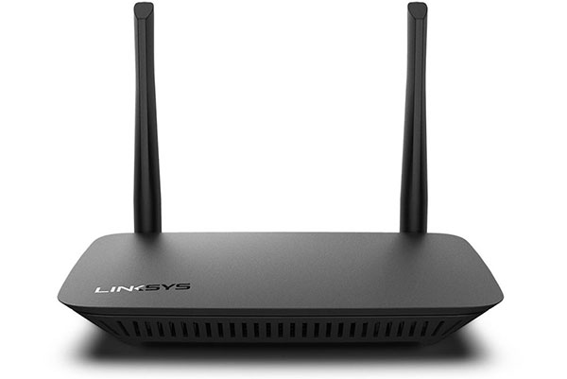

A wireless router is a device that performs the functions of a router and also includes the functions of a wireless access point. It is used to provide access to the Internet or a private computer network.

Appendix M. GRAMMARIAN’S CERTIFICATE AND SIGNATURE

*FIGURE 34 – GRAMMARIAN’S CERTIFICATE*

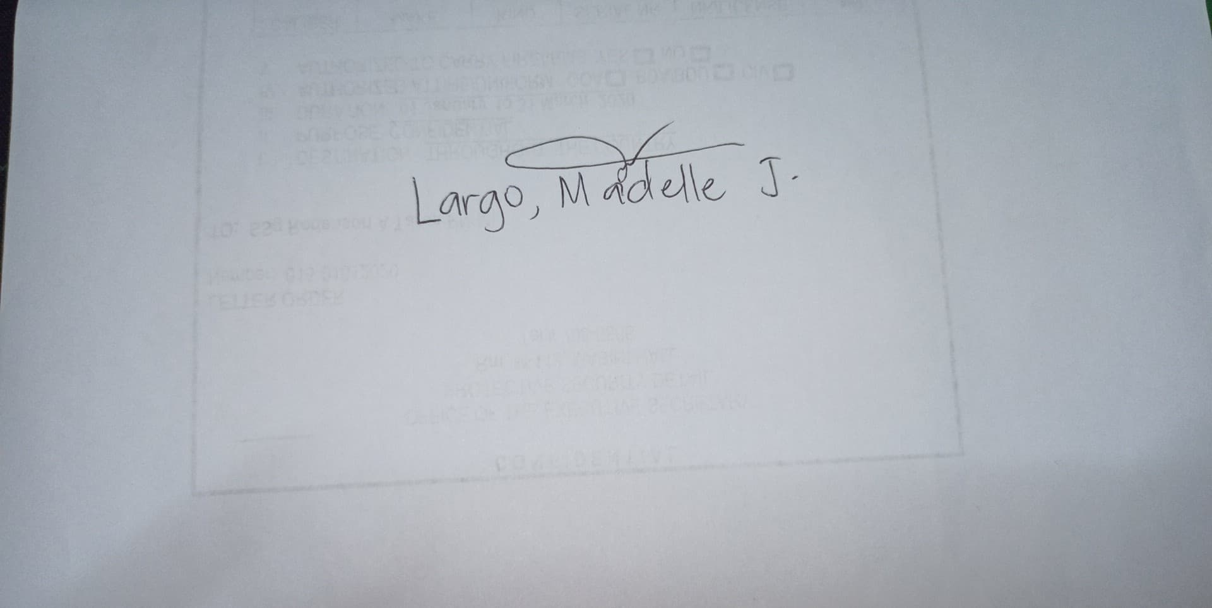*FIGURE 35 – GRAMMARIAN’S SIGNATURE*